# 1.List all customers with a rating of 100.

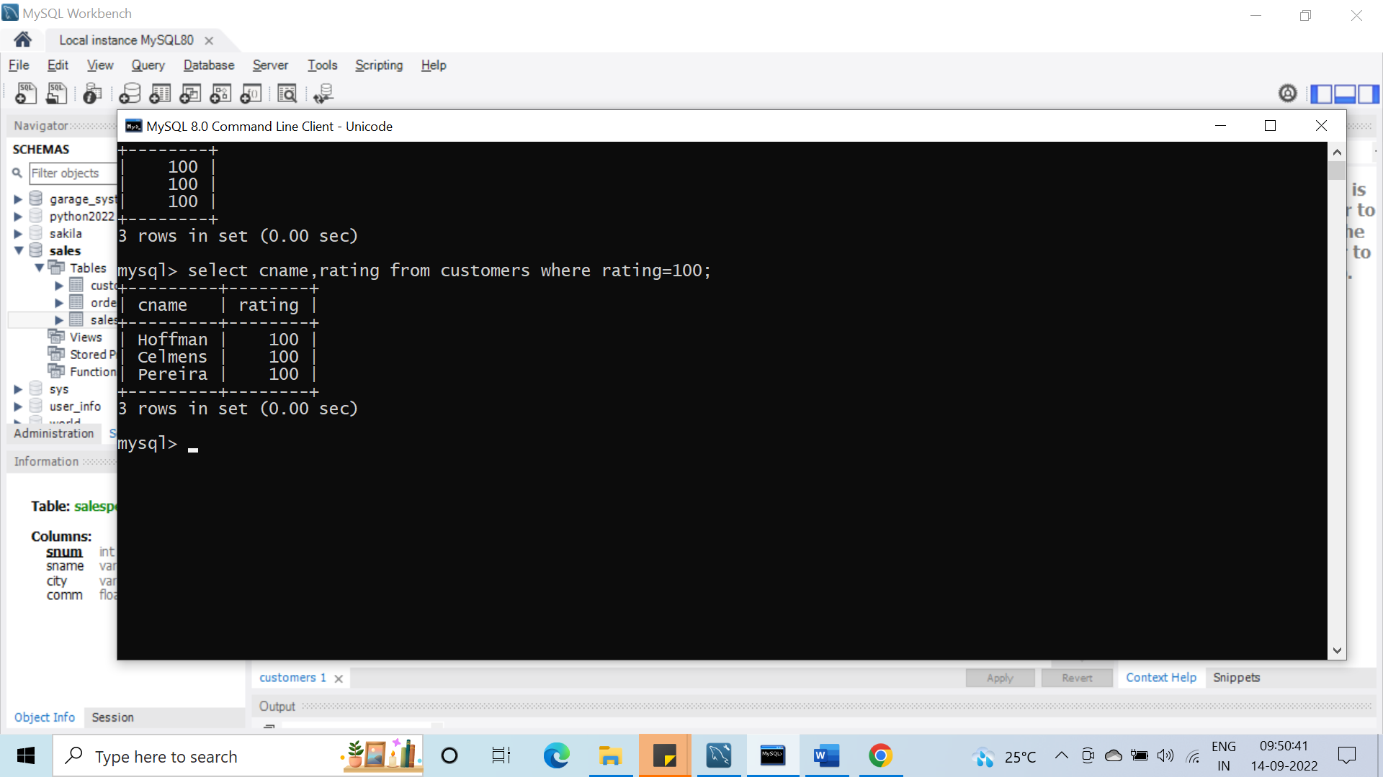

#2.Find all records in the Customer table with NULL values in the city column.

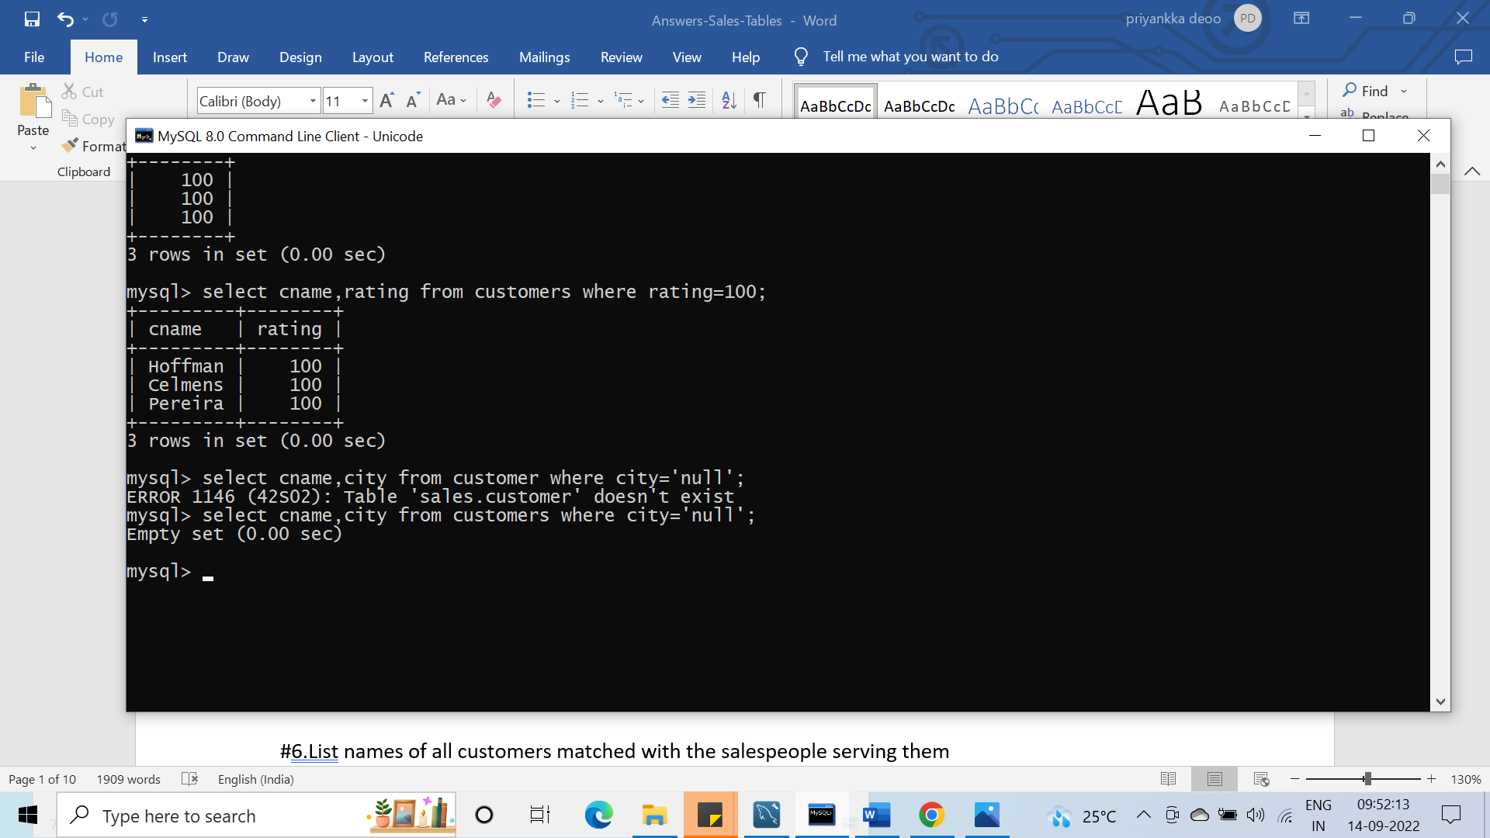

#3.Find the largest order taken by each salesperson on each date.

Select snum,odate,max(amt) from orders group by odate,snum;

#4.Arrange the Orders table by descending customer number.

Select * from orders

Order by cnum desc;

#5.Find which salespeople currently have orders in the Orders table.

Select sname,snum

from salespeople join orders using(snum);

#6.List names of all customers matched with the salespeople serving them

Select sname,snum

from salespeople join customers using(snum);

#7.Find the names and numbers of all salespeople who had more than one customer.

Select snmae,snum from salepeople

where snum in(select snum group by snum having count(*)>1;

#8.Count the orders of each of the salespeople and output the results in descending order.

Select count(onum),snum from order group by snum order by count(onum) desc;

#9.List the Customer table if and only if one or more of the customers in the Customer tables are located in San Jose.

Select * from customers where city in(select city from customers where city=’san jose’ group by city having count(city)>1);

#10. Match salespeople to customers according to what city they lived in

Select sname,cname,city from salespeople join customers using(city)

#11. Find the largest order taken by each salesperson.

Select snum,sname,max(amt) from salespeople join order using(snum);

#12. Find customers in San Jose who has a rating above 200.

Select cname,city,rating from customers where city=’san jose’ and rating>200;

#13. List the names and commissions of all salespeople in London.

Select snmae,city,comm from salespeople where city=”London”;

#14. List all the orders of salesperson Monika from the Orders table.

Select sname,snum,amt from salespeople join orders using(snum) where sname=”monika”;

#15. Find all customers with orders on October 3.

Select cname,odate from customers join orders using(cnum) where odate=”1996-10-03”

#16. Give the sums of the amounts from the orders table, grouped by date

Select sum(amt),odate from orders group by odate:

#17. Eliminating all those dates where the SUM was not at least 2000.00 above the MAX amount.

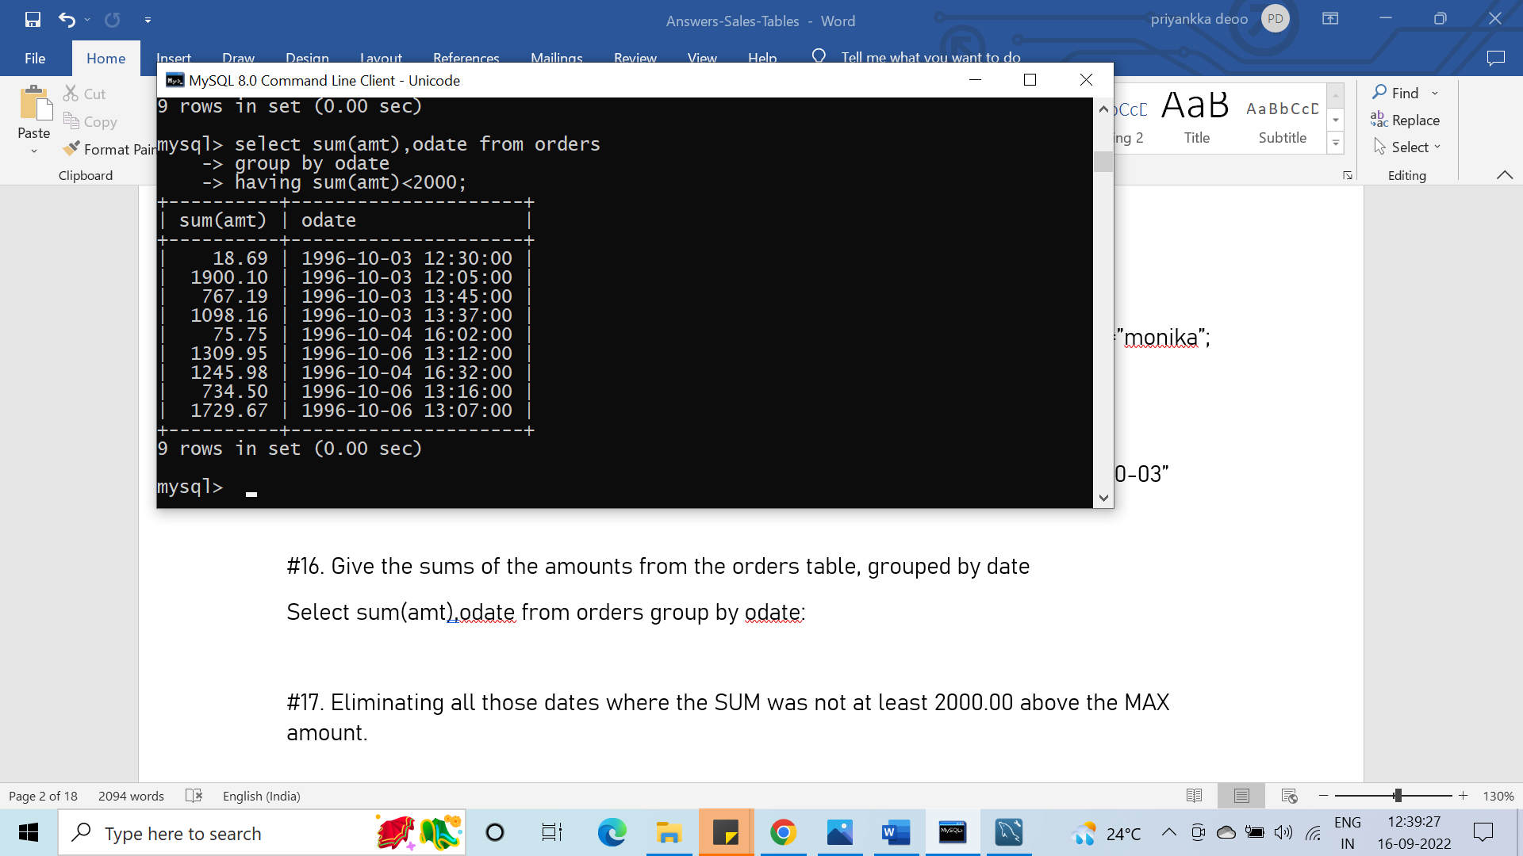

#18. Select all orders that had amounts that were greater than at least one of the orders from October 6.

Select amt,odate from orders where amt<(select max(amt) from orders) group by odate;

#19. Write a query that uses the EXISTS operator to extract all salespeople who have customers with a rating of 300.

Select cname from customers where exists(select rating from orders where customers.rating=300);

#20. Find all pairs of customers having the same rating.

Select cname,rating from customers

Order by rating;

#21. Find all customers with CNUM, is 1000 above the SNUM of Serres.

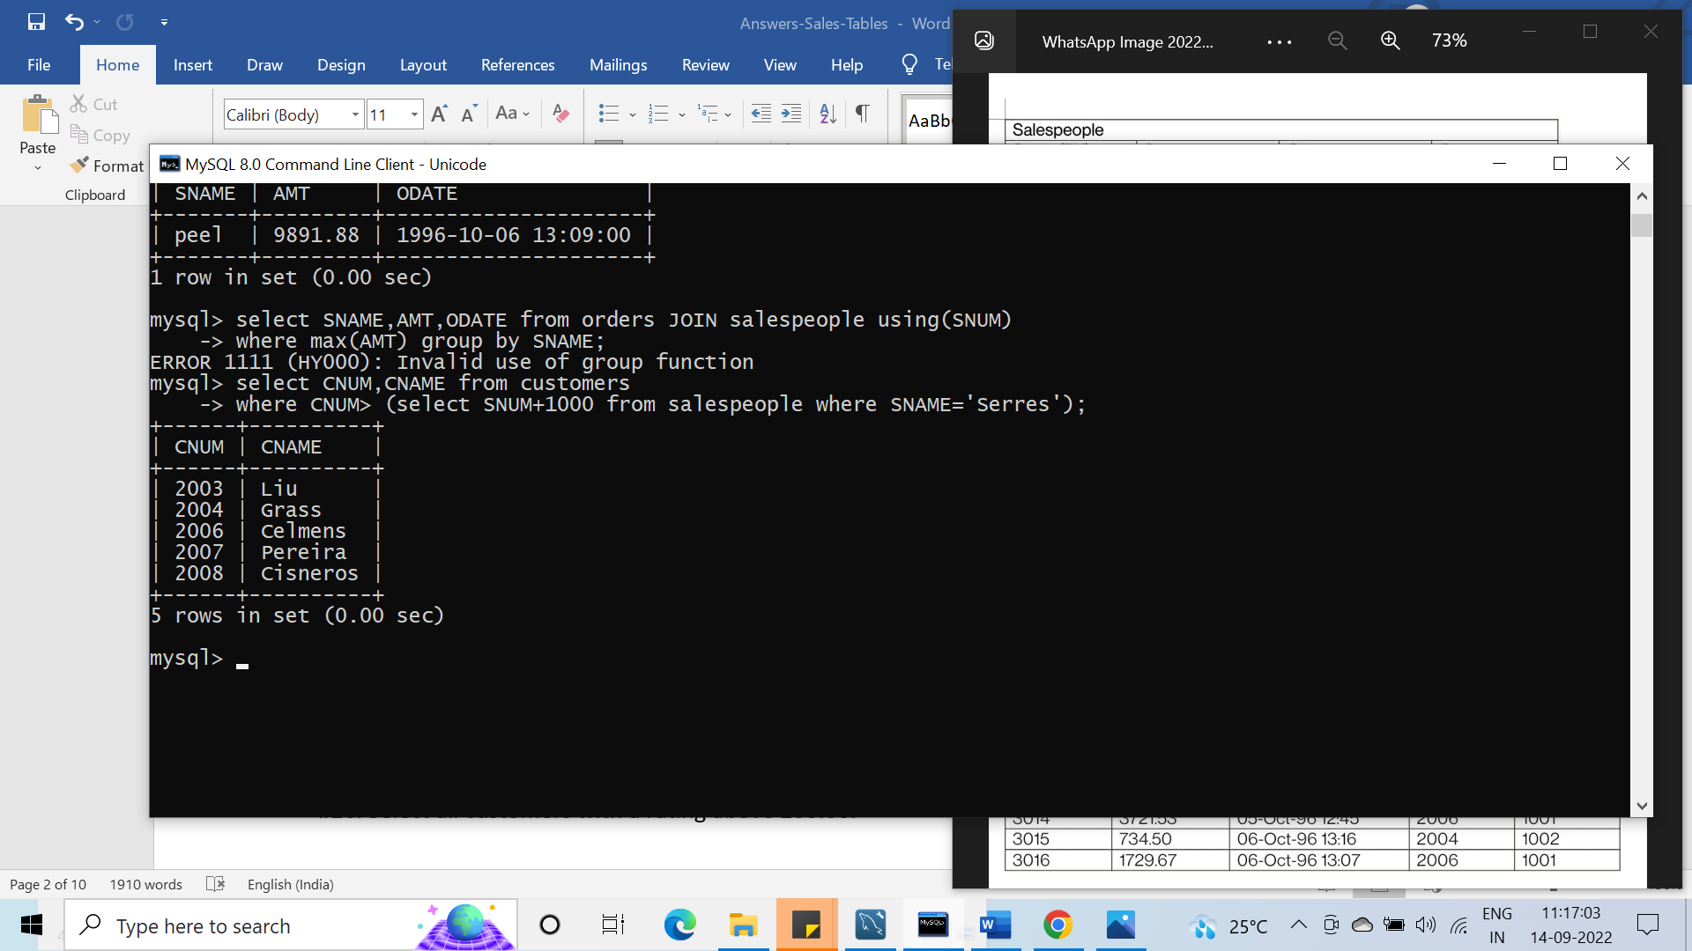

#22. Give the salespeople’s commissions as percentage instead of decimal numbers.

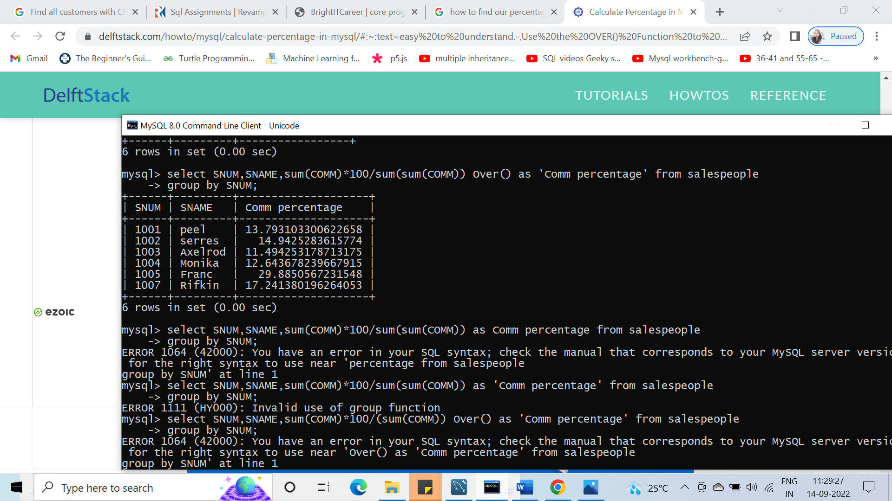

#23. Find the largest order taken by each salesperson on each date, eliminating those MAX orders, which are less than $3000.00 in value.

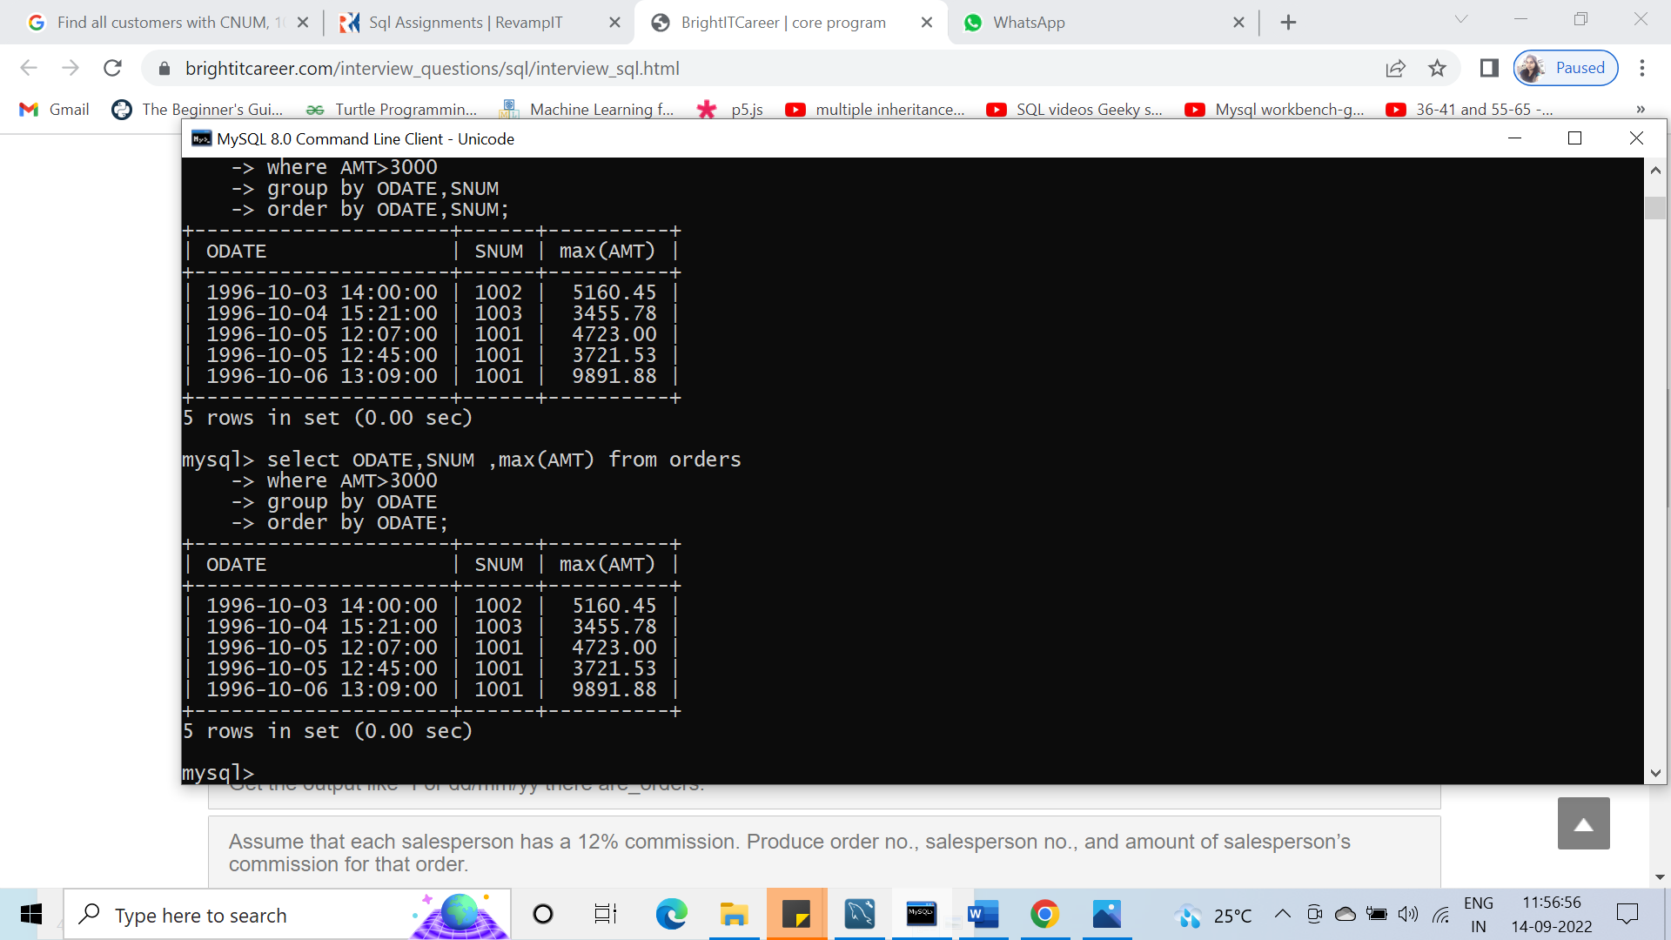

#24. List the largest orders on October 3, for each salesperson.

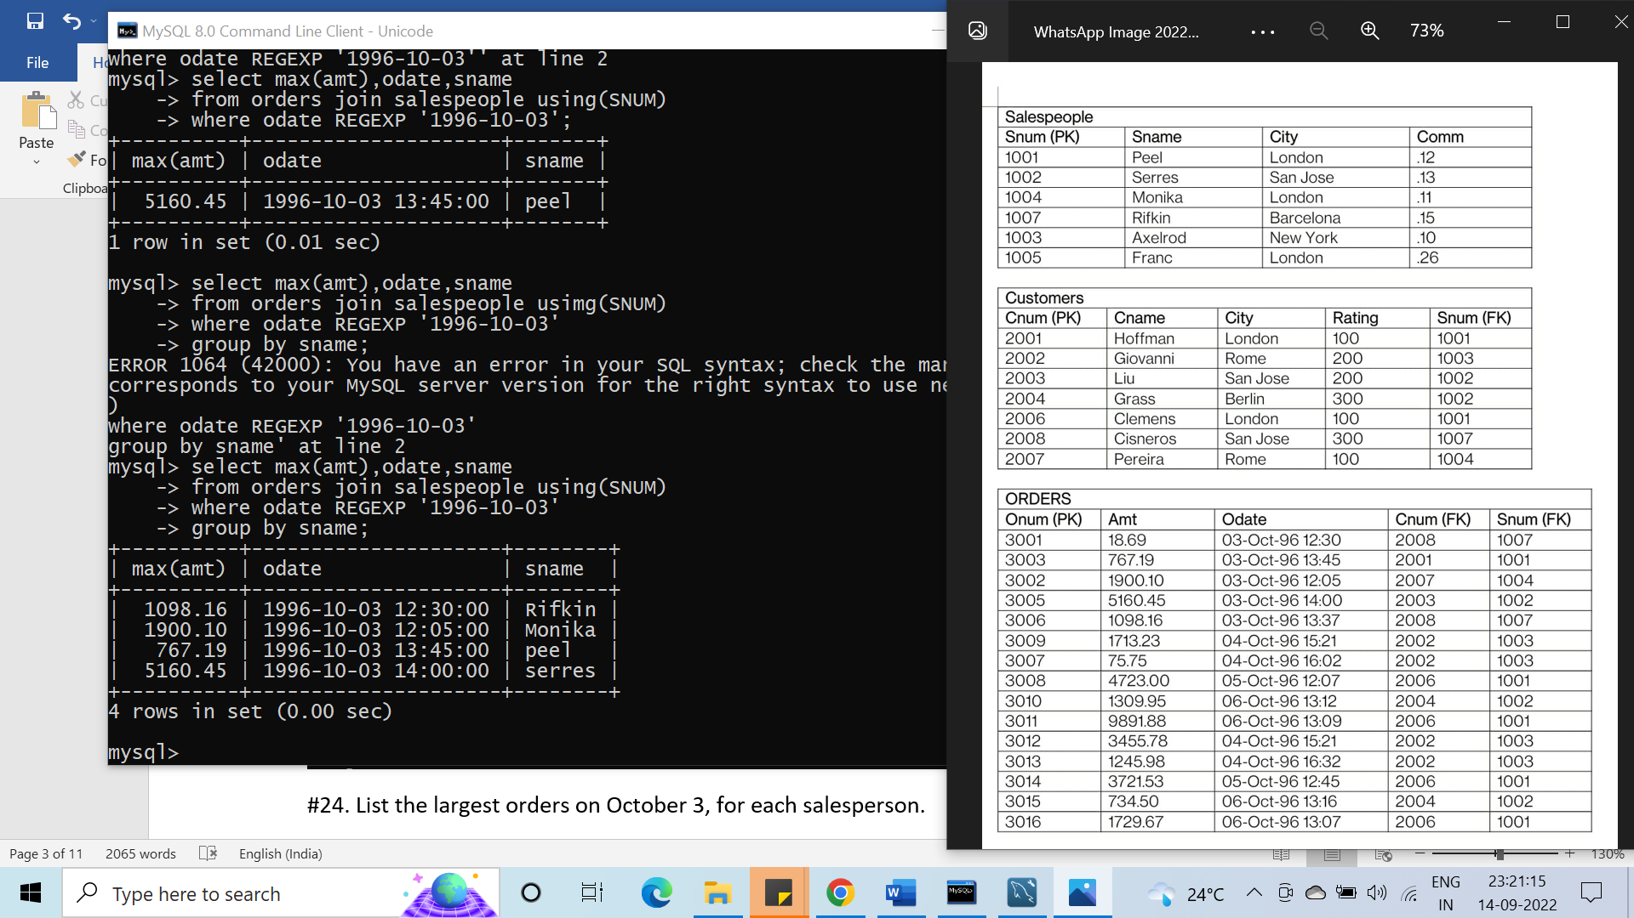

#25. Find all customers located in cities where Serres (SNUM 1002) has customers.

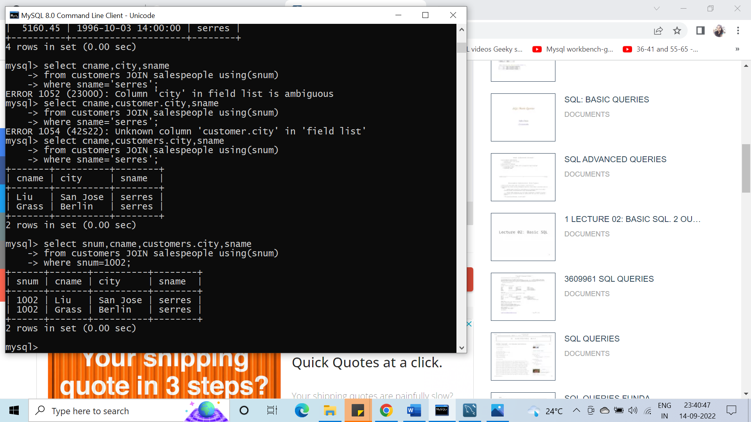

#26. Select all customers with a rating above 200.00.

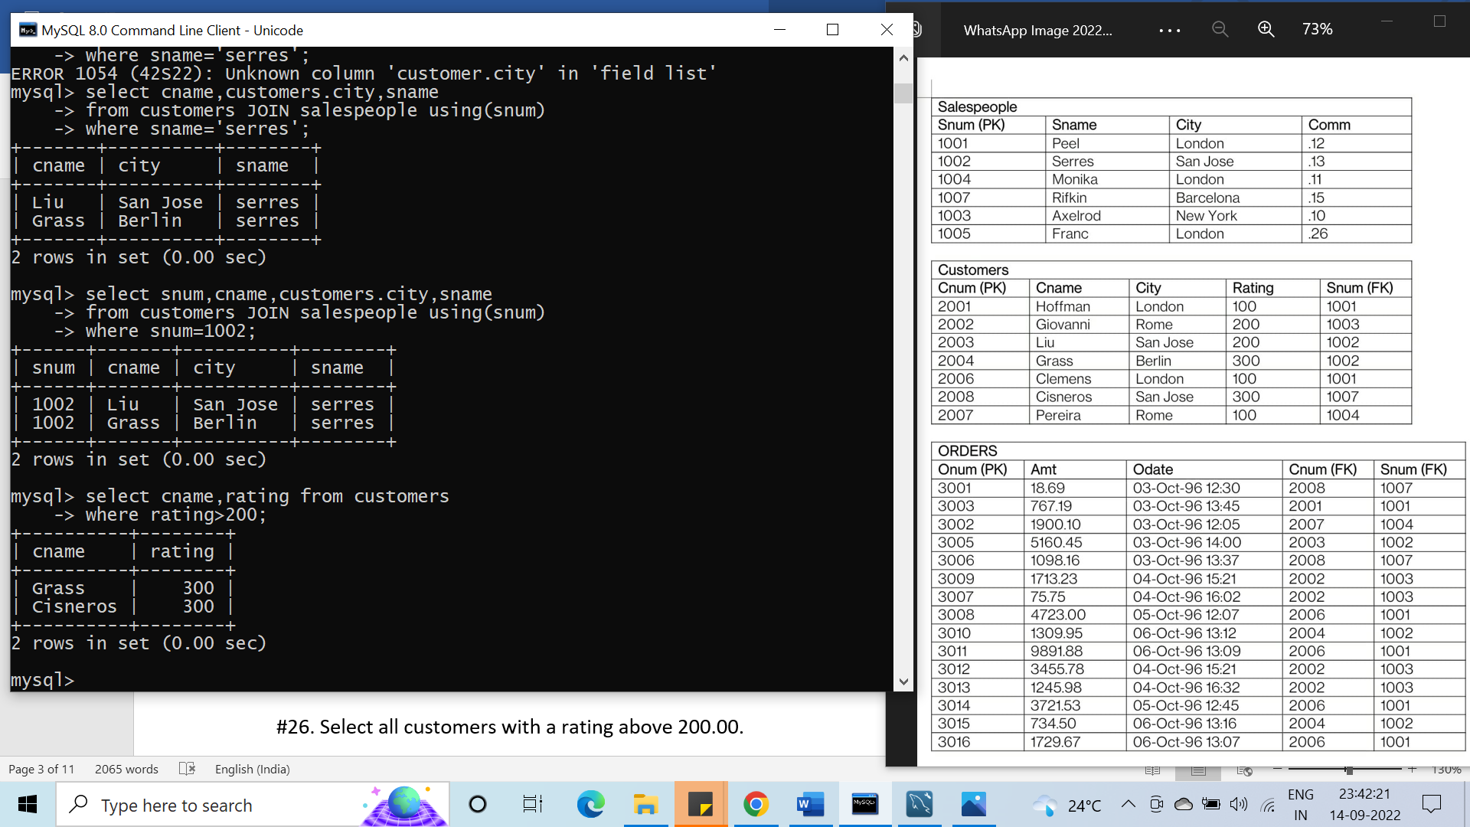

#27. Count the number of salespeople currently listing orders in the Orders table.

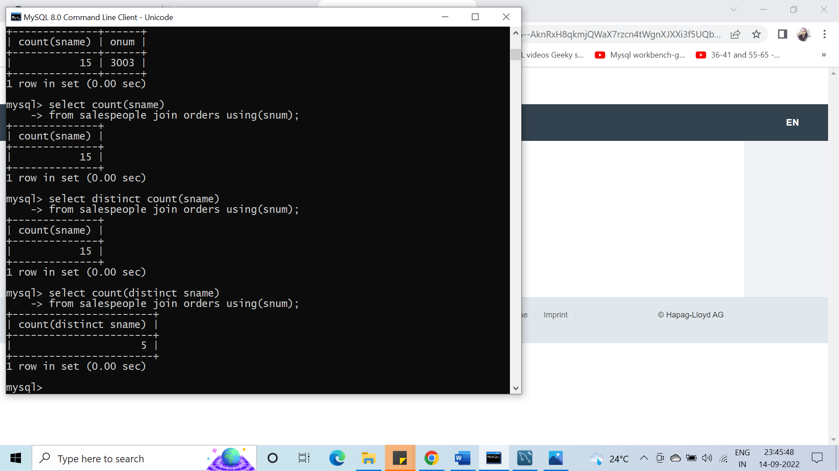

#28. Write a query that produces all customers serviced by salespeople with a commission above 12%. Output the customer’s name and the salesperson‘s rate of commission.

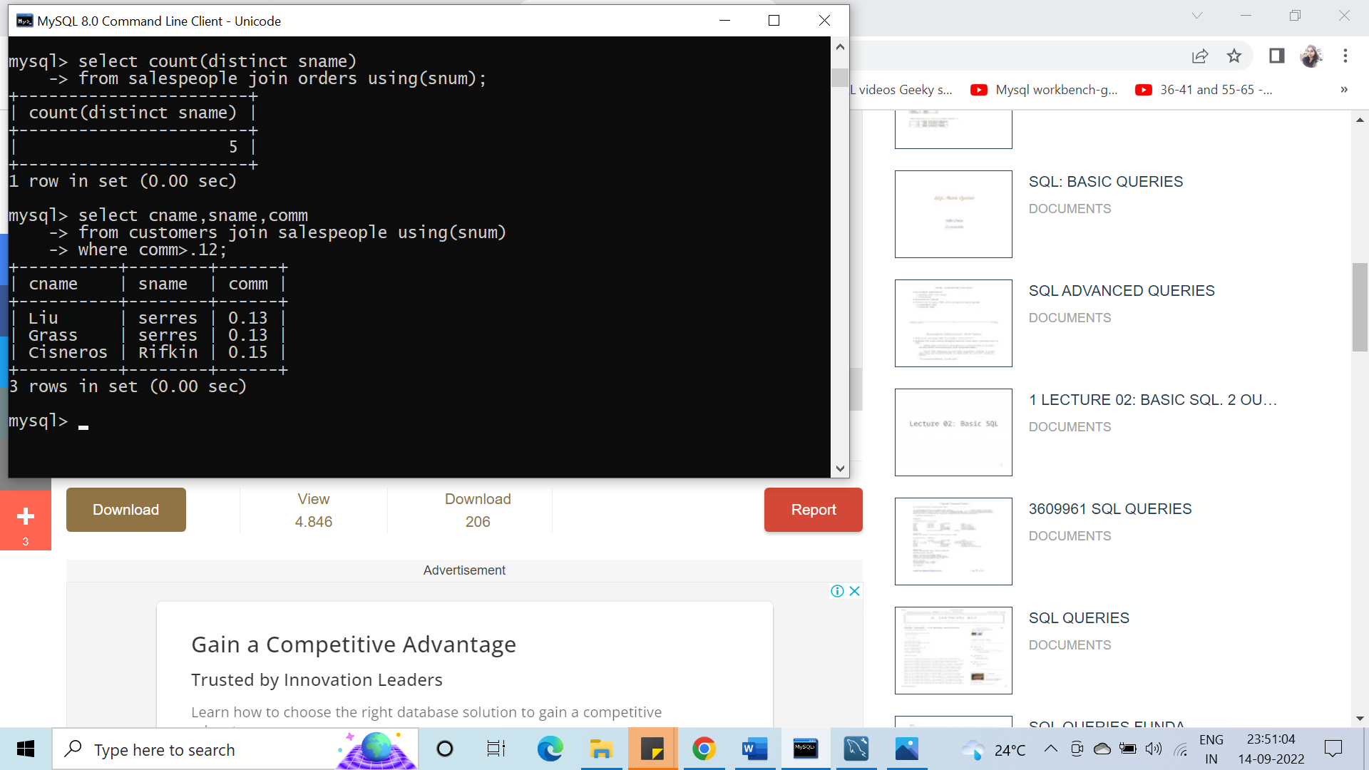

#29. Find salespeople who have multiple customers

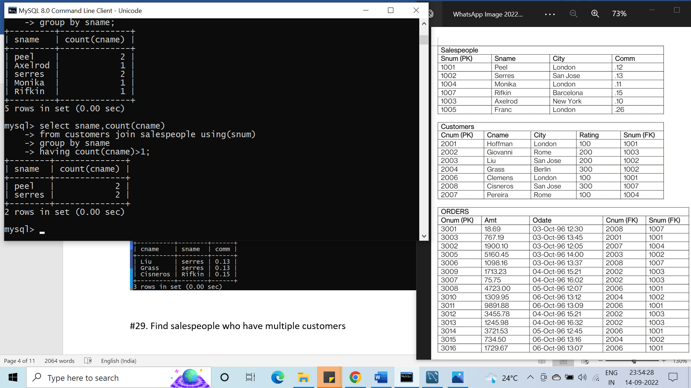

#30. Find salespeople with customers located in their city

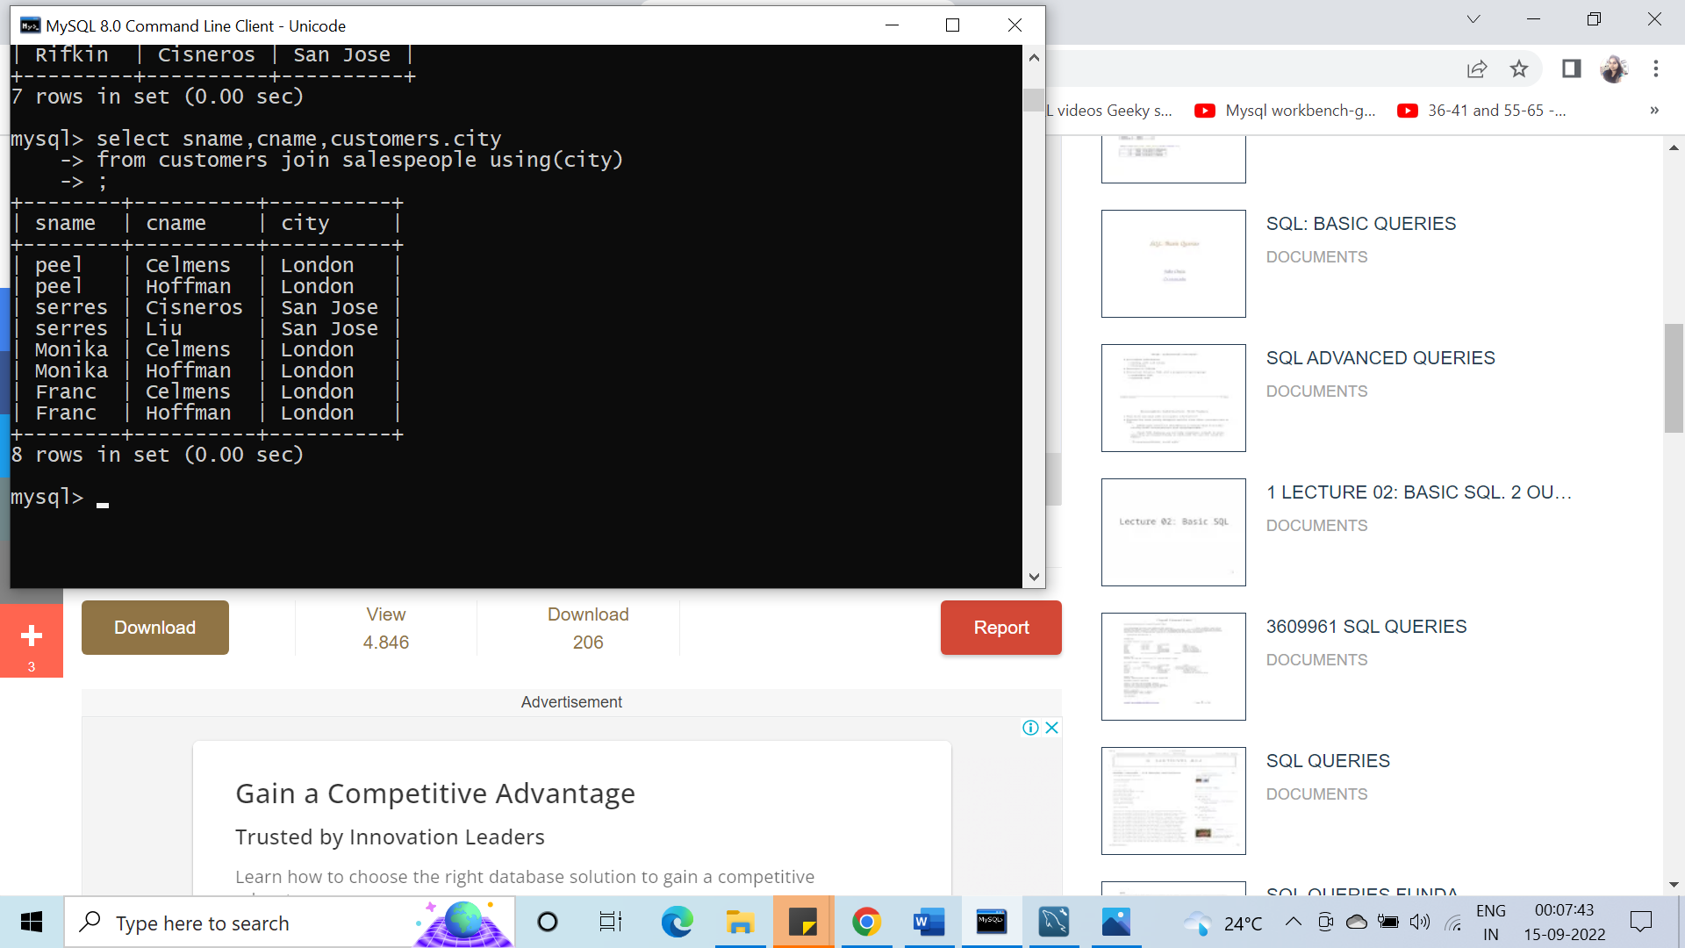

#31. Find all salespeople whose name starts with ‘P’ and the fourth character is ‘I’.

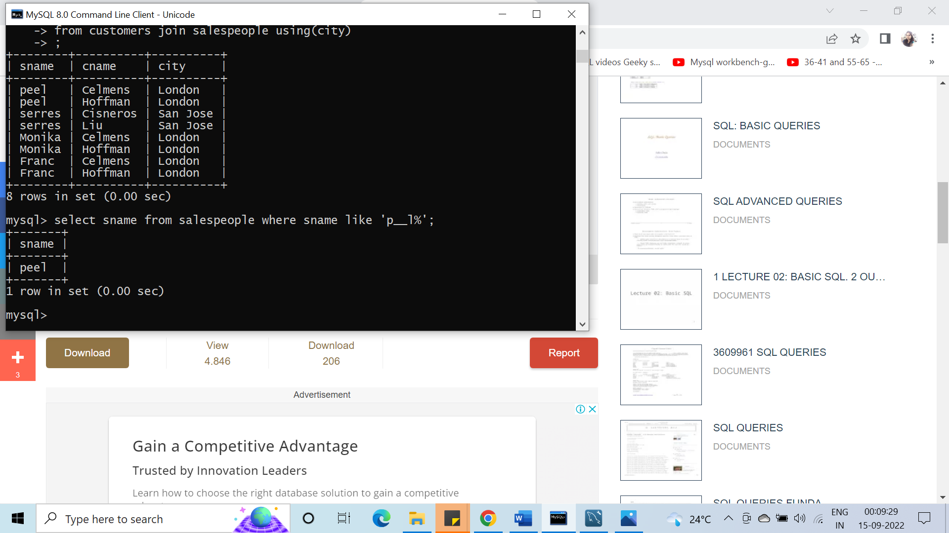

#32. Write a query that uses a sub query to obtain all orders for the customer named ‘Cisneros’. Assume you do not know his customer number.

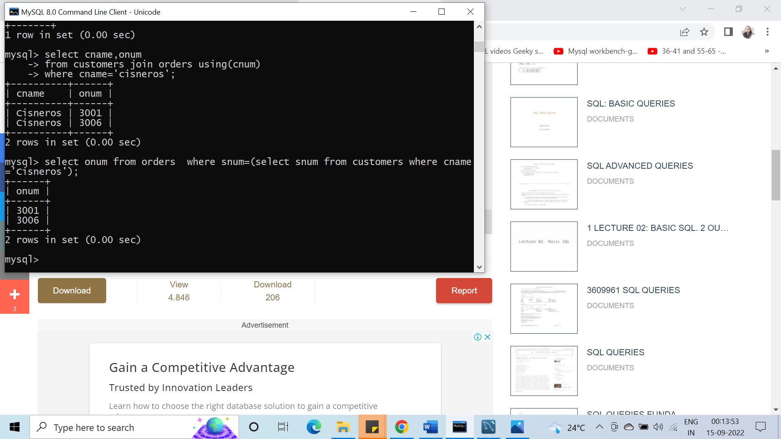

#33. Find the largest orders for ‘Serres’ and ‘Rifkin’.

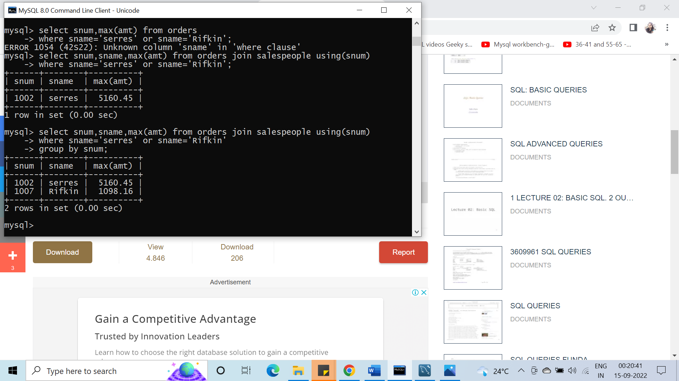

#34. Extract the Salespeople table in the following order: SNUM, SNAME, COMMISSION, CITY.

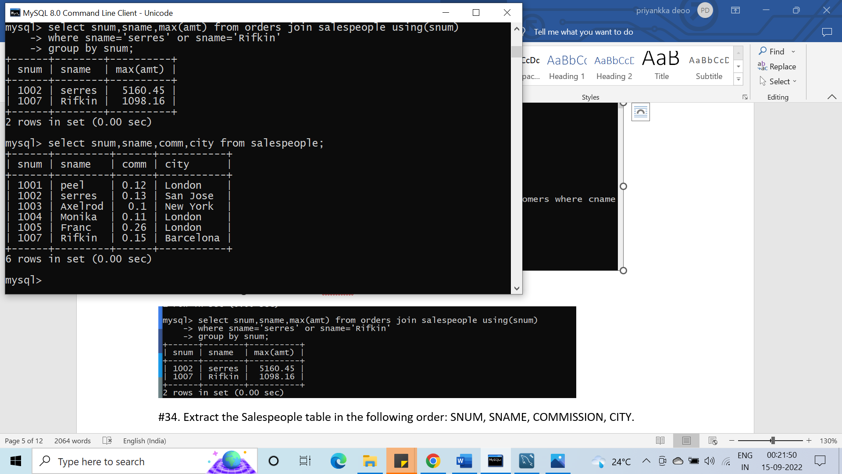

#35. Select all customers whose names fall in between ‘A’ and ‘G’ alphabetical range.

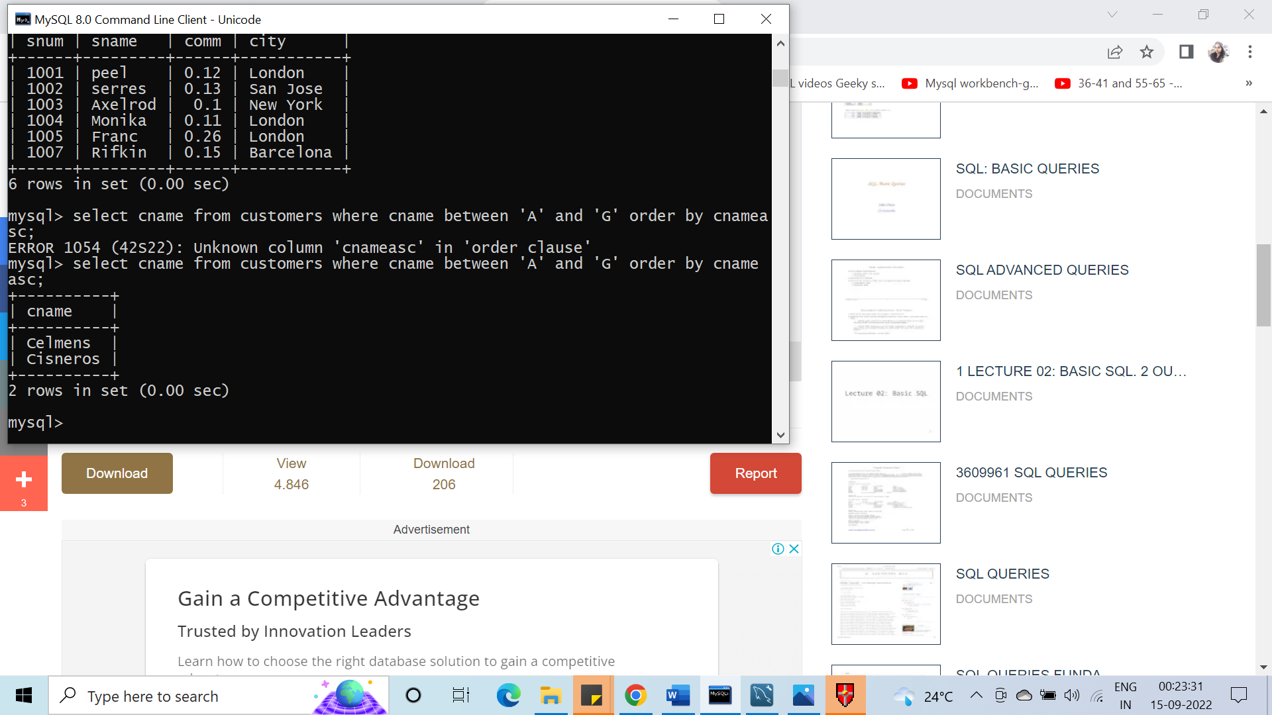

#36. Select all the possible combinations of customers that you can assign.

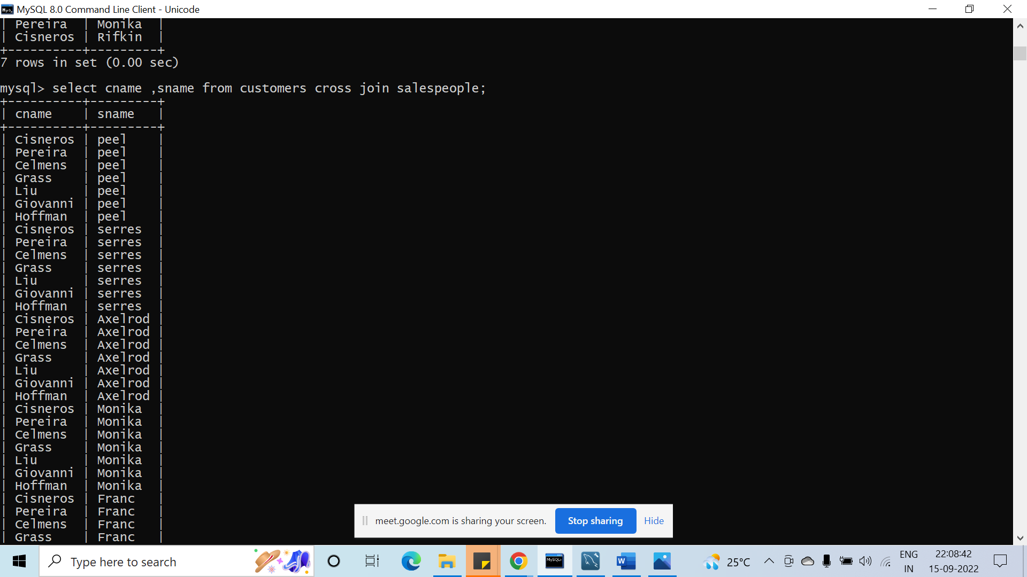

#37. Select all orders that are greater than the average for October 4.

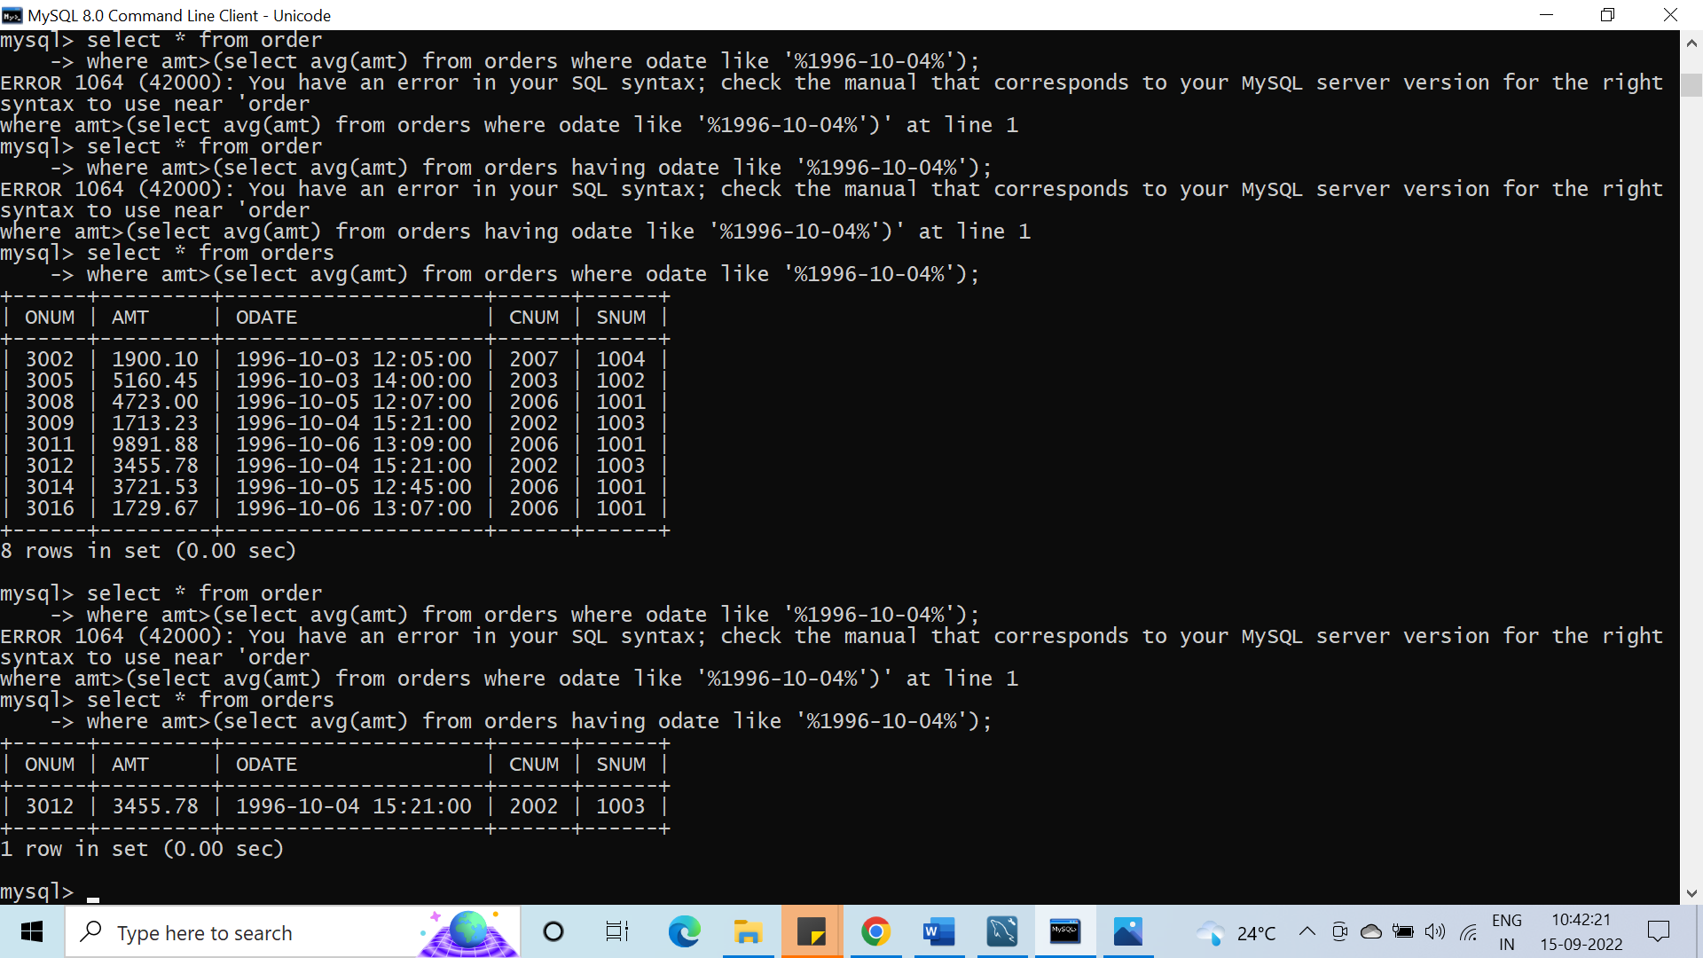

#38. Write a select command using a correlated sub query that selects the names and numbers of all customers with ratings equal to the maximum for their city.

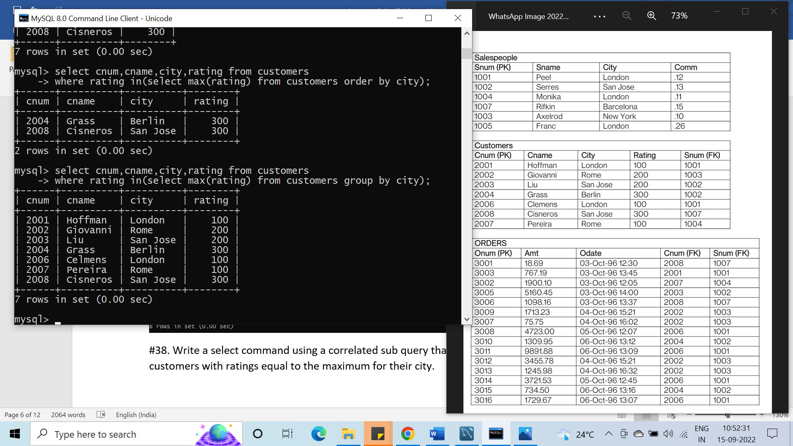

#39. Write a query that totals the orders for each day and places the results in descending order

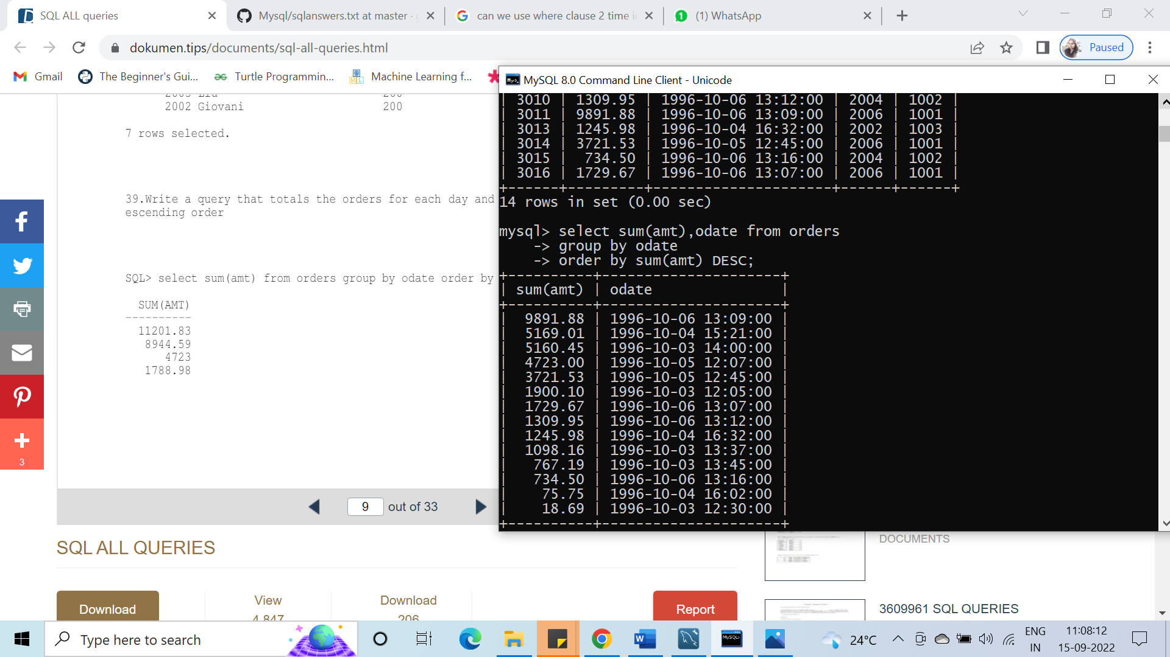

#40. Write a select command that produces the rating followed by the name of each customer in San Jose.

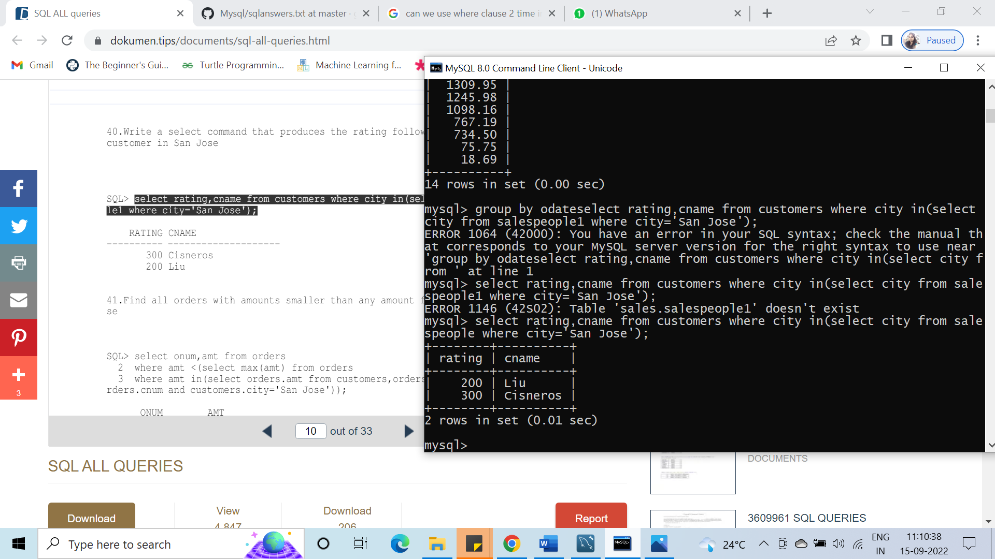

#41. Find all orders with amounts smaller than any amount for a customer in San Jose.

#42. Find all orders with above average amounts for their customers

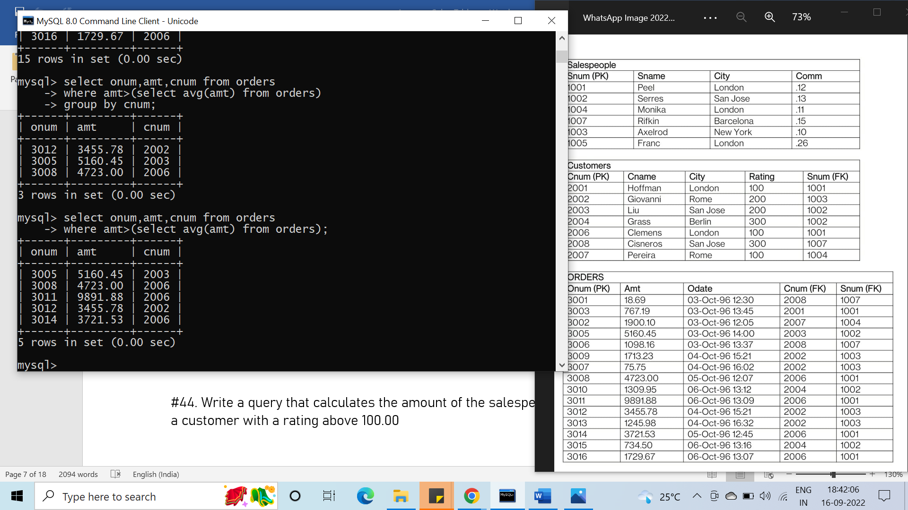

#43. Write a query that selects the highest rating in each city

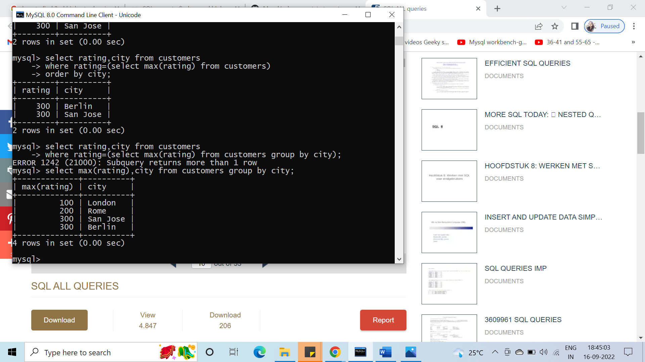

#44. Write a query that calculates the amount of the salesperson’s commission on order by a customer with a rating above 100.00

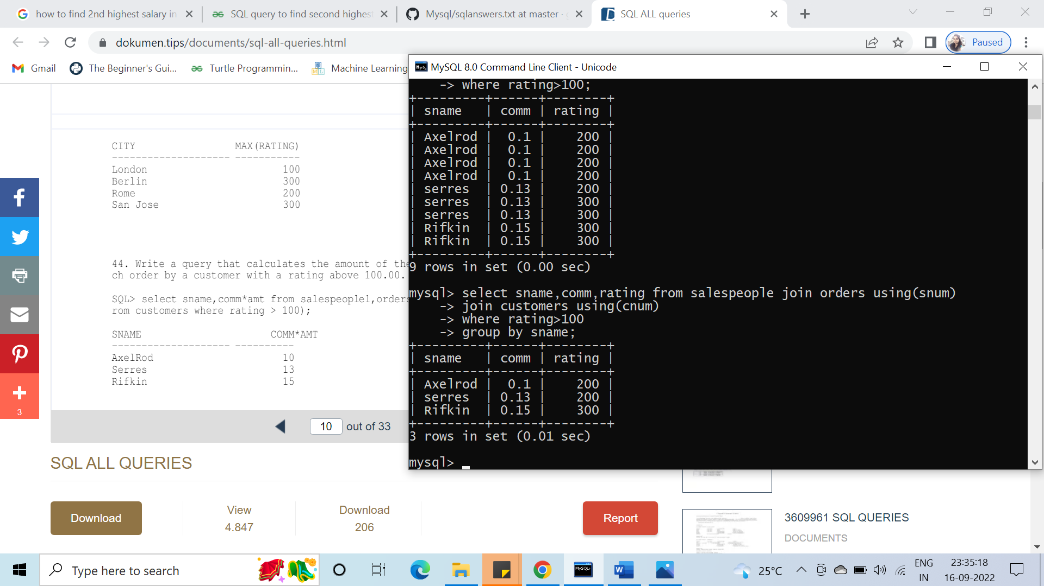

#45. Count the customers with rating above San Jose’s average.

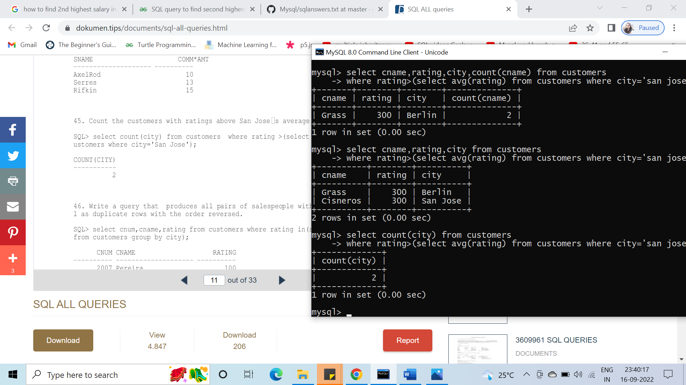

#46. Write a query that produces all pairs of salespeople with themselves as well as duplicate rows with the order reversed.

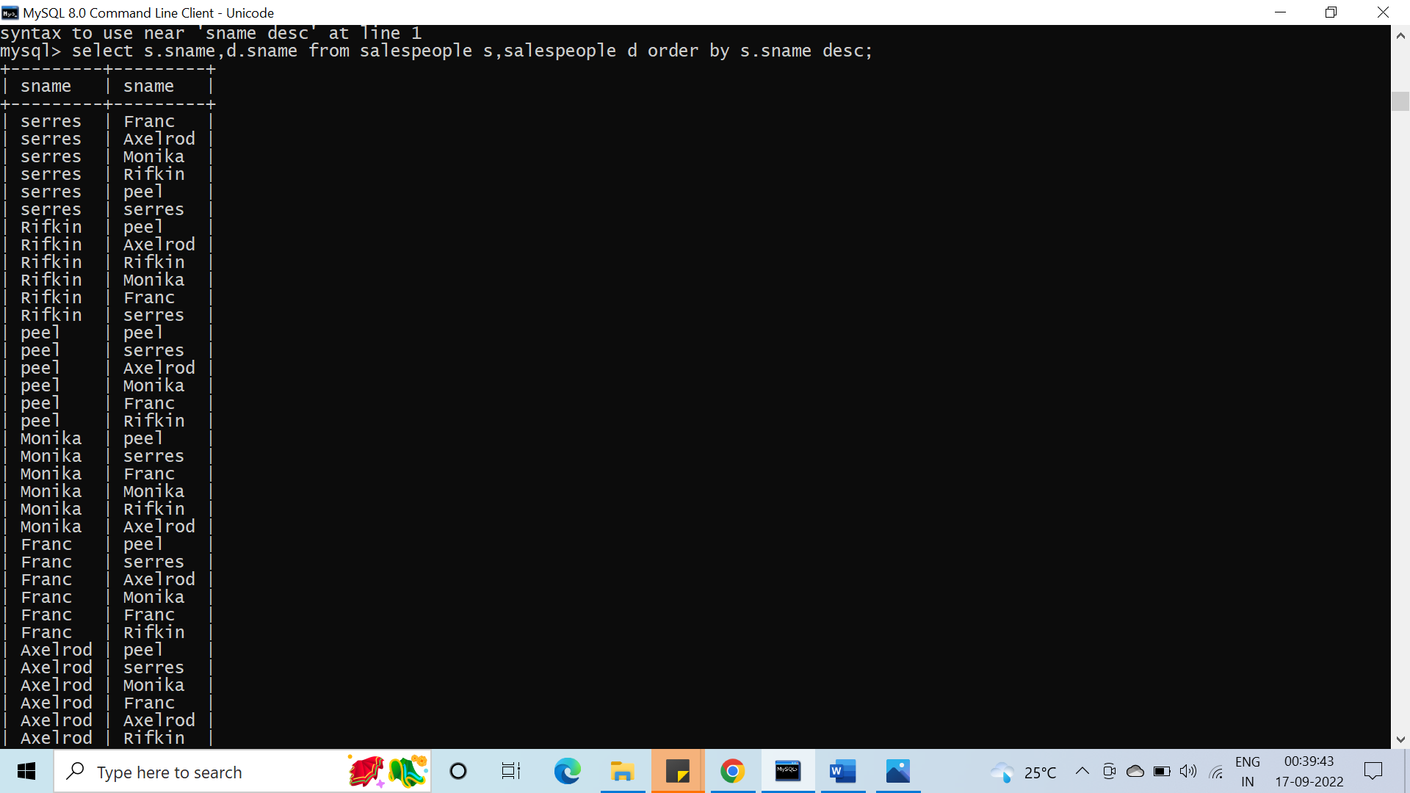

#47. Find all salespeople that are located in either Barcelona or London.

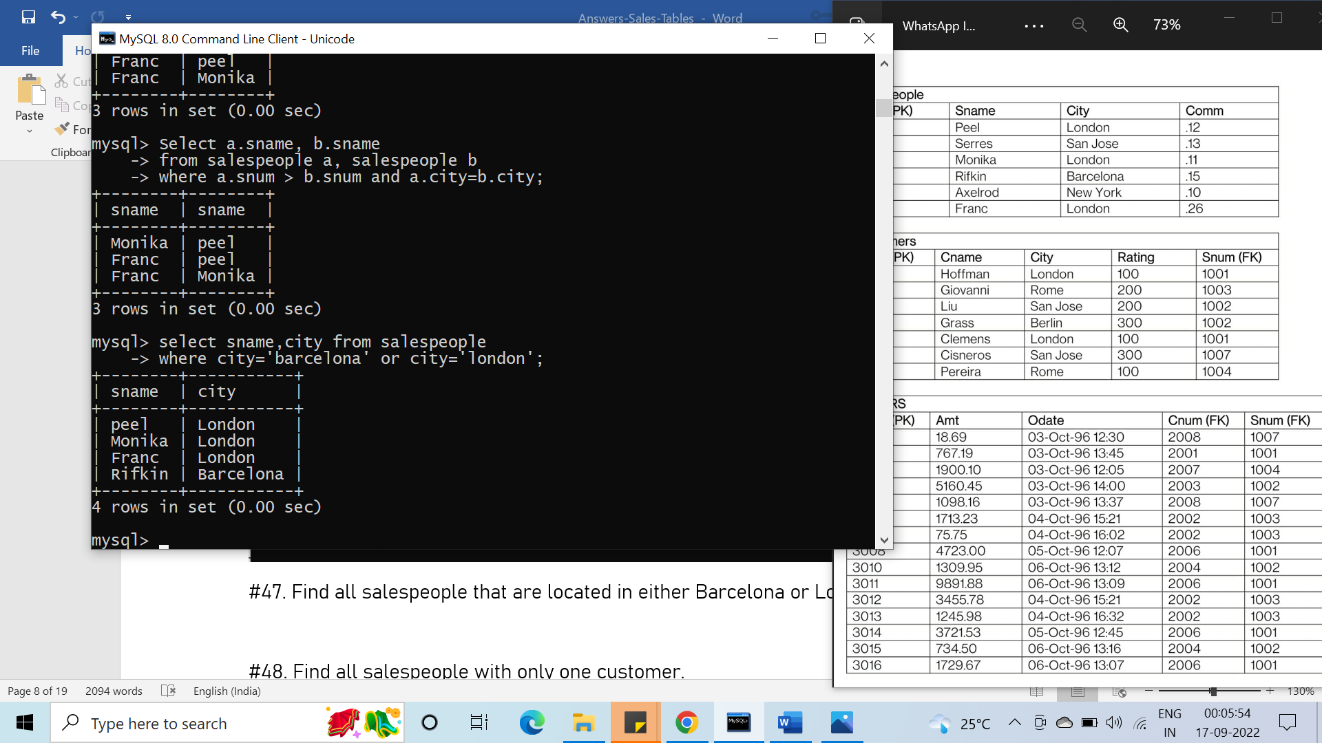

#48. Find all salespeople with only one customer.

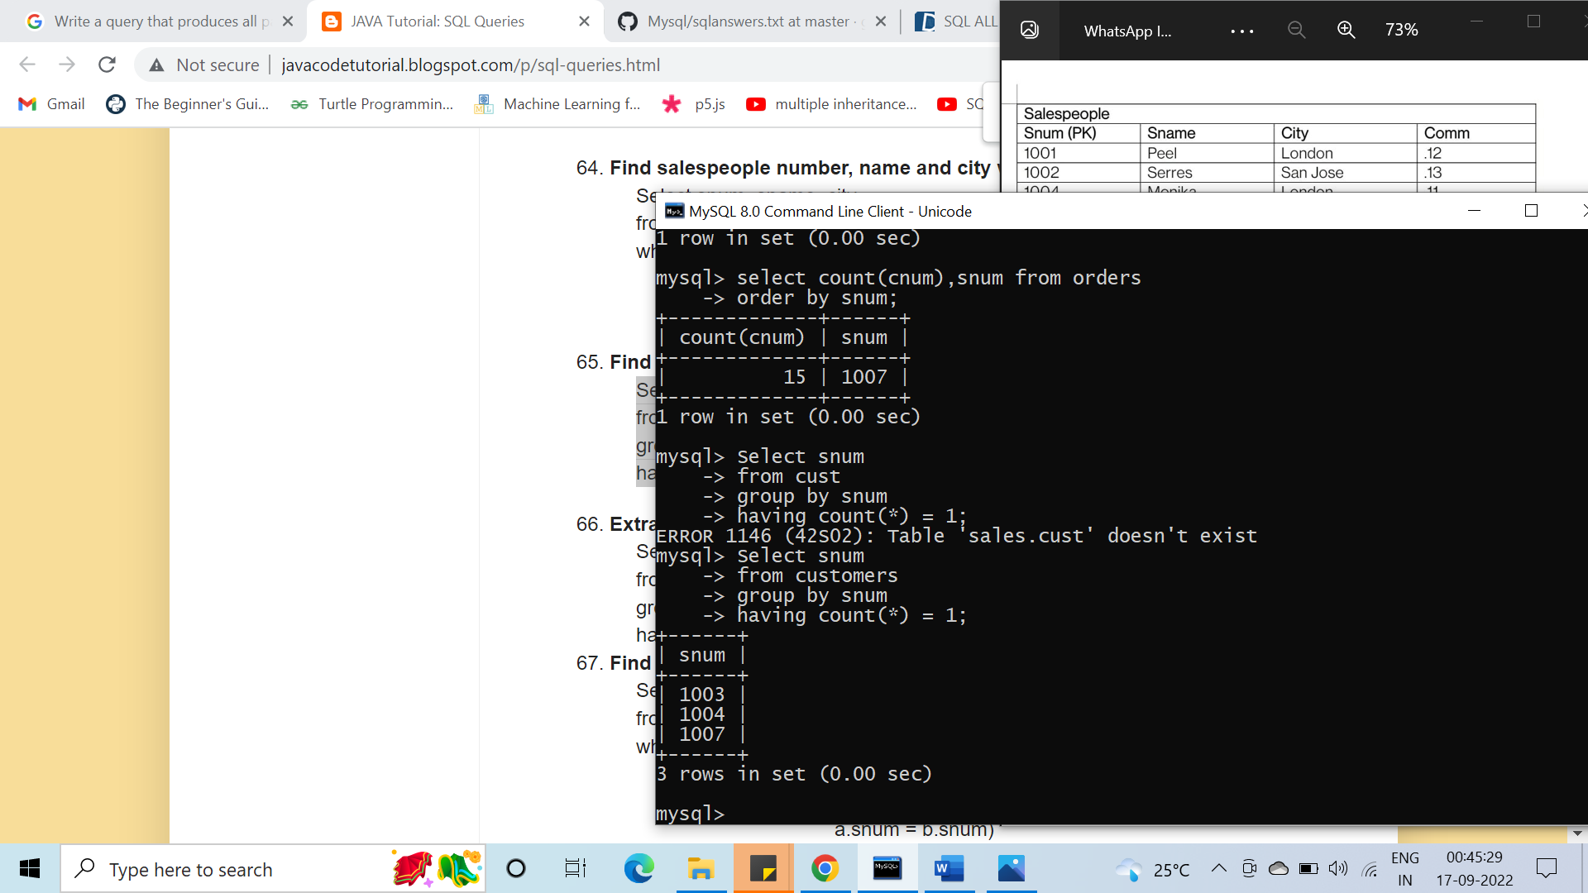

#49. Write a query that joins the Customer table to itself to find all pairs of customers served by a single salesperson.

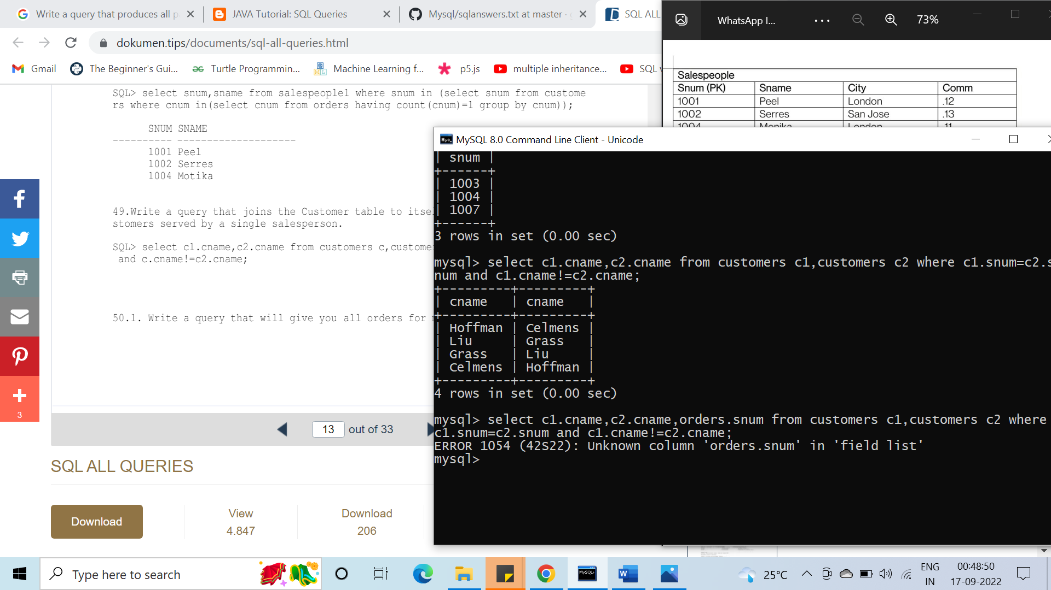

#50. Write a query that will give you all orders for more than $1000.00.

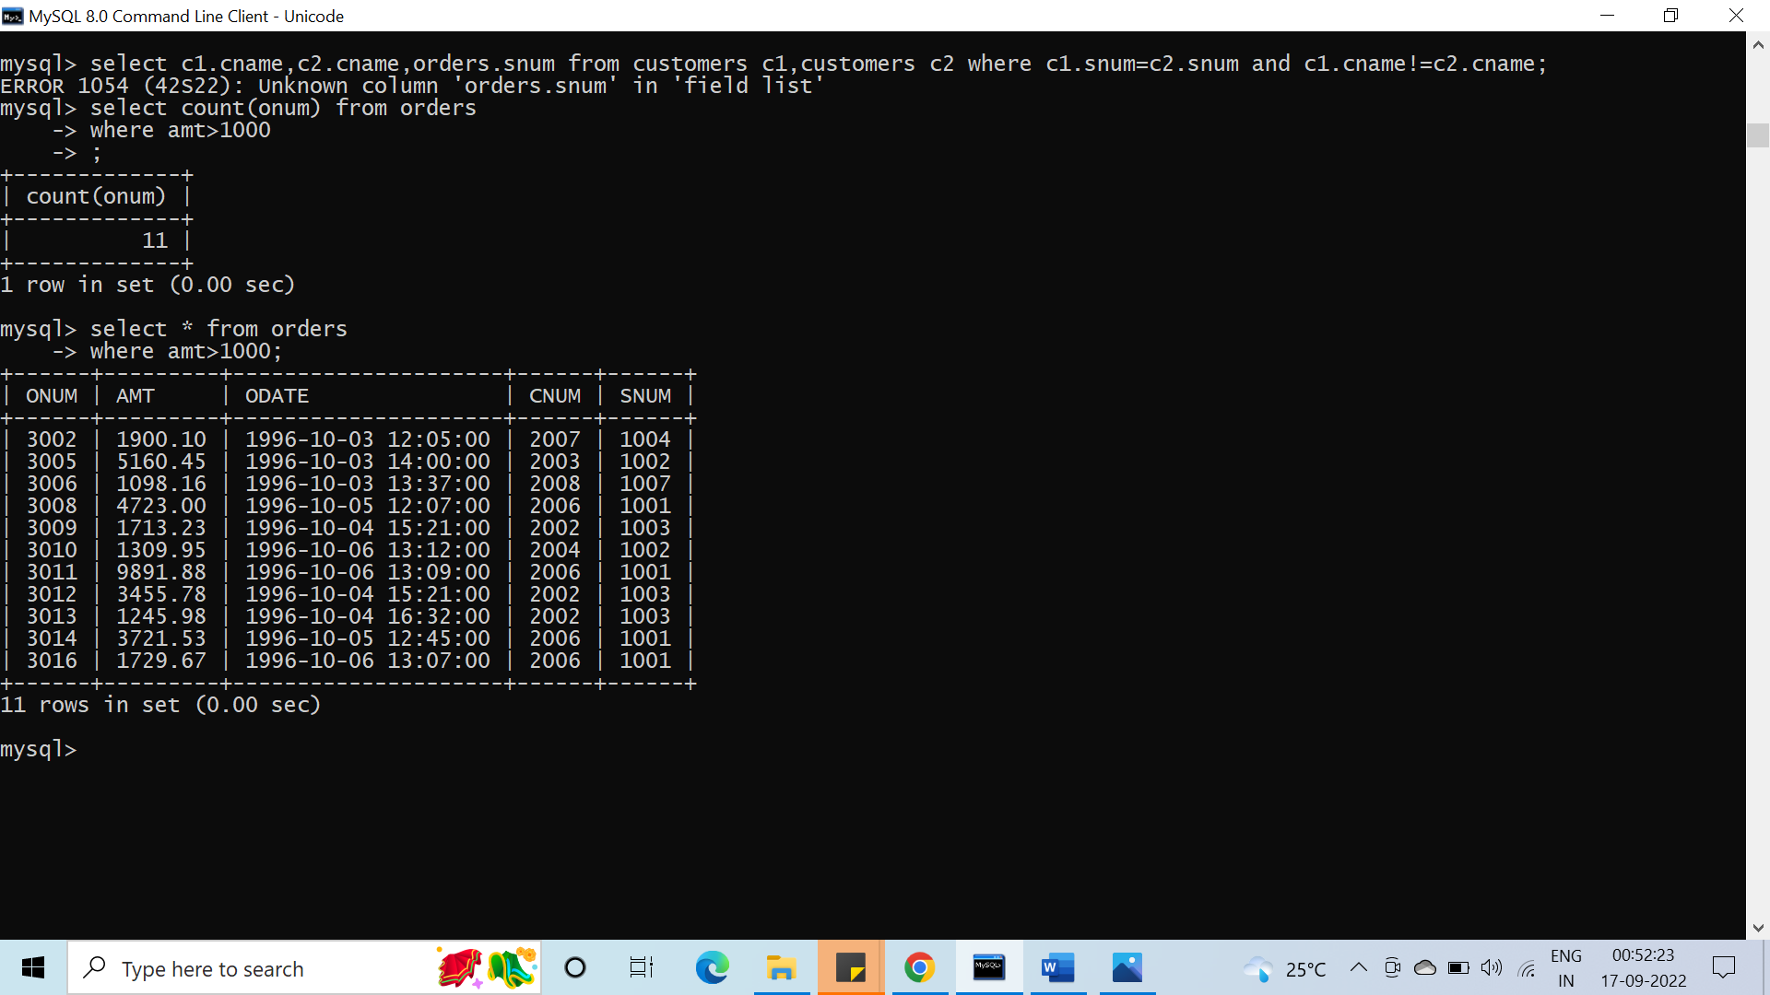

#51. Write a query that lists each order number followed by the name of the customer who made that order.

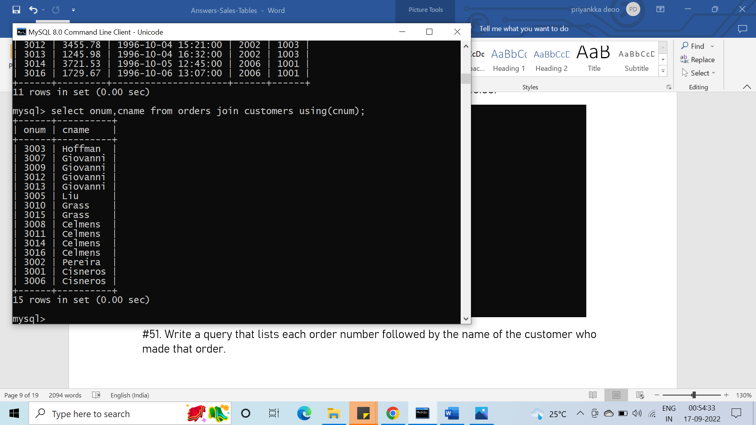

#52. Write 2 queries that select all salespeople (by name and number) who have customers in their cities who they do not service, one using a join and one a correlated subquery. Which solution is more elegant?

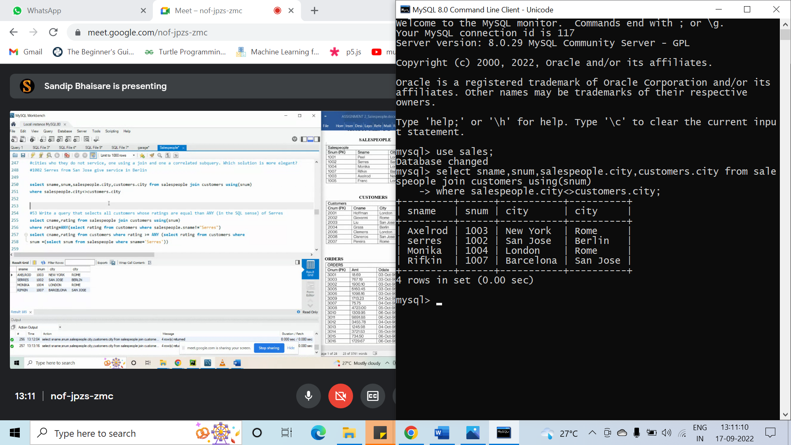

#53. Write a query that selects all customers whose ratings are equal than ANY (in the SQL sense) of Serres.

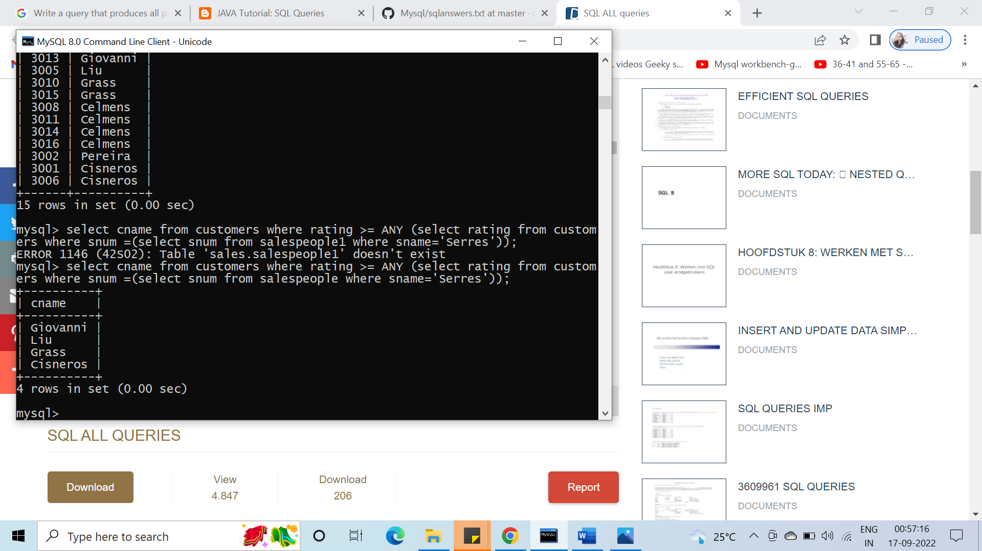

#54. Write2 queries that will produce all orders taken on October3 or October 4.

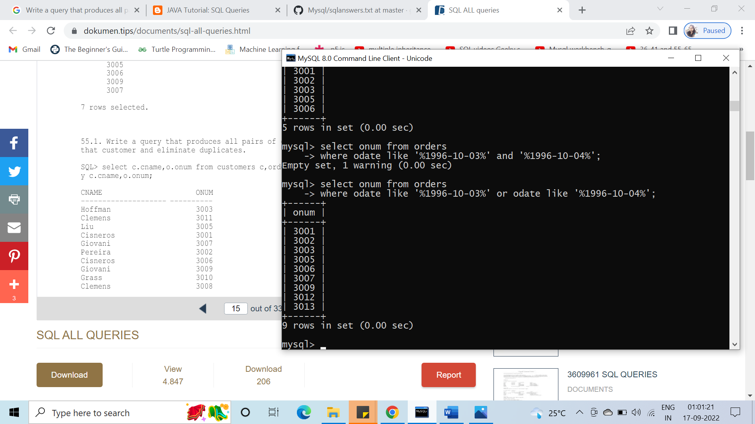

#55. Write a query that produces all pairs of orders by a given customer. Name that customer and eliminate duplicates.

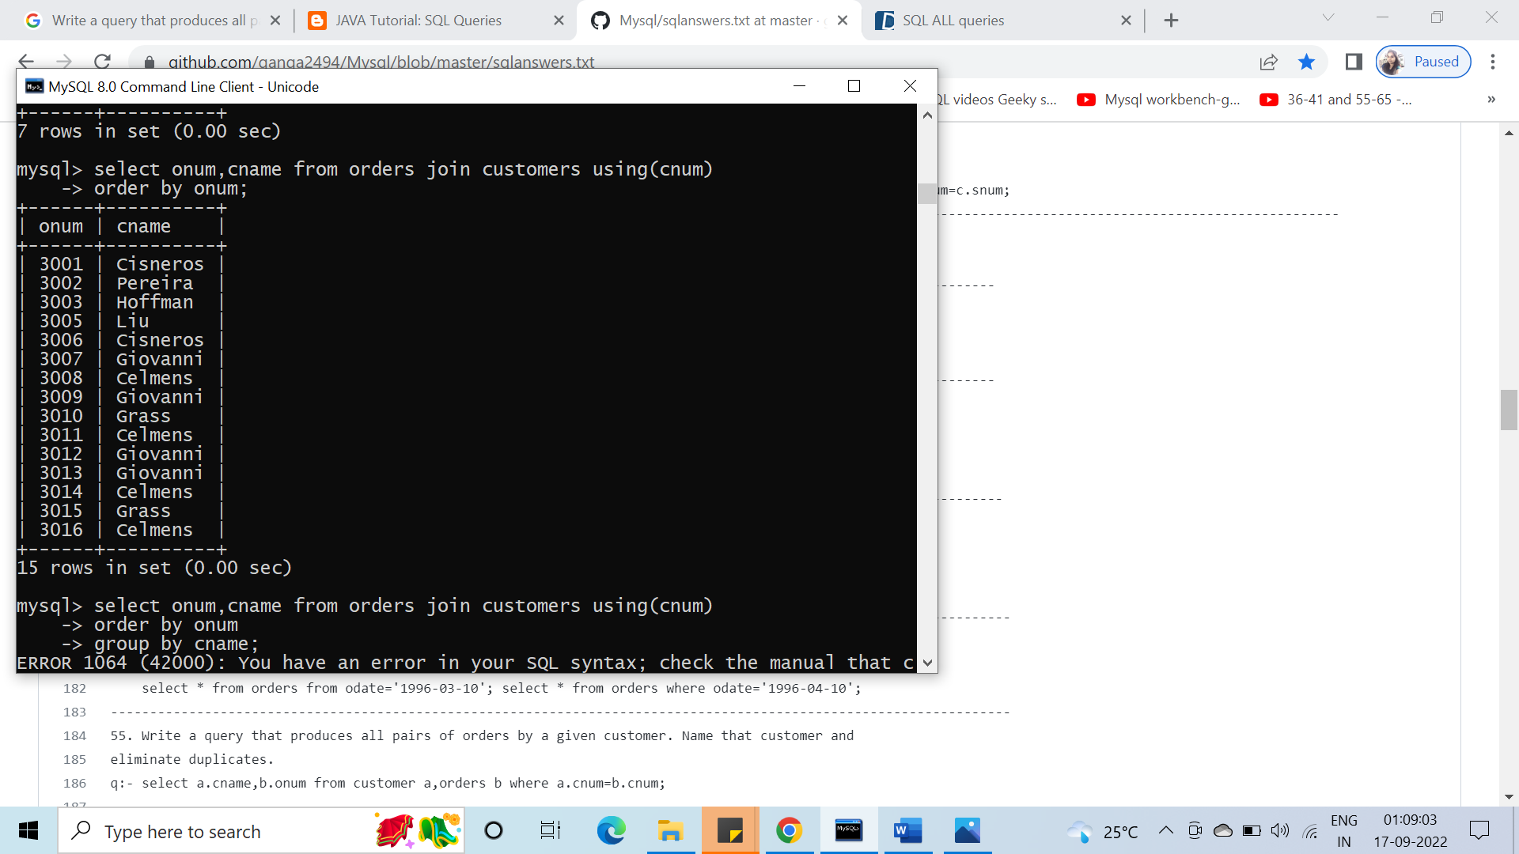

#56. Find only those customers whose ratings are higher than every customer in Rome.

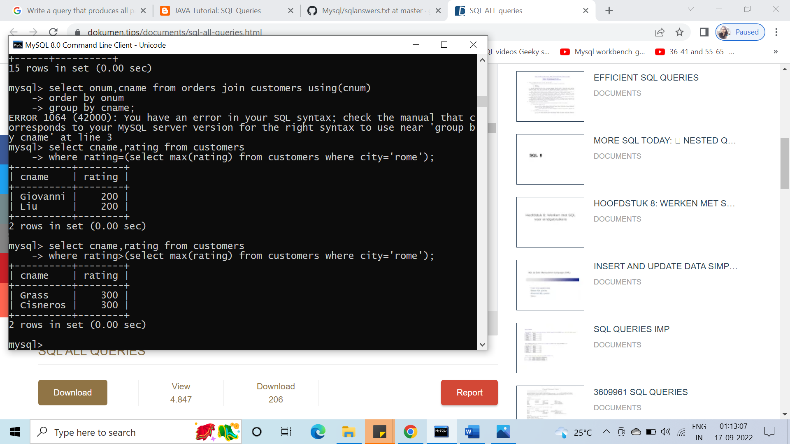

#57. Write a query on the customers table whose output will exclude all customers with a rating < = 100.00, unless they are located in Rome.

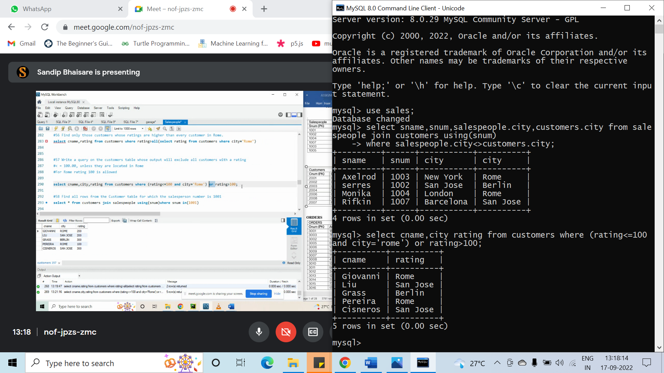

#58.Find all rows from the Customer table for which the salesperson number is 1001.

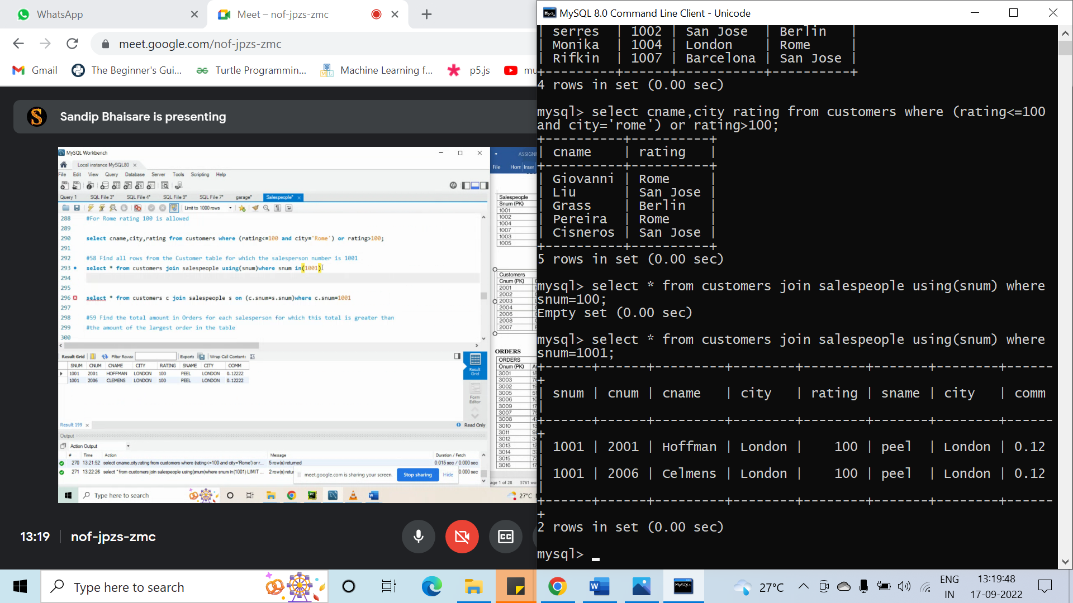

#59. Find the total amount in Orders for each salesperson for which this total is greater than the amount of the largest order in the table.

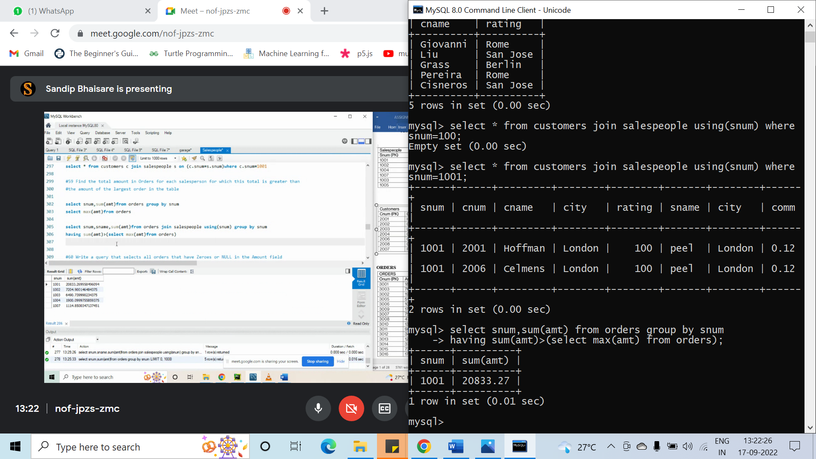

#60. Write a query that selects all orders that have Zeroes or NULL in the Amount field

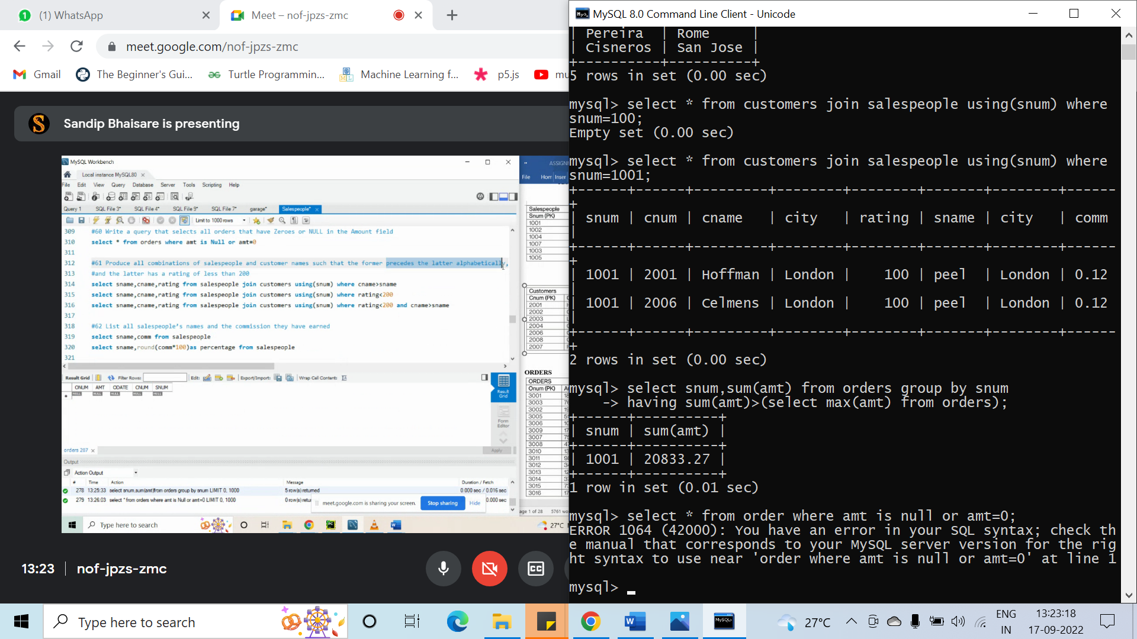

#61. Produce all combinations of salespeople and customer names such that the former precedes the latter alphabetically, and the latter has a rating of less than 200

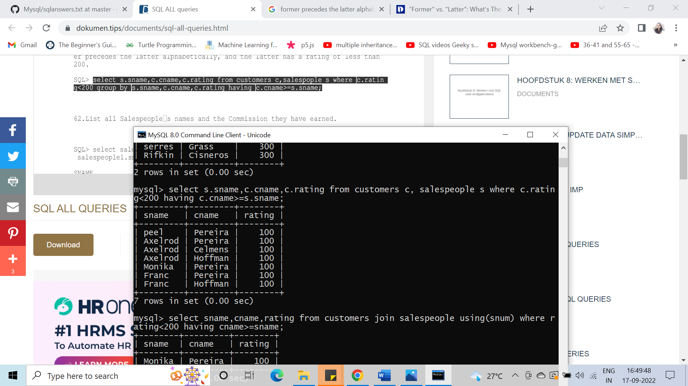

#62. List all salespeople’s names and the commission they have earned.

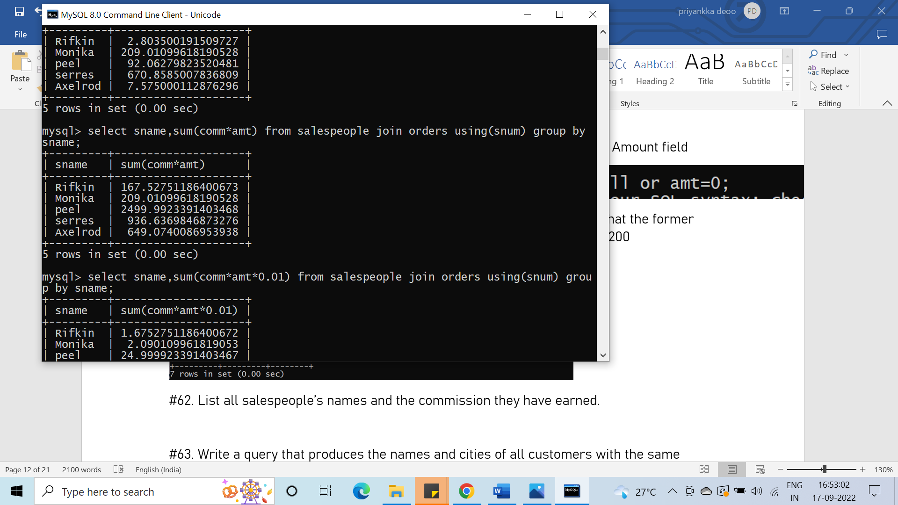

#63. Write a query that produces the names and cities of all customers with the same rating as Hoffman. Write the query using Hoffman’s CNUM rather than his rating, so that it would still be usable if his rating changed.

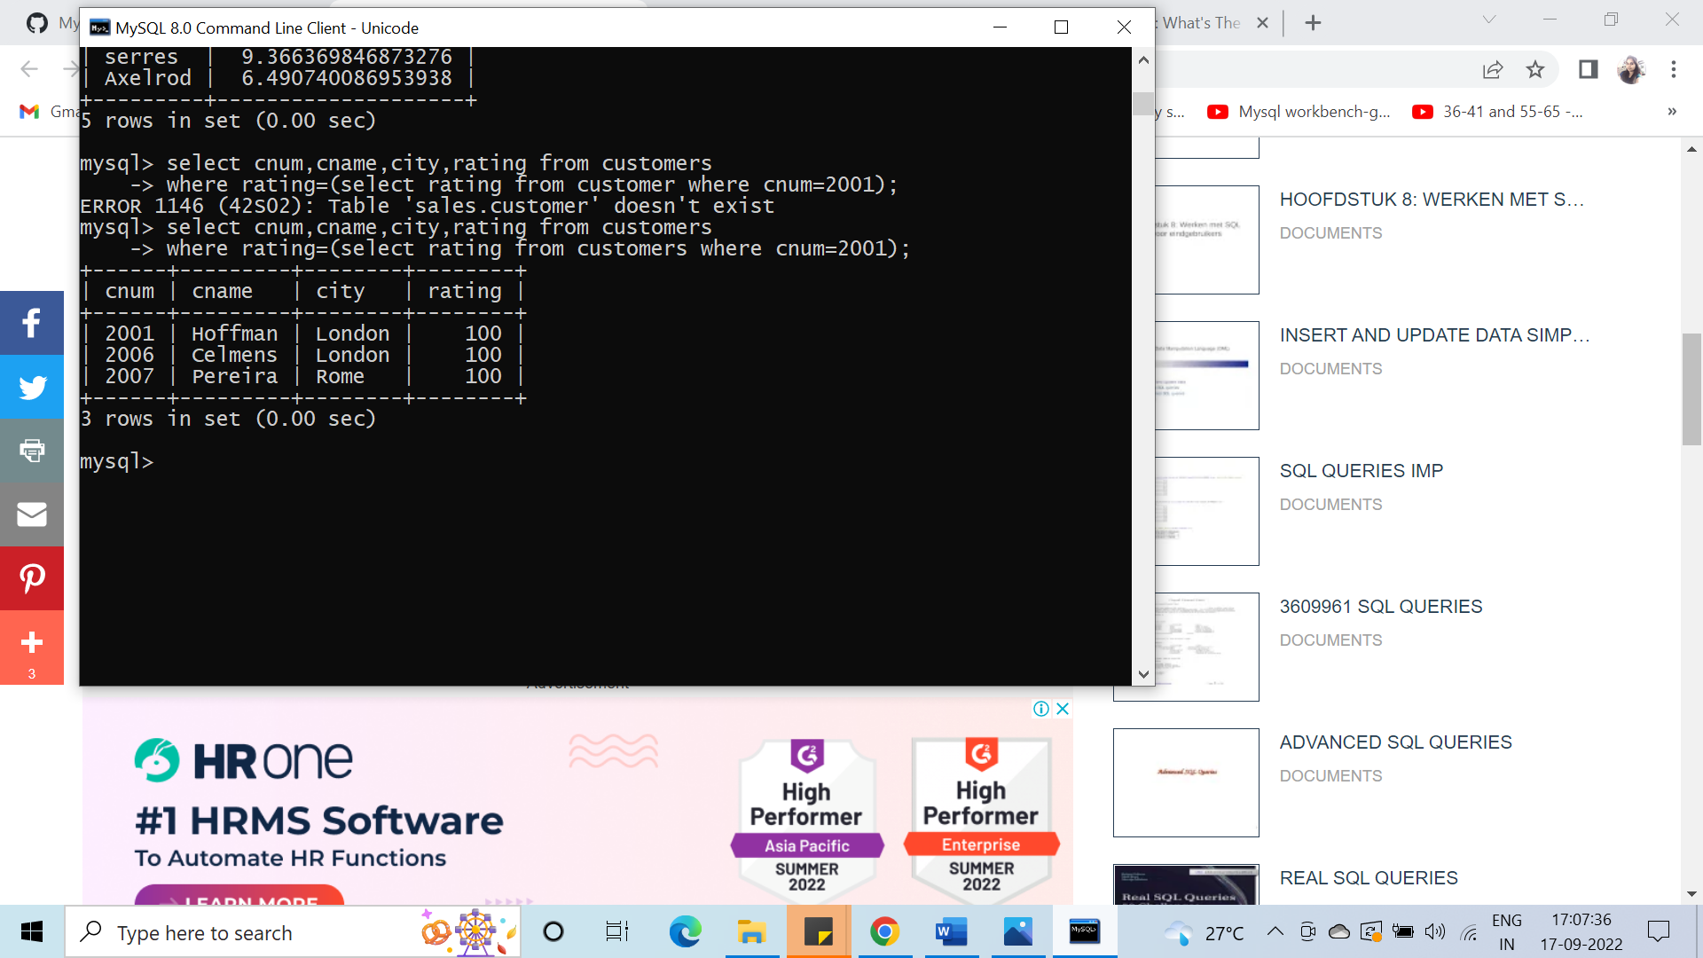

#64. Find all salespeople for whom there are customers that follow them in alphabetical order.

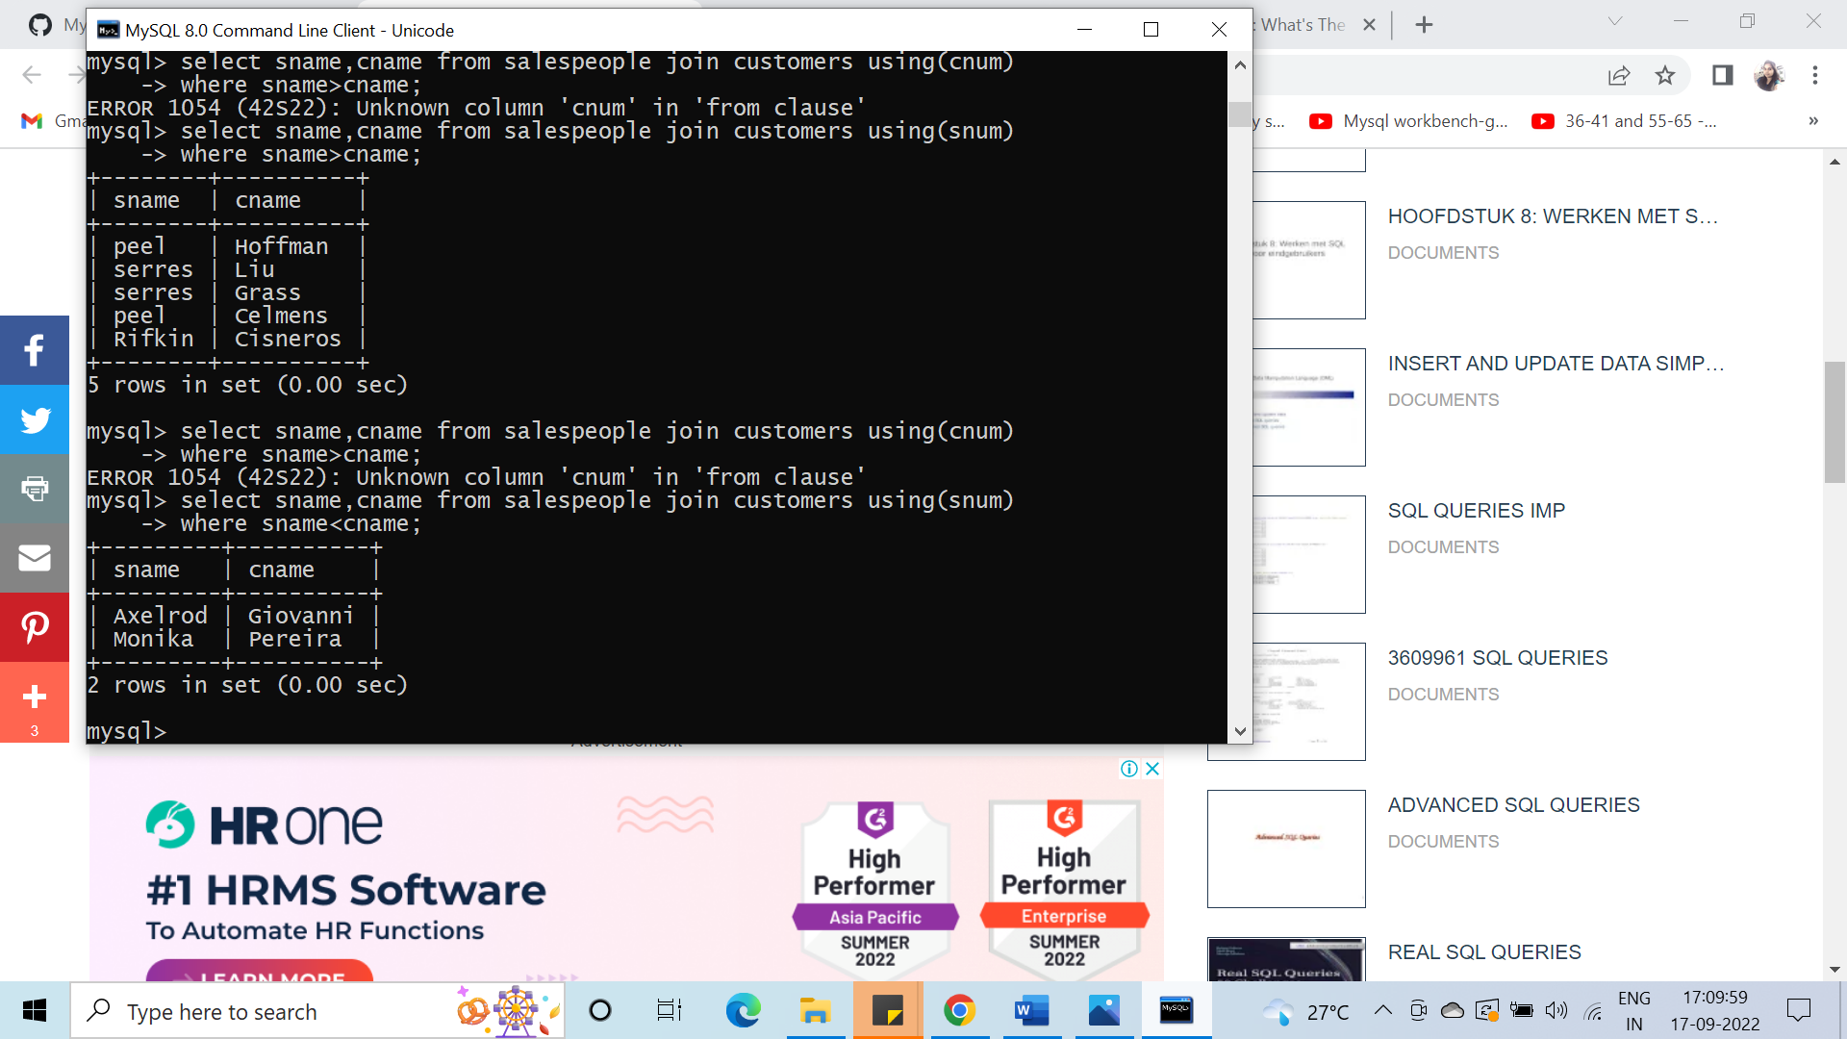

#66.find all purchase from order table

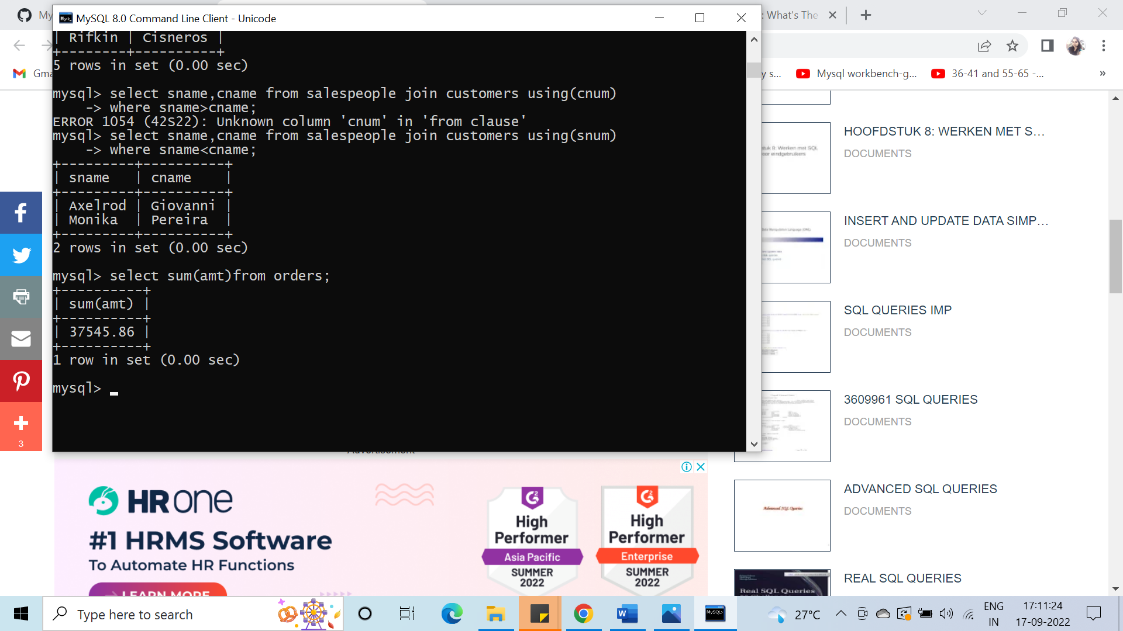

#67. Write a select command that produces the order number, amount, and date for all rows in the Order table.

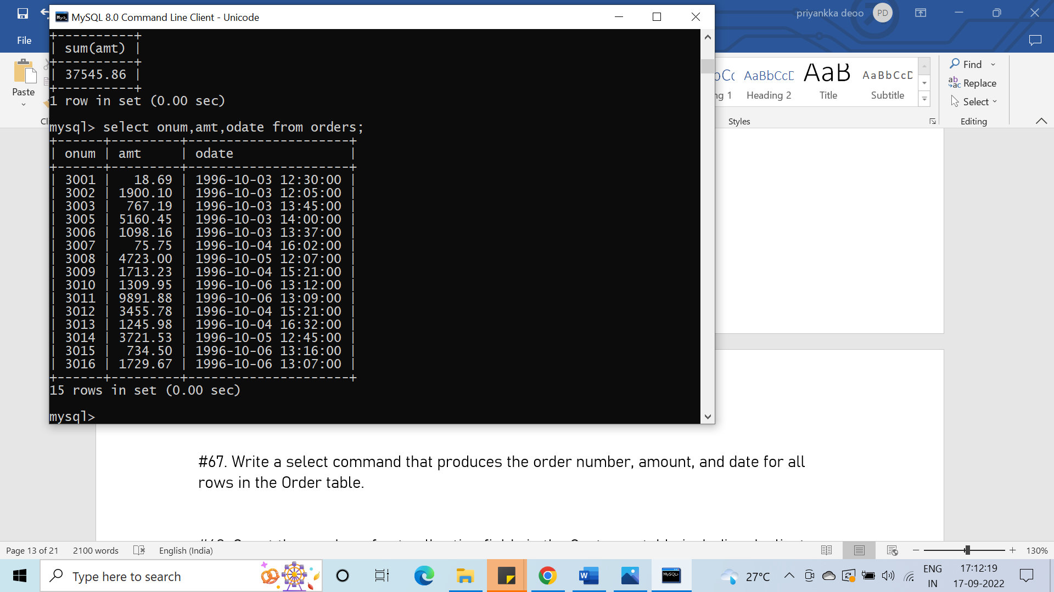

#68. Count the number of not null rating fields in the Customer table including duplicates.

select count(rating) from customers;

#69. Write a query that gives the names of both the salesperson and the customer for each order after the order number

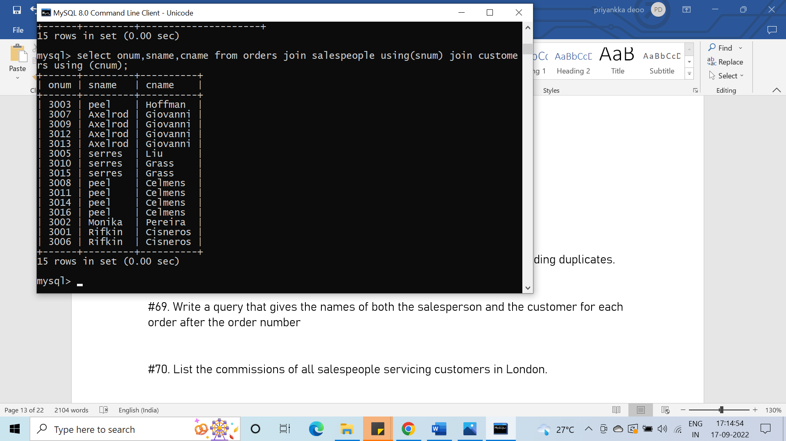

#70. List the commissions of all salespeople servicing customers in London.

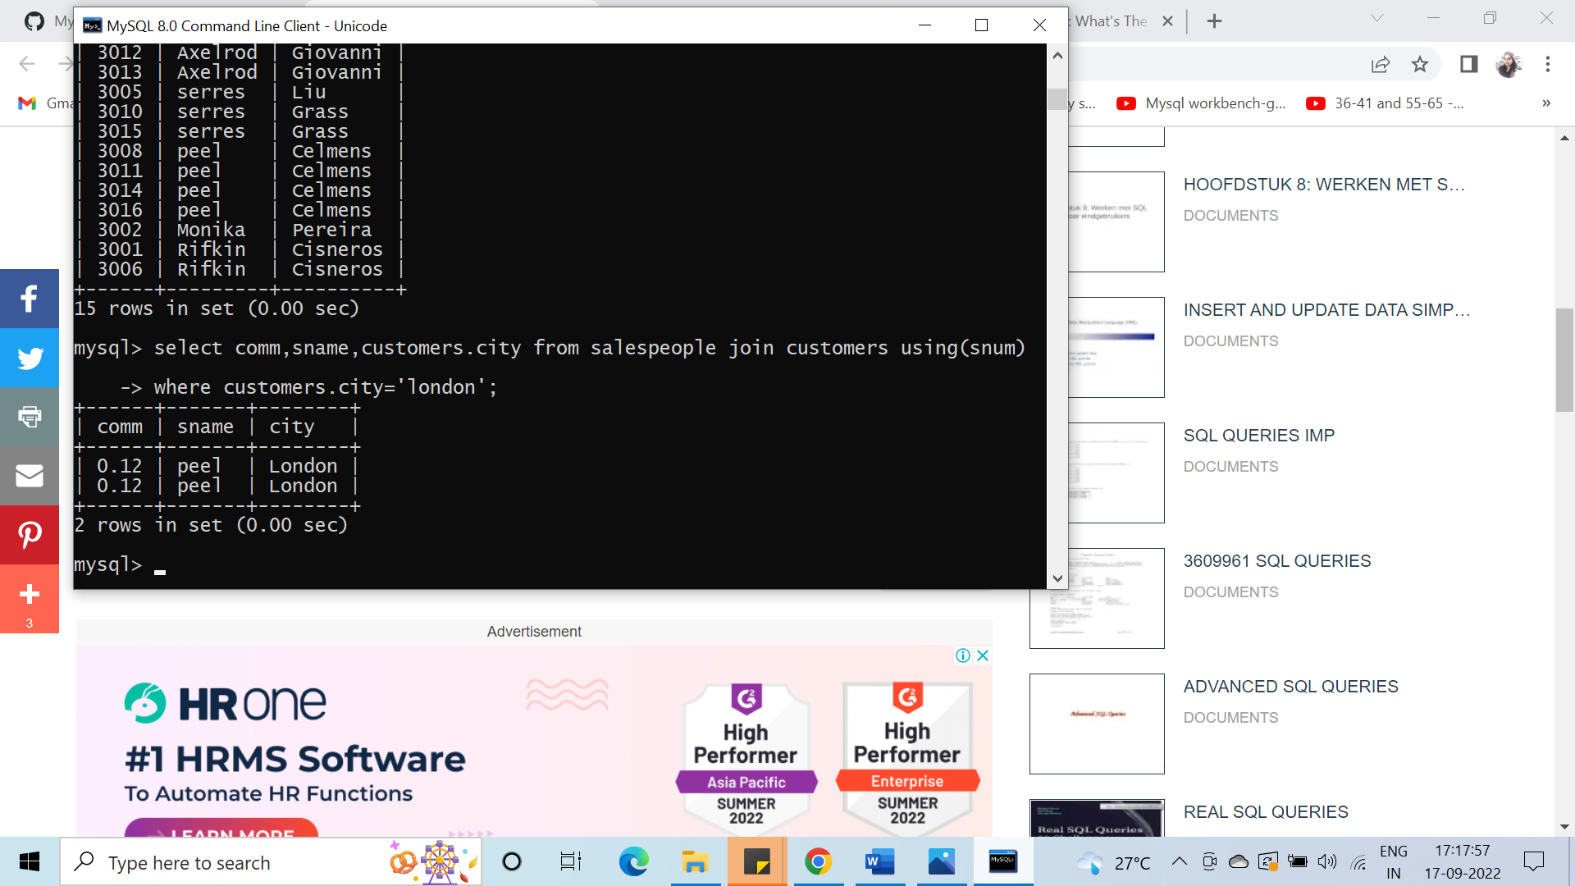

#71. Write a query using ANY or ALL that will find all salespeople who have no customers located in their city.

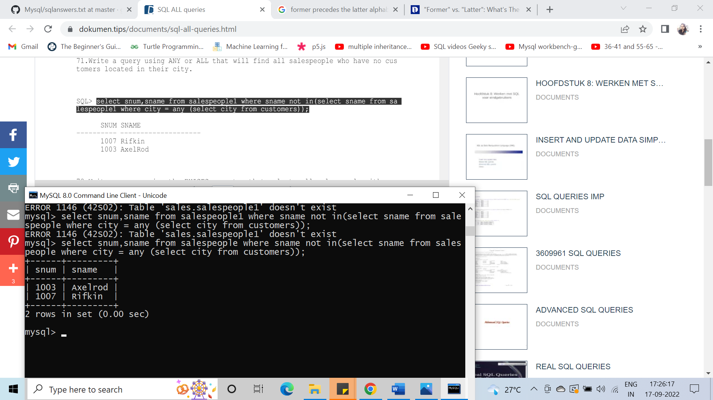

#72. Write a query using the EXISTS operator that selects all salespeople with customers located in their cities who are not assigned to them.

#73. Write a query that selects all customers serviced by Peel or Motika.

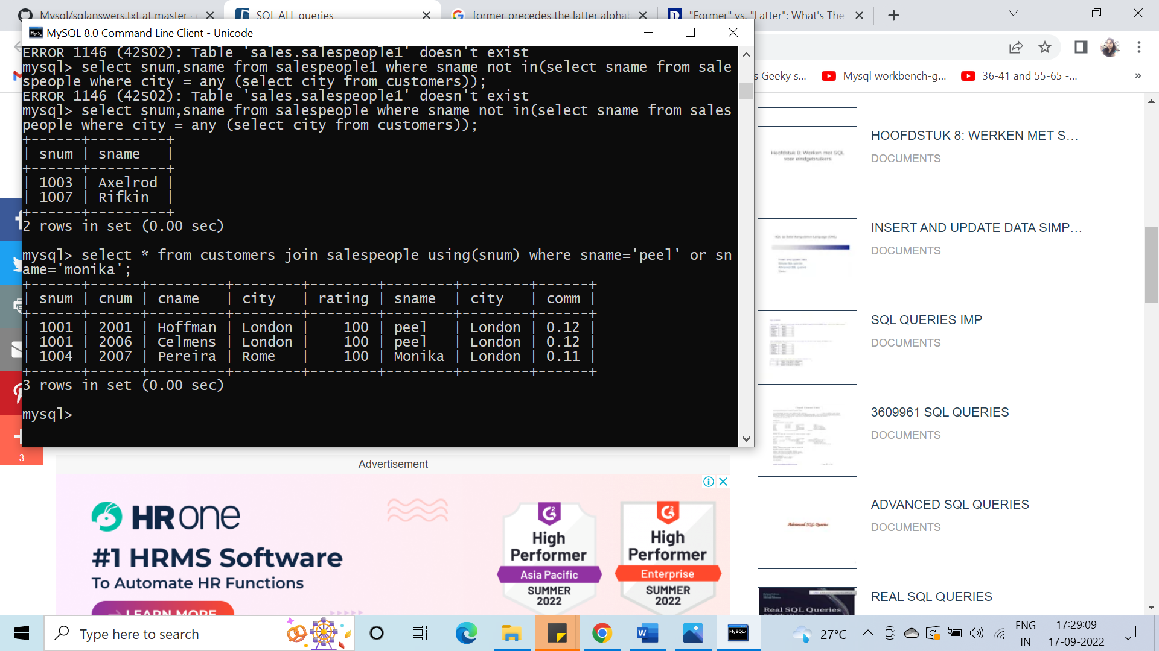

#74. Count the number of salespeople registering orders for each day. (If a salesperson has more than one order on a given day, he or she should be counted only once.).

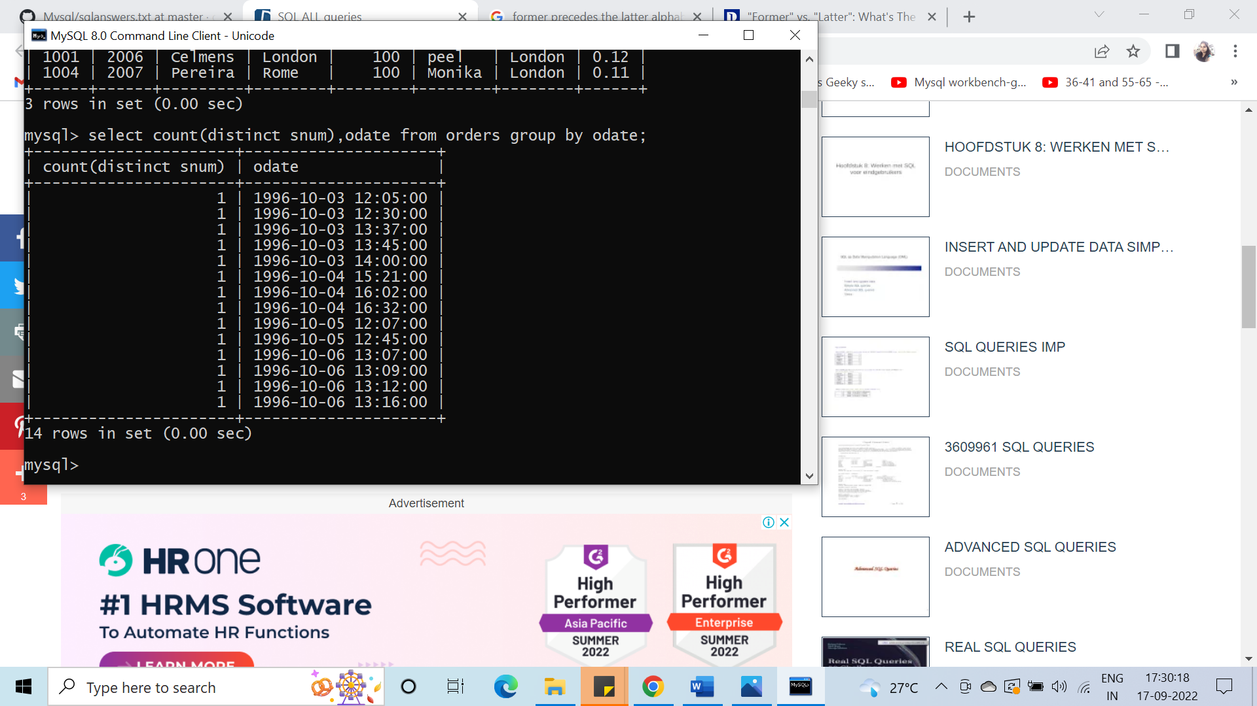

#75. Find all orders attributed to salespeople in London.

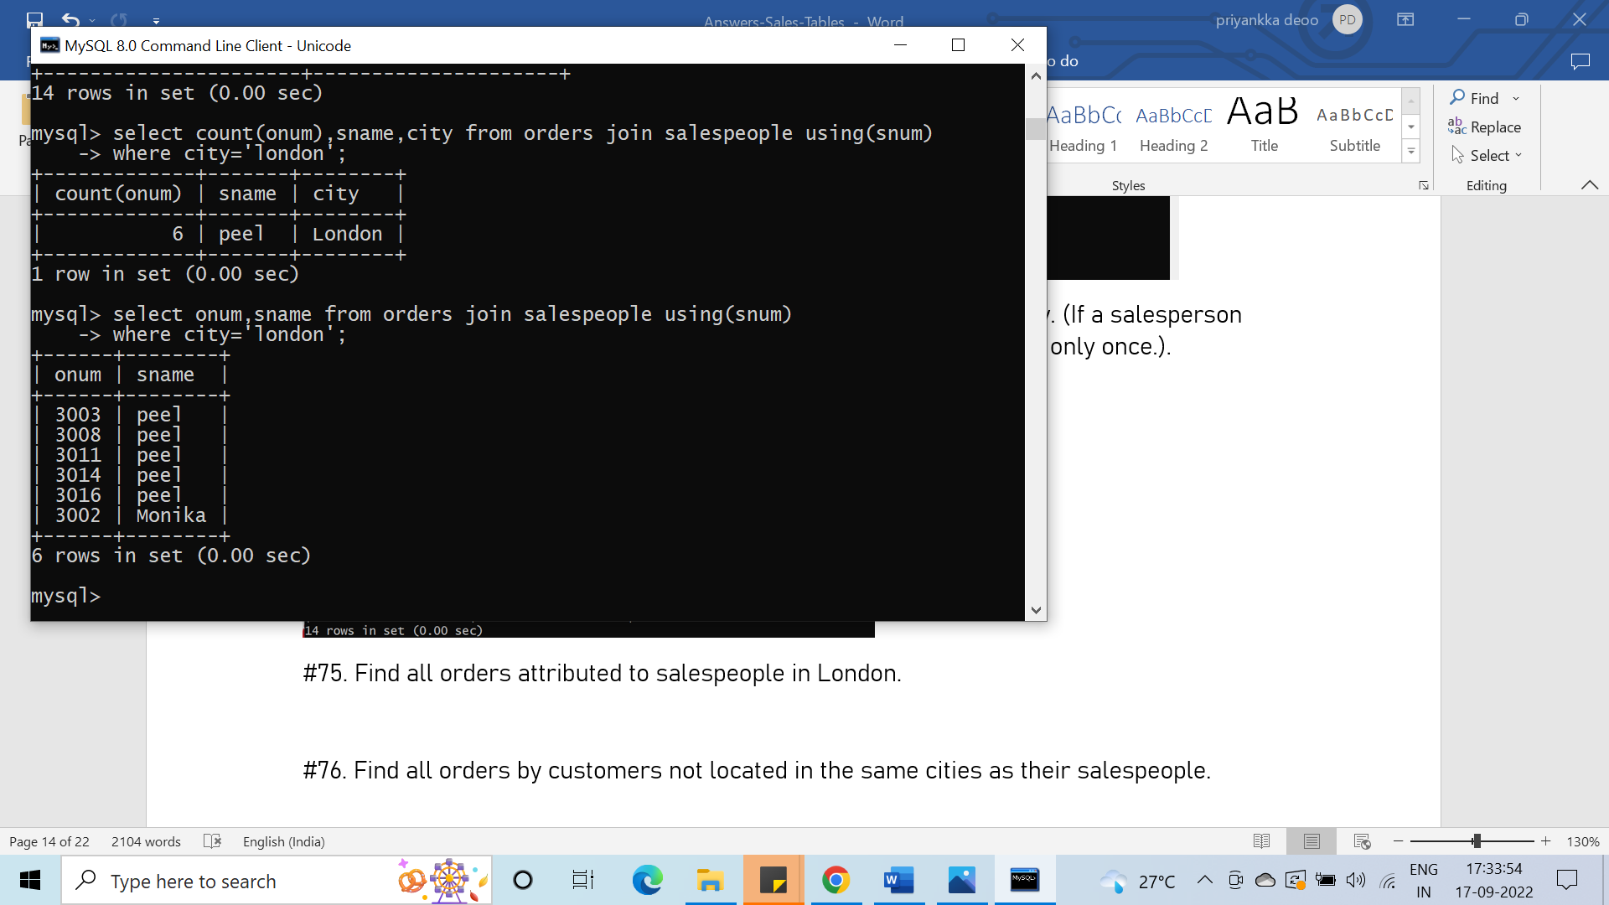

#76. Find all orders by customers not located in the same cities as their salespeople.

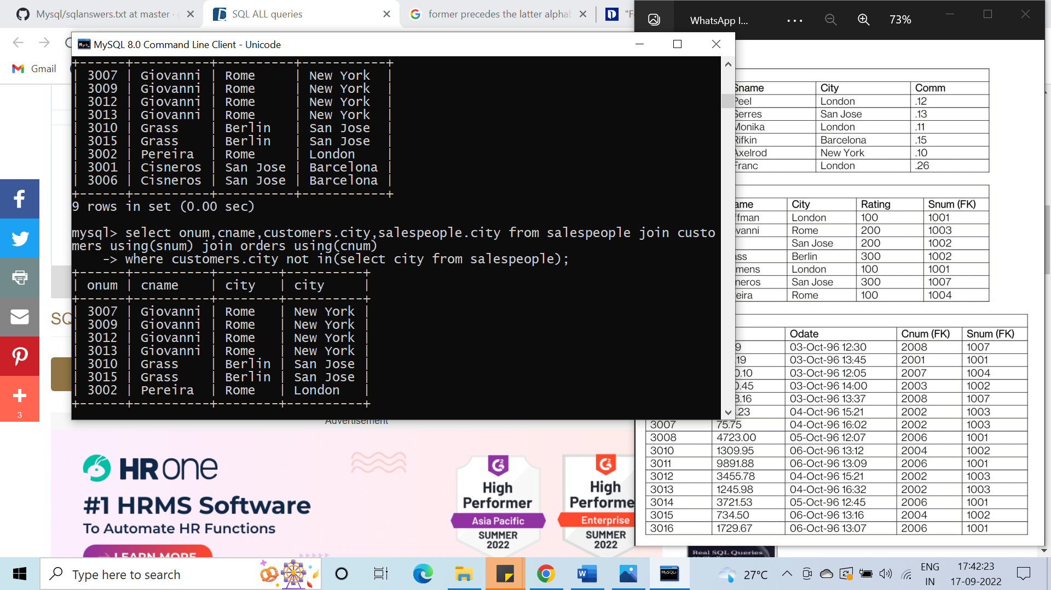

#77. Find all salespeople who have customers with more than one current order.

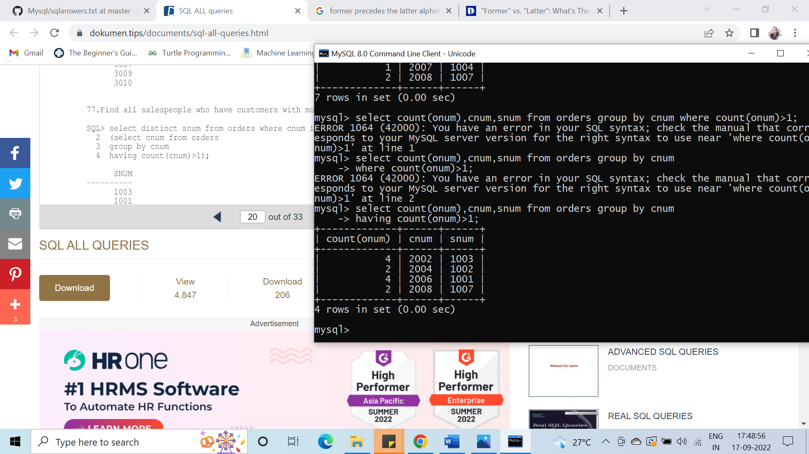

#78. Write a query that extracts from the Customer table every customer assigned to a salesperson who currently has at least one other customer (besides the customer being selected) with orders in the Orders table.

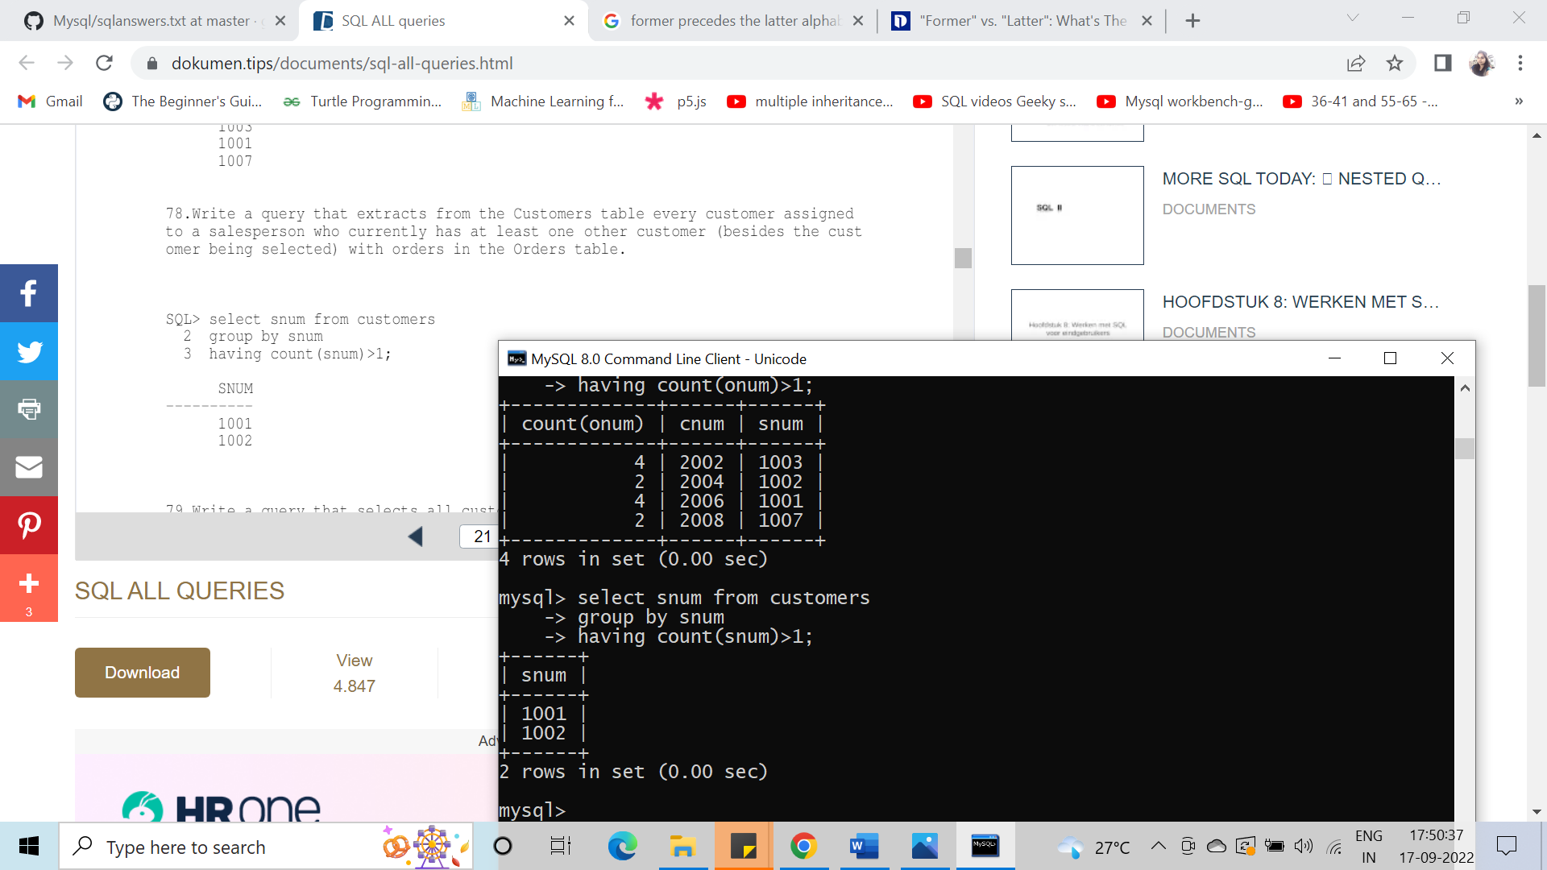

#79. Write a query that selects all customers whose name begins with ‘C’.

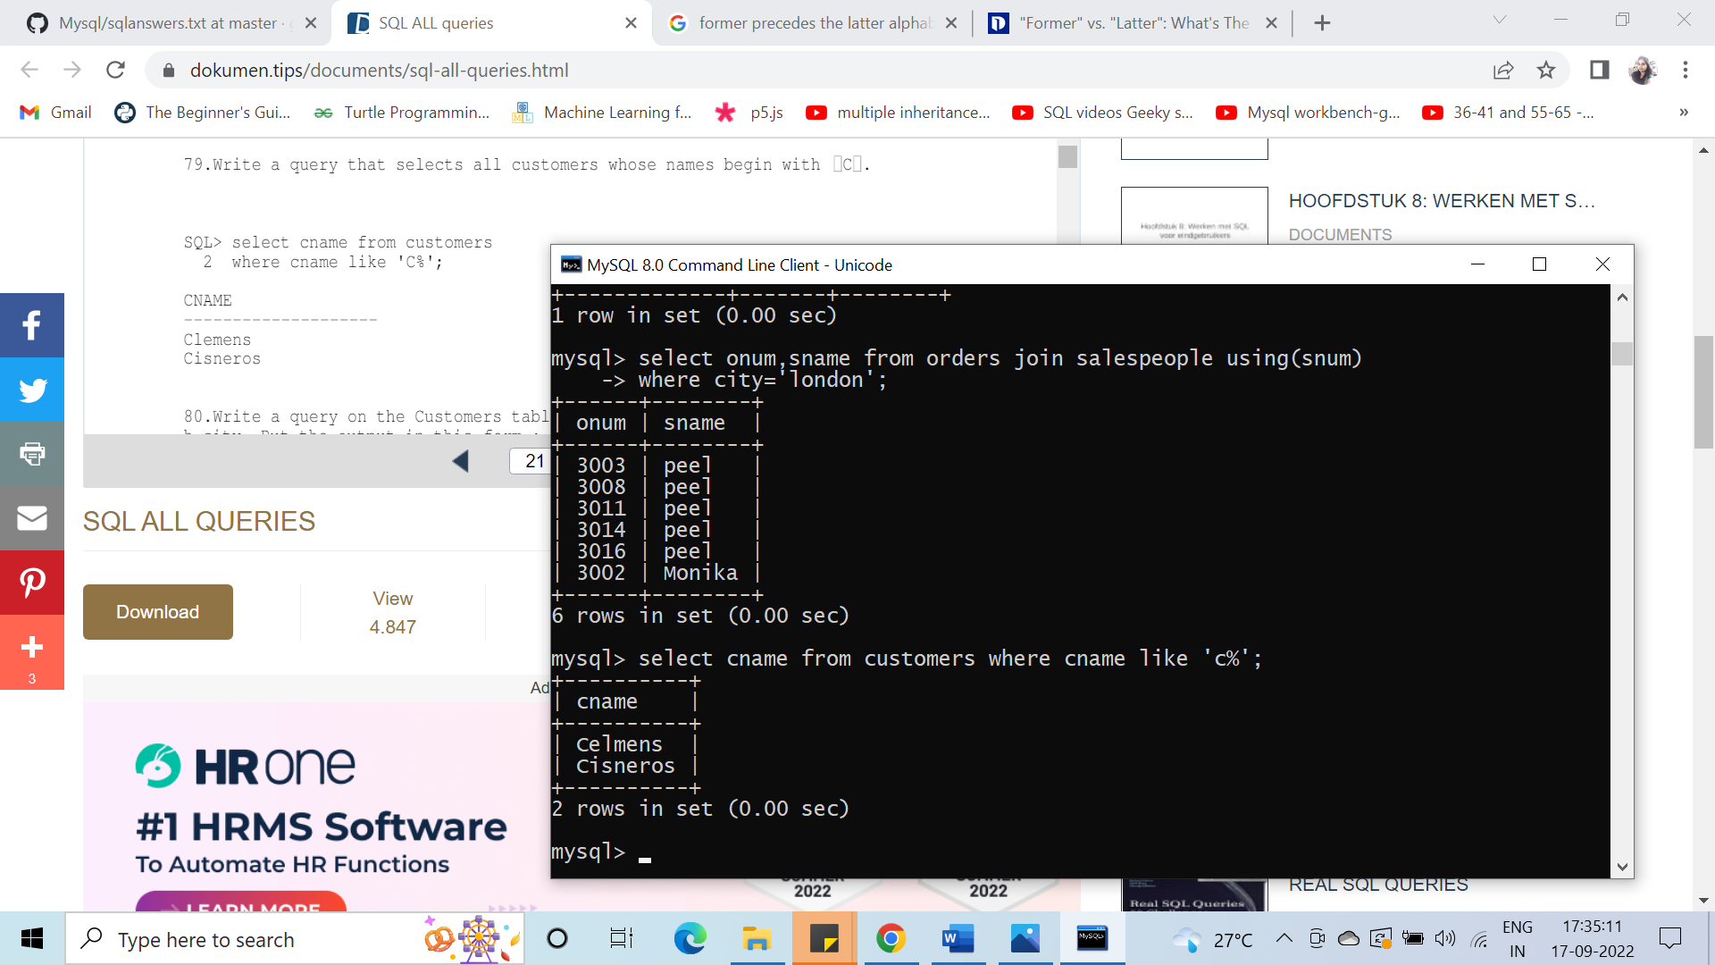

#80. Write a query on the Customers table that will find the highest rating in each city. Put the output in this form: for the city (city) the highest rating is : (rating).

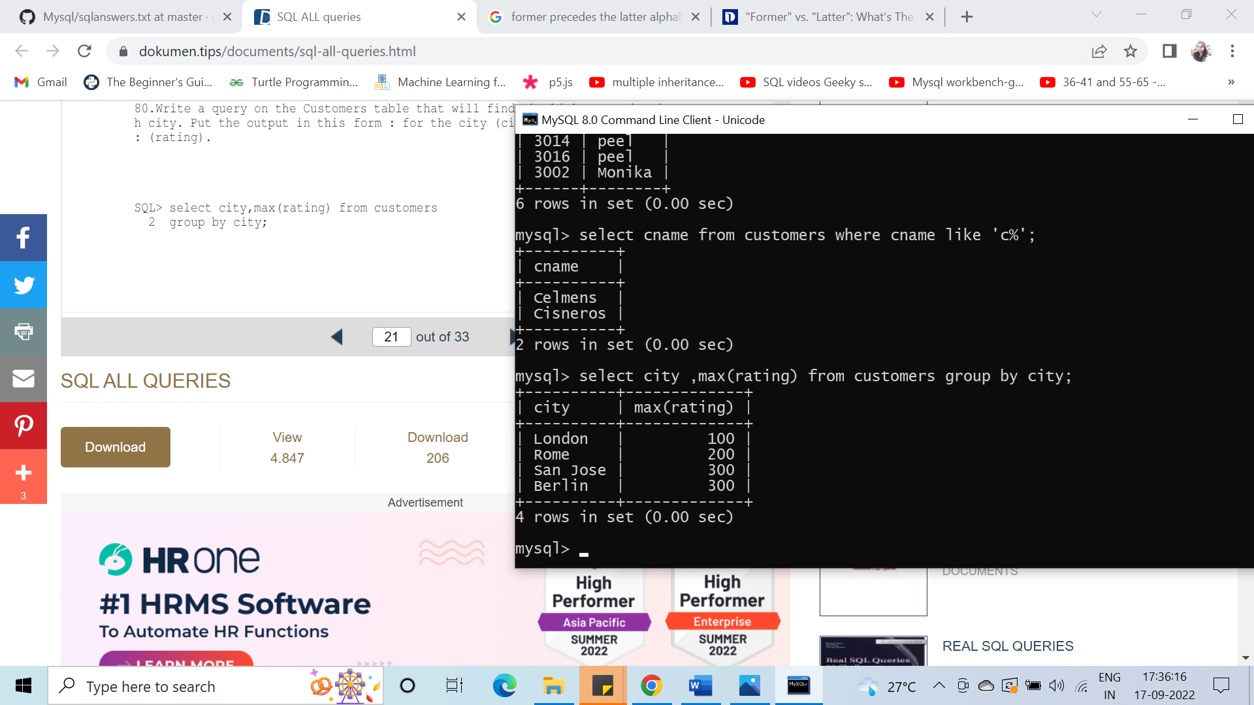

#81. Write a query that will produce the Snum values of all salespeople with orders currently in the Orders table without any repeats.

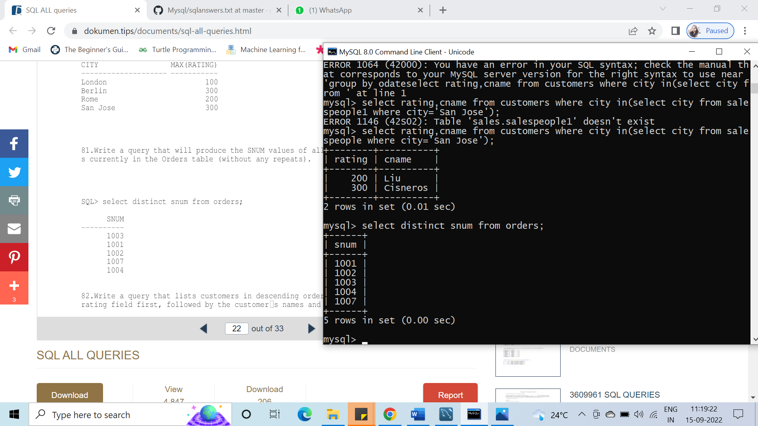

#82. Write a query that lists customers in descending order of rating. Output the rating field first, followed by the customers’ names and numbers.

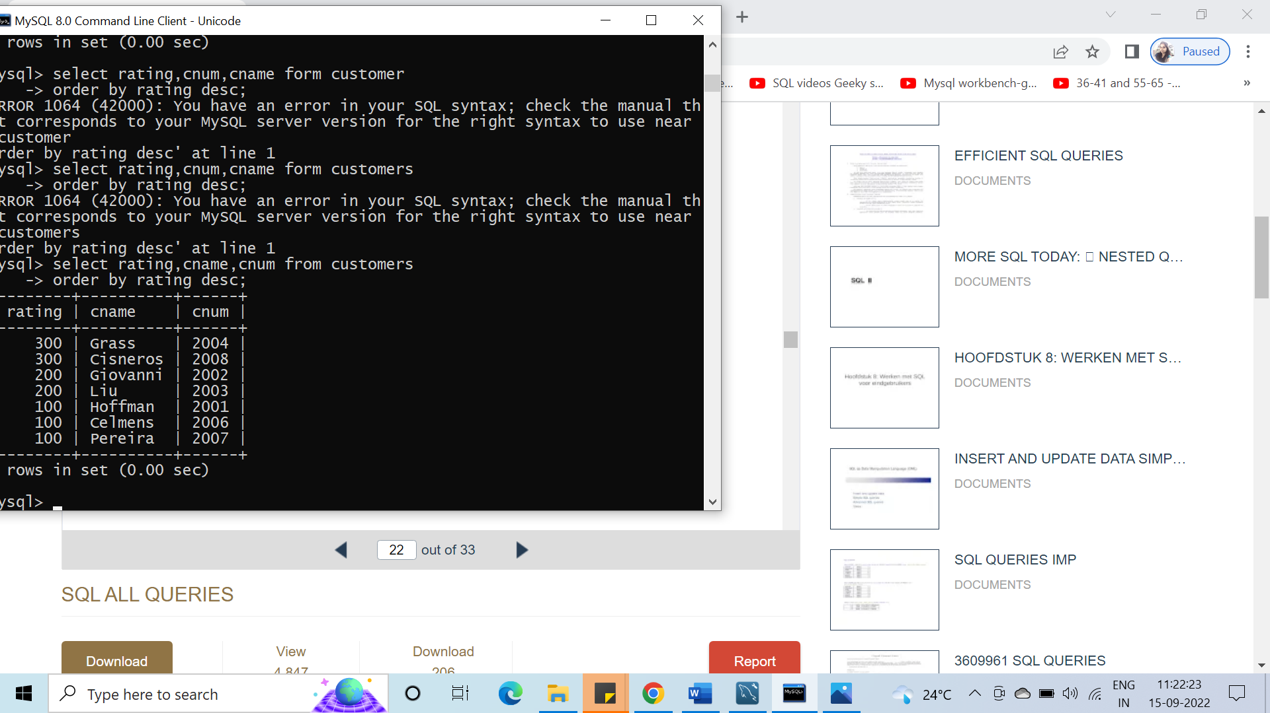

#83. Find the average commission for salespeople in London.

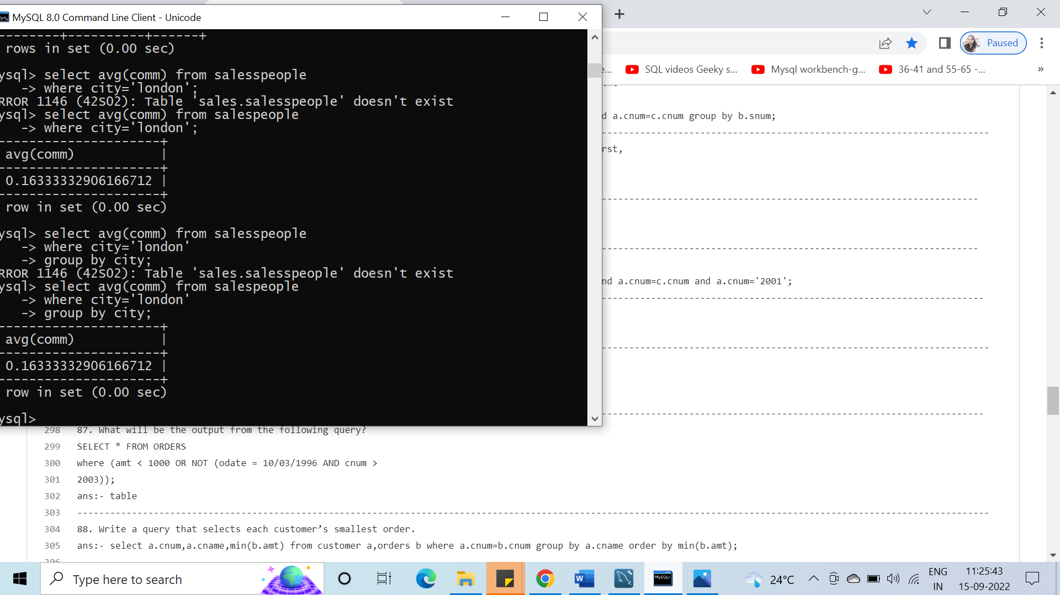

#84. Find all orders credited to the same salesperson that services Hoffman.

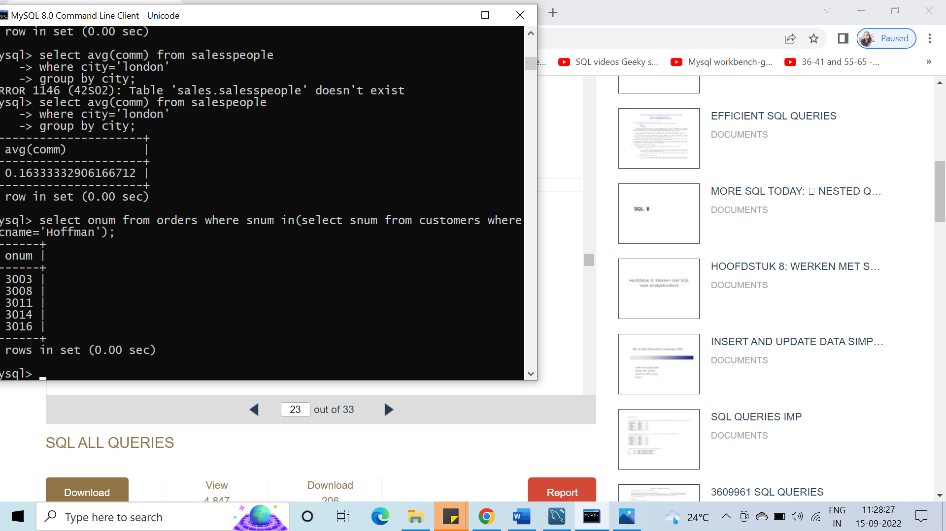

#85. Find all salespeople whose commission is in between 0.10 and 0.12 both inclusive.

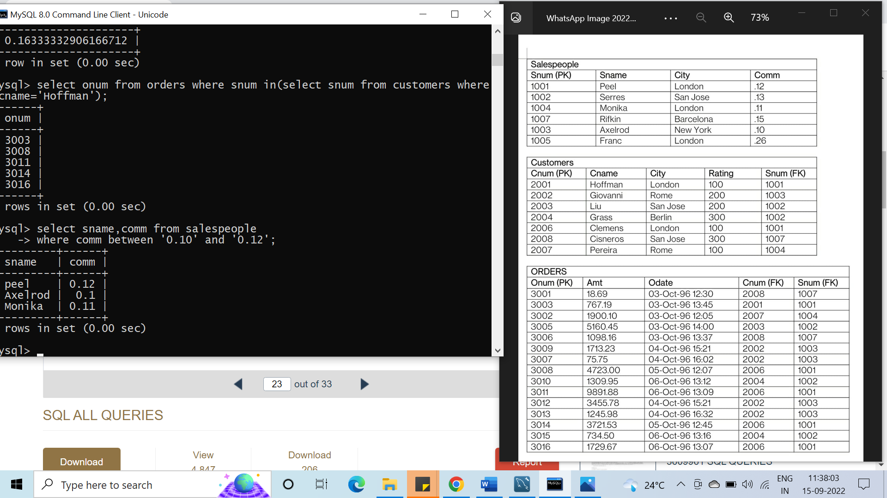

#86. Write a query that will give you the names and cities of all salespeople in London with commission above 0.10

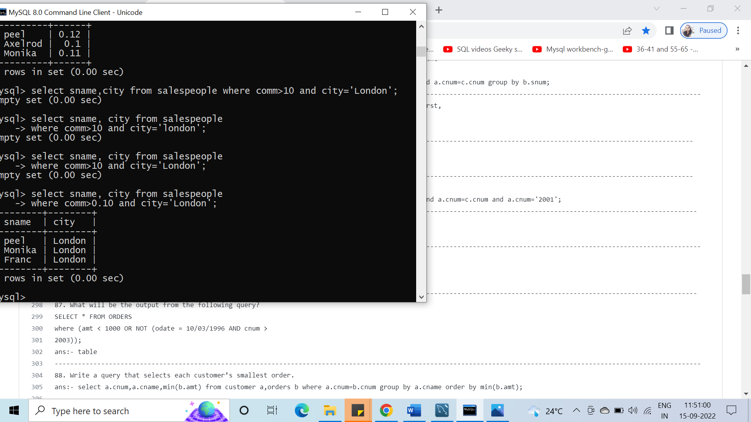

#87. What will be the output from the following query?

select * from orders where(amt<1000 or not(odate='03-oct-96' and cnum>2003));

#88. Write a query that selects each customer’s smallest order.

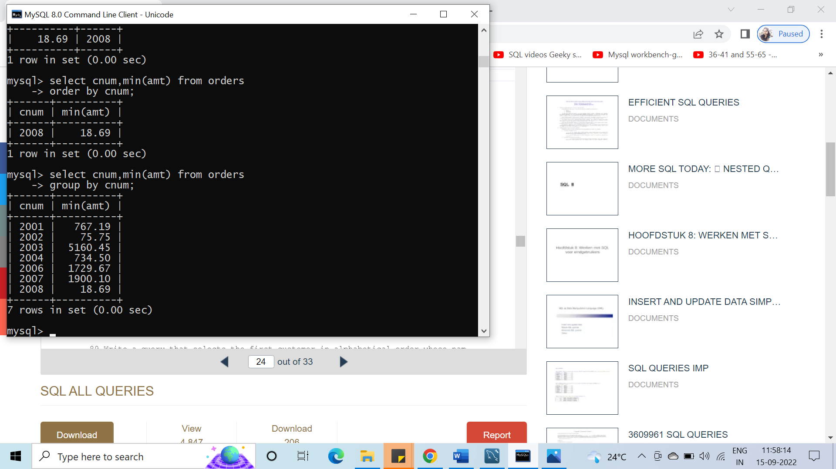

#89. Write a query that selects the first customer in alphabetical order whose name begins with ‘G’.

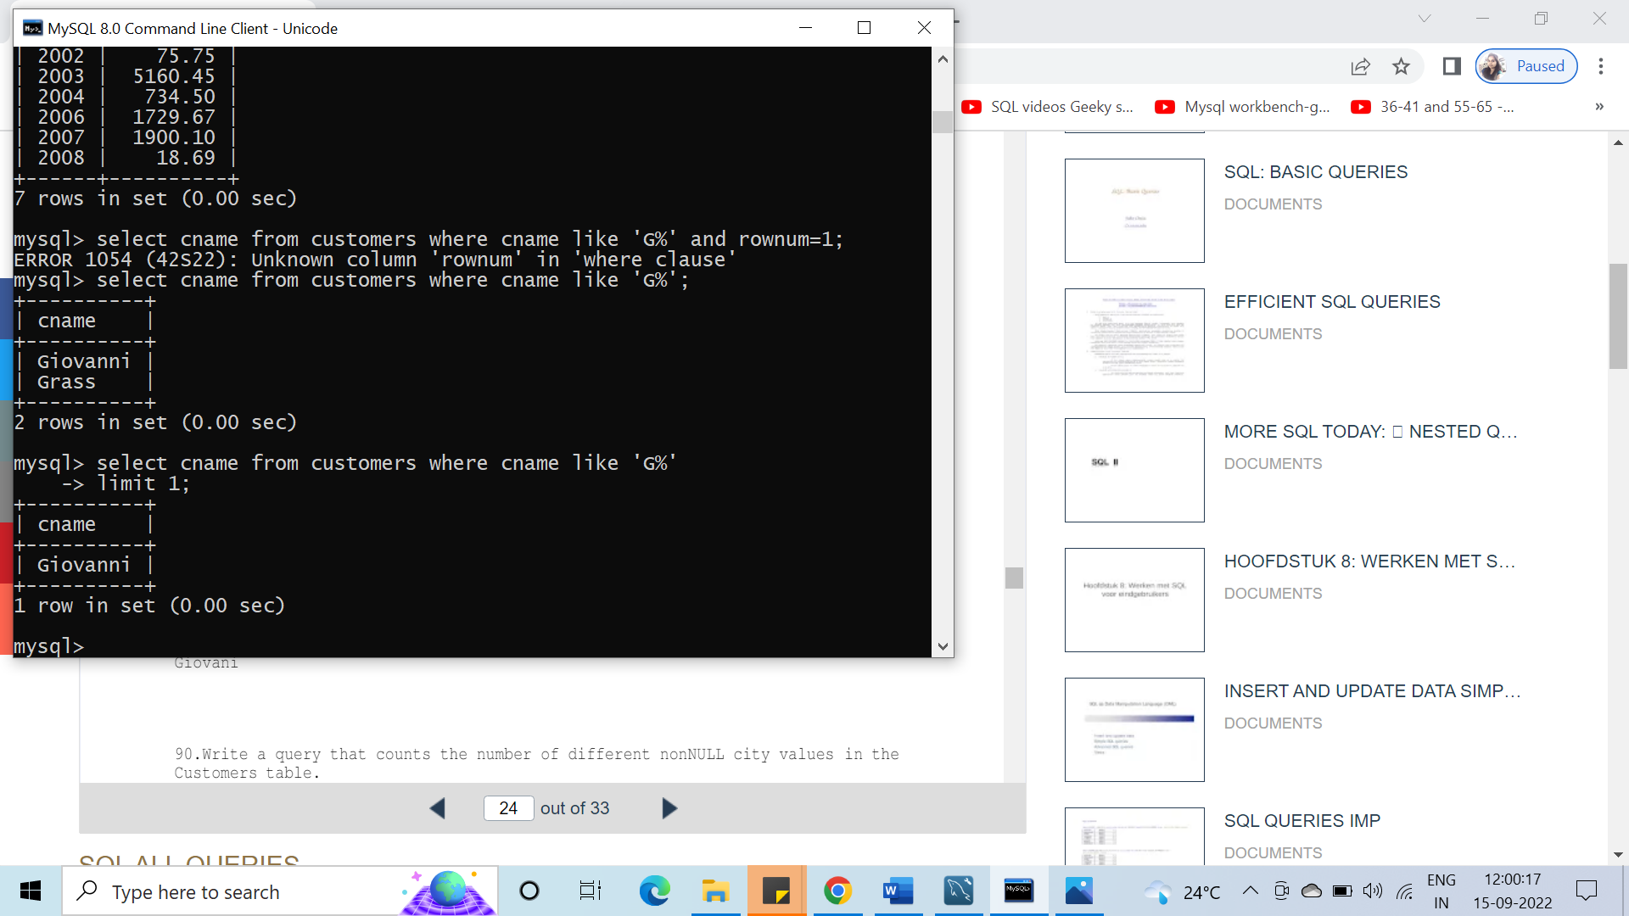

#90. Write a query that counts the number of different not NULL city values in the Customers table.

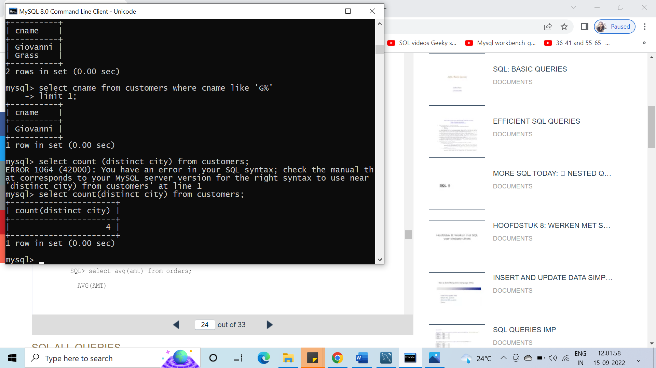

#91. Find the average amount from the Orders table.

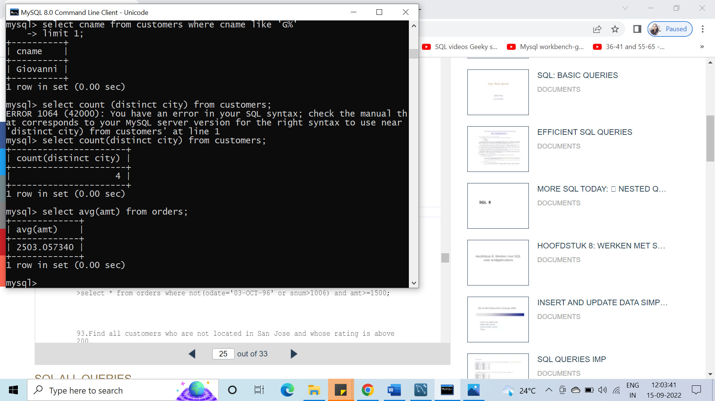

#92. What would be the output from the following query?

SELECT * FROM ORDERS WHERE NOT (odate = 10/03/96 OR snum > 1006) AND amt >= 1500);

#93. Find all customers who are not located in San Jose & whose rating is above 200.

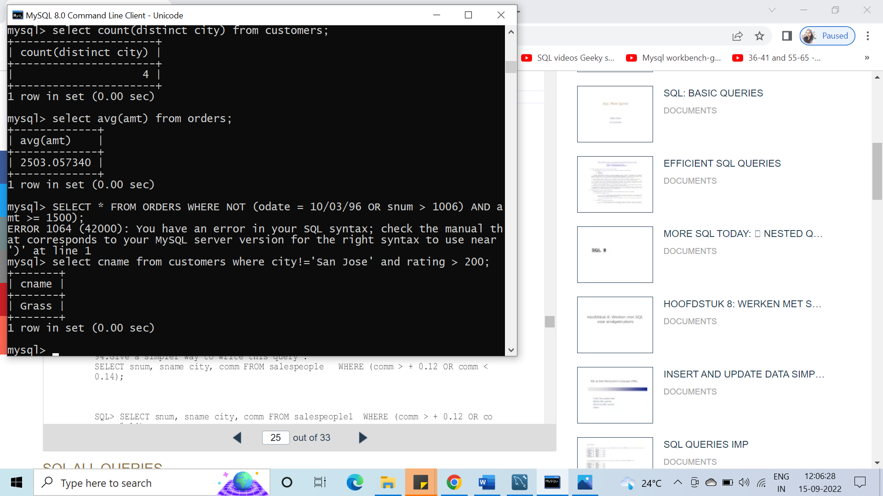

#94. Give a simpler way to write this query:

SELECT Snum, Sname, city, Comm FROM salespeople WHERE (Comm>0.12 and Comm <0.14);

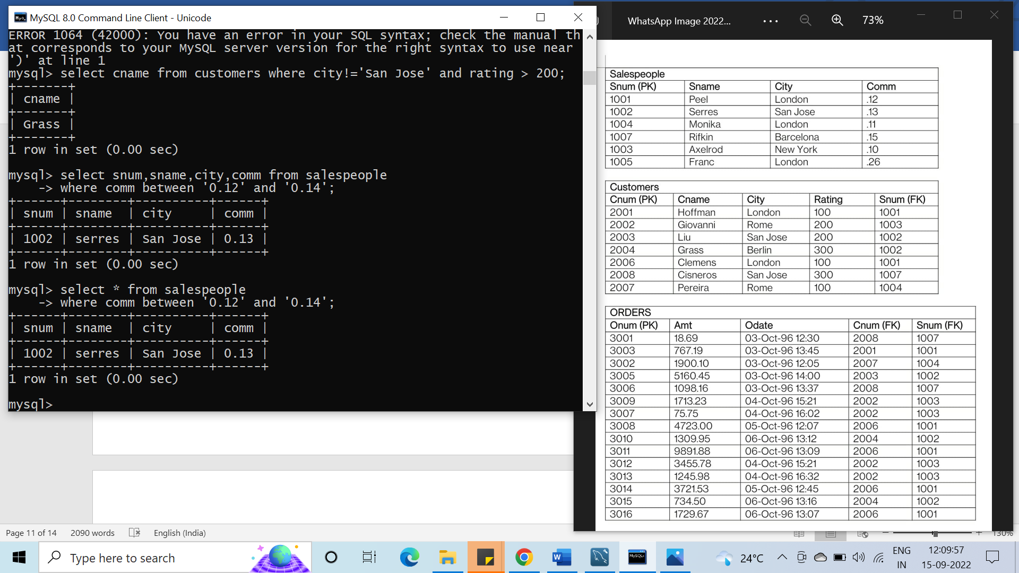

#95. Evaluate the following query:

SELECT * FROM orders WHERE NOT ((Odate = 10/03/1996 AND Snum>1002) OR amt>2000);

#96. Which salespeople attend to customers not in the city they have been assigned to?

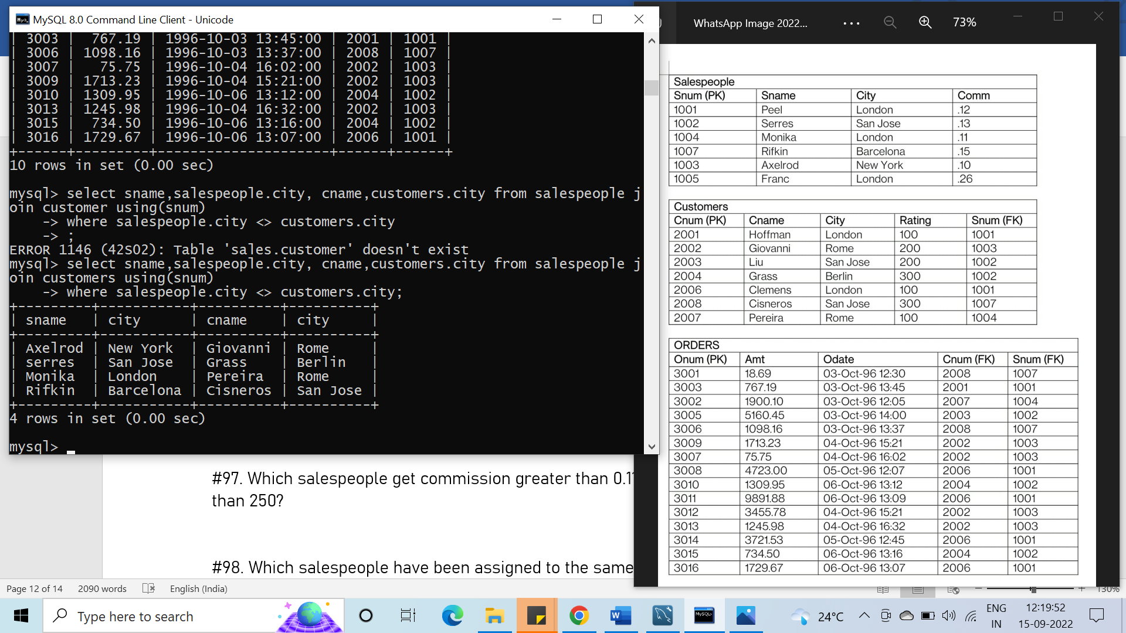

#97. Which salespeople get commission greater than 0.11 and serving customers rated less than 250?

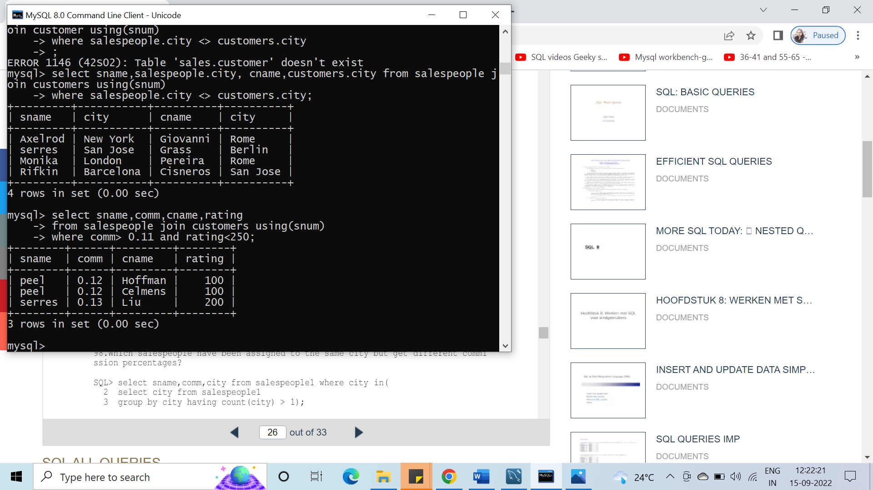

#98. Which salespeople have been assigned to the same city but get different commission percentages?

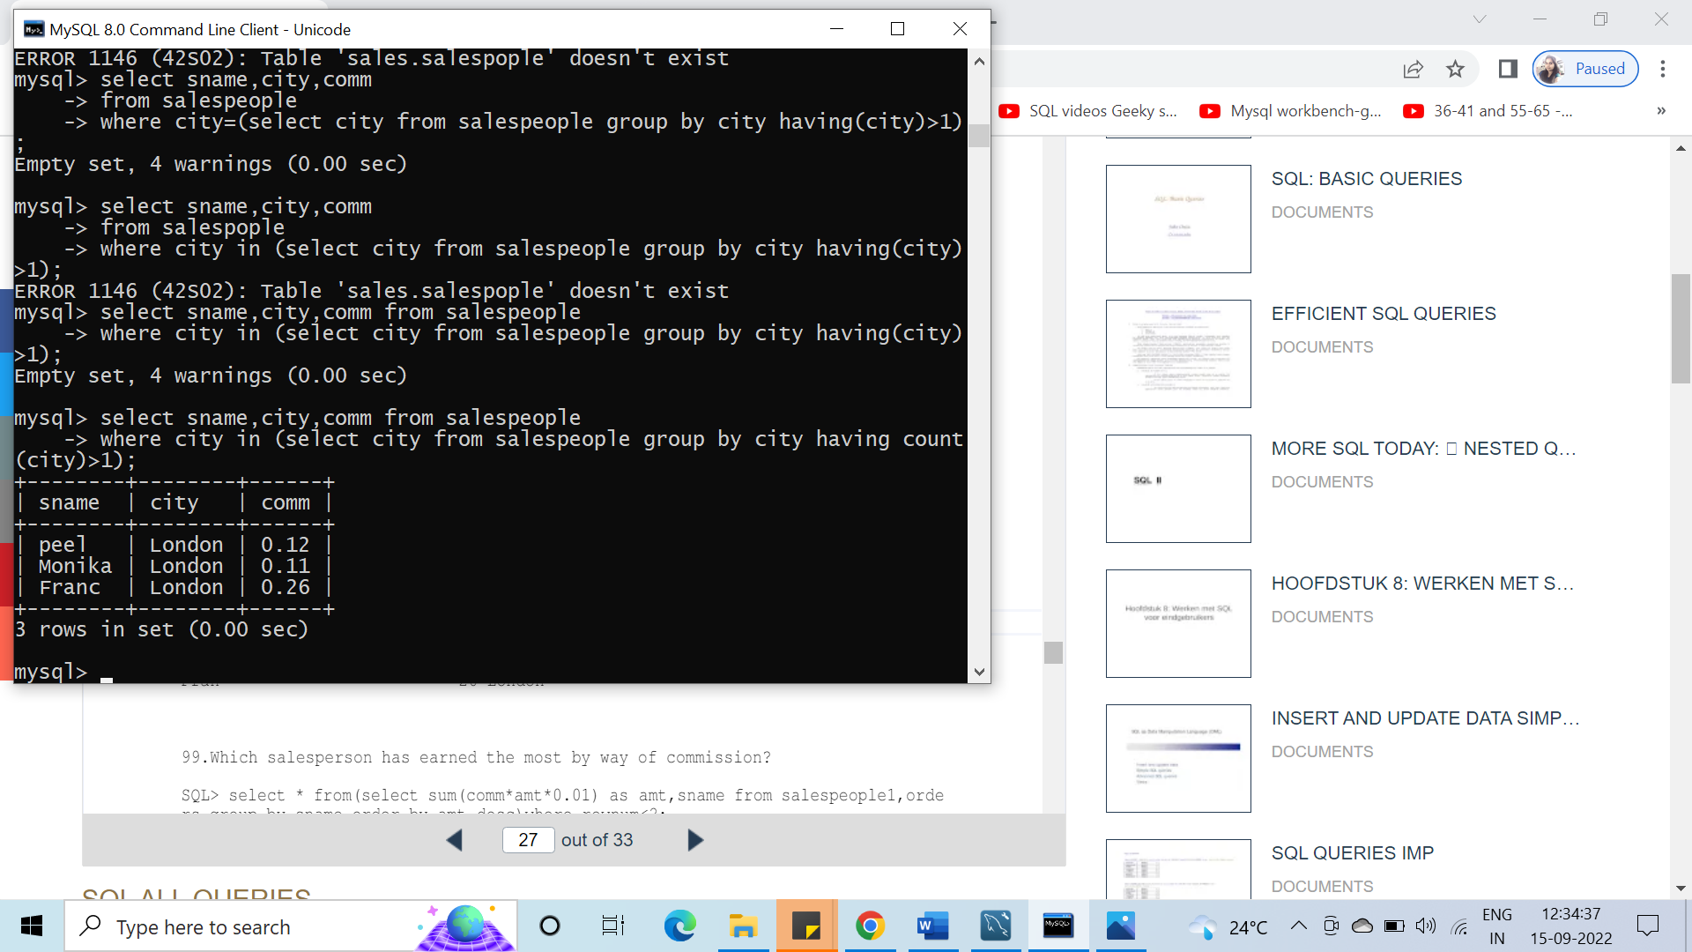

#99. Which salesperson has earned the most by way of commission?

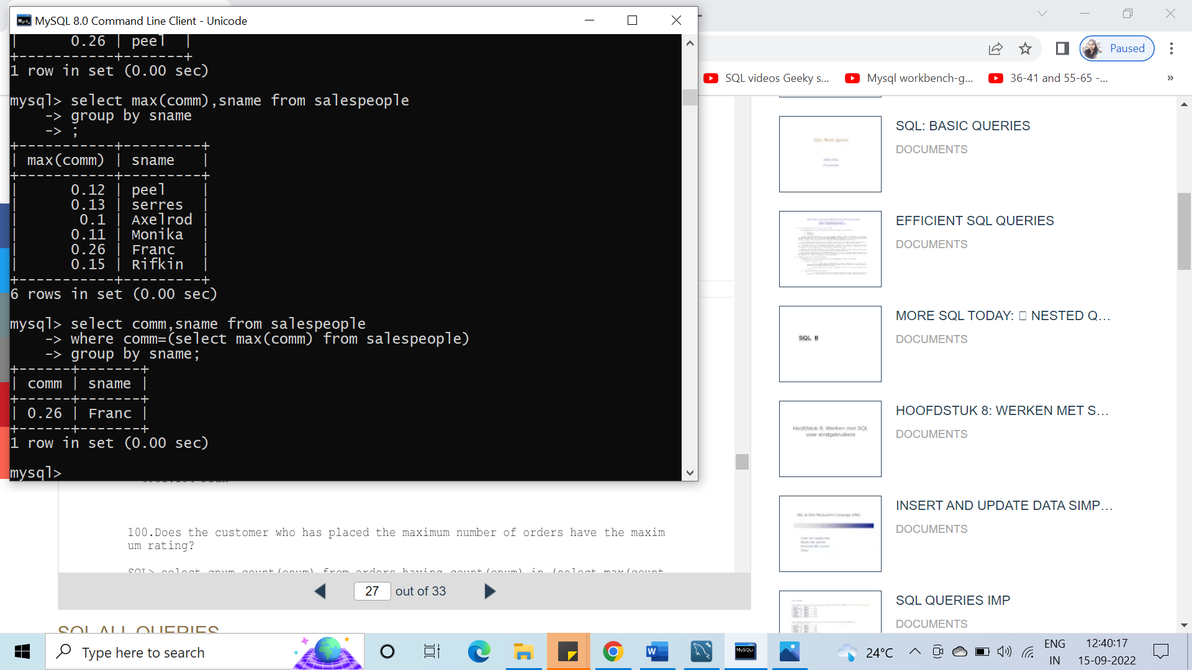

#100. Does the customer who has placed the maximum number of orders have the maximum rating?

#101. Has the customer who has spent the largest amount of money been given the highest rating?

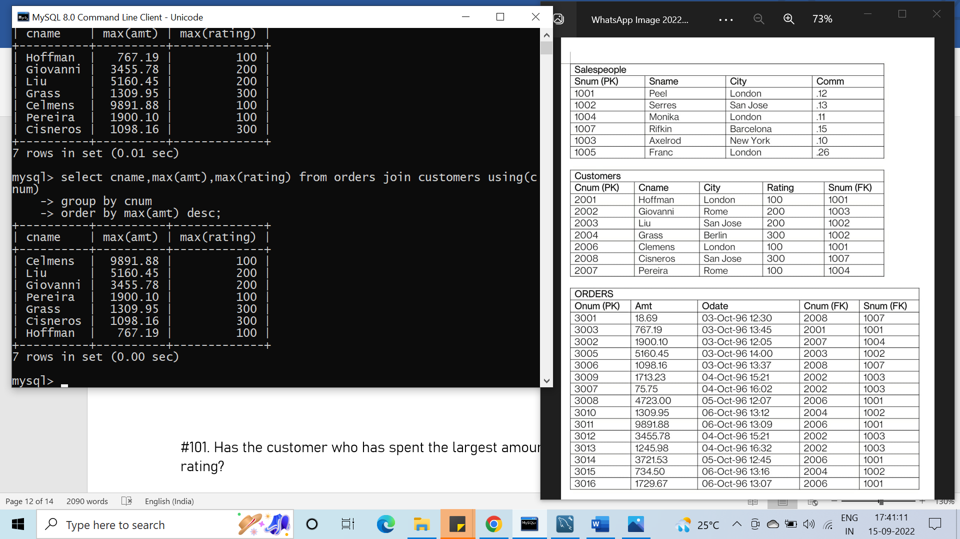

#102. List all customers in descending order of customer rating

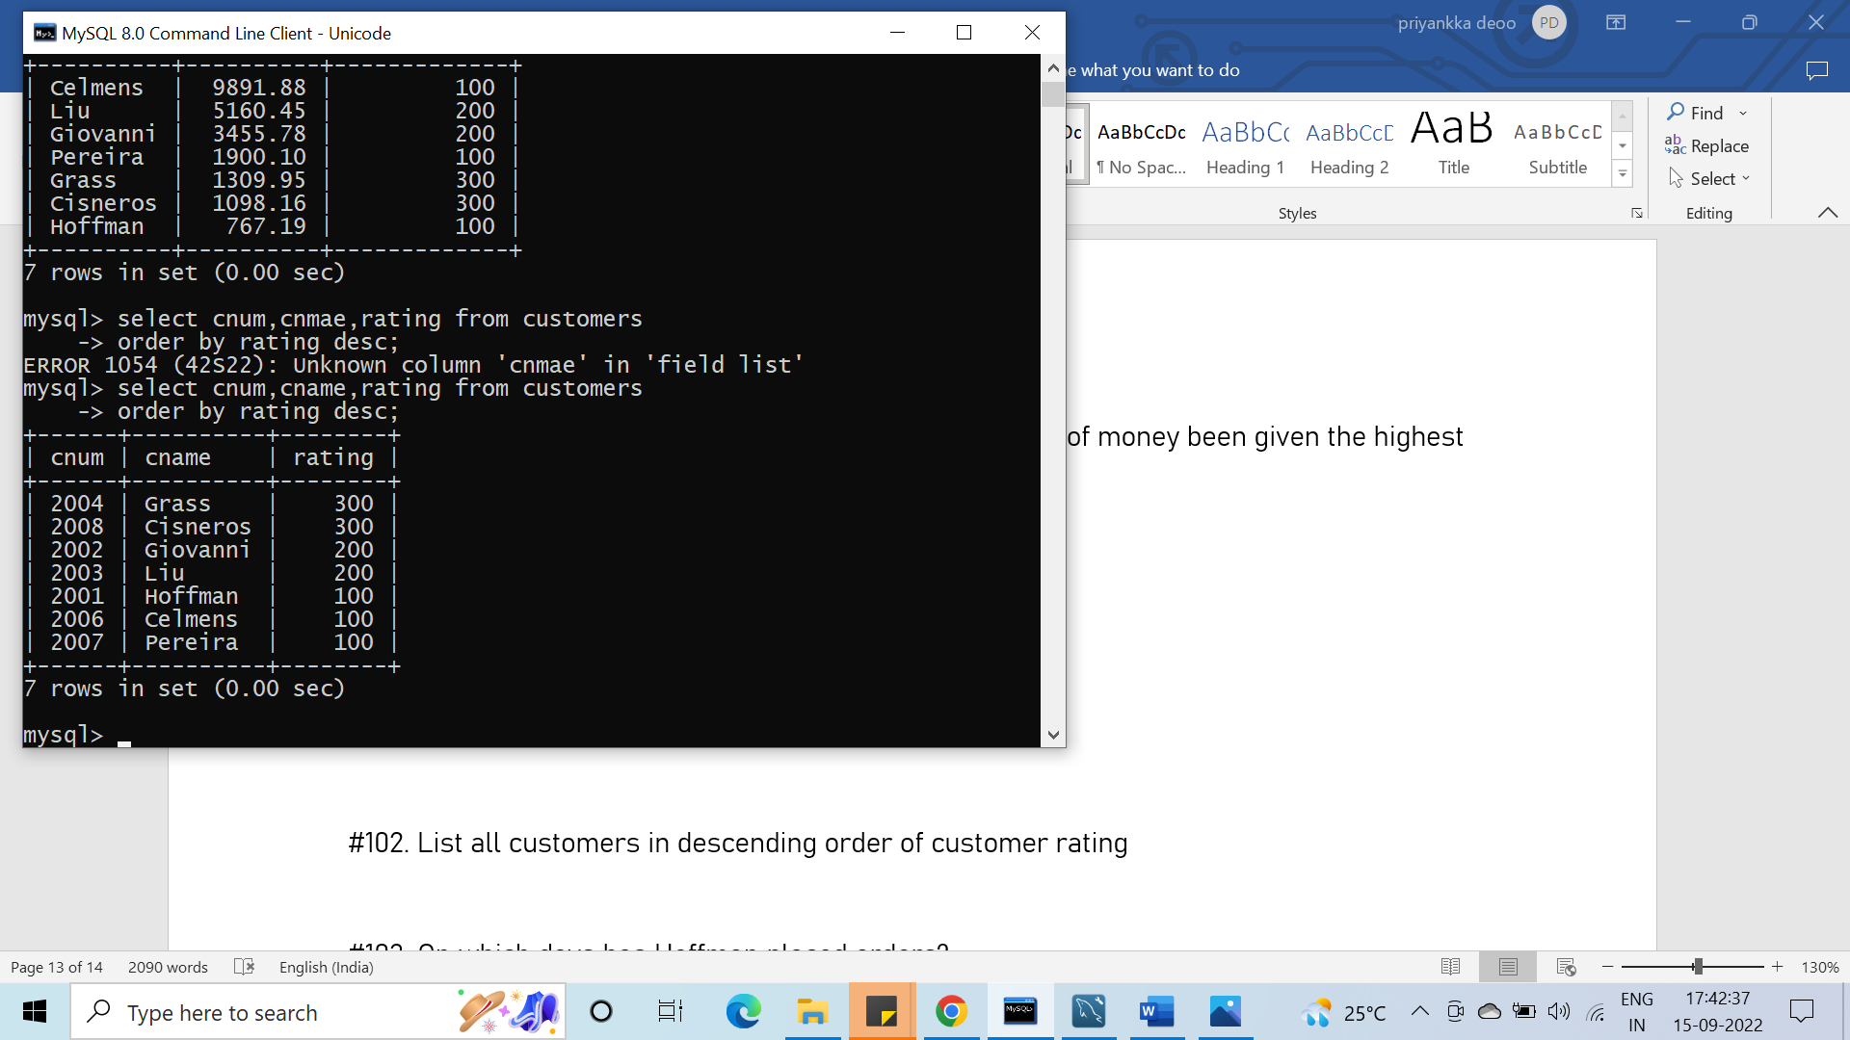

#103. On which days has Hoffman placed orders?

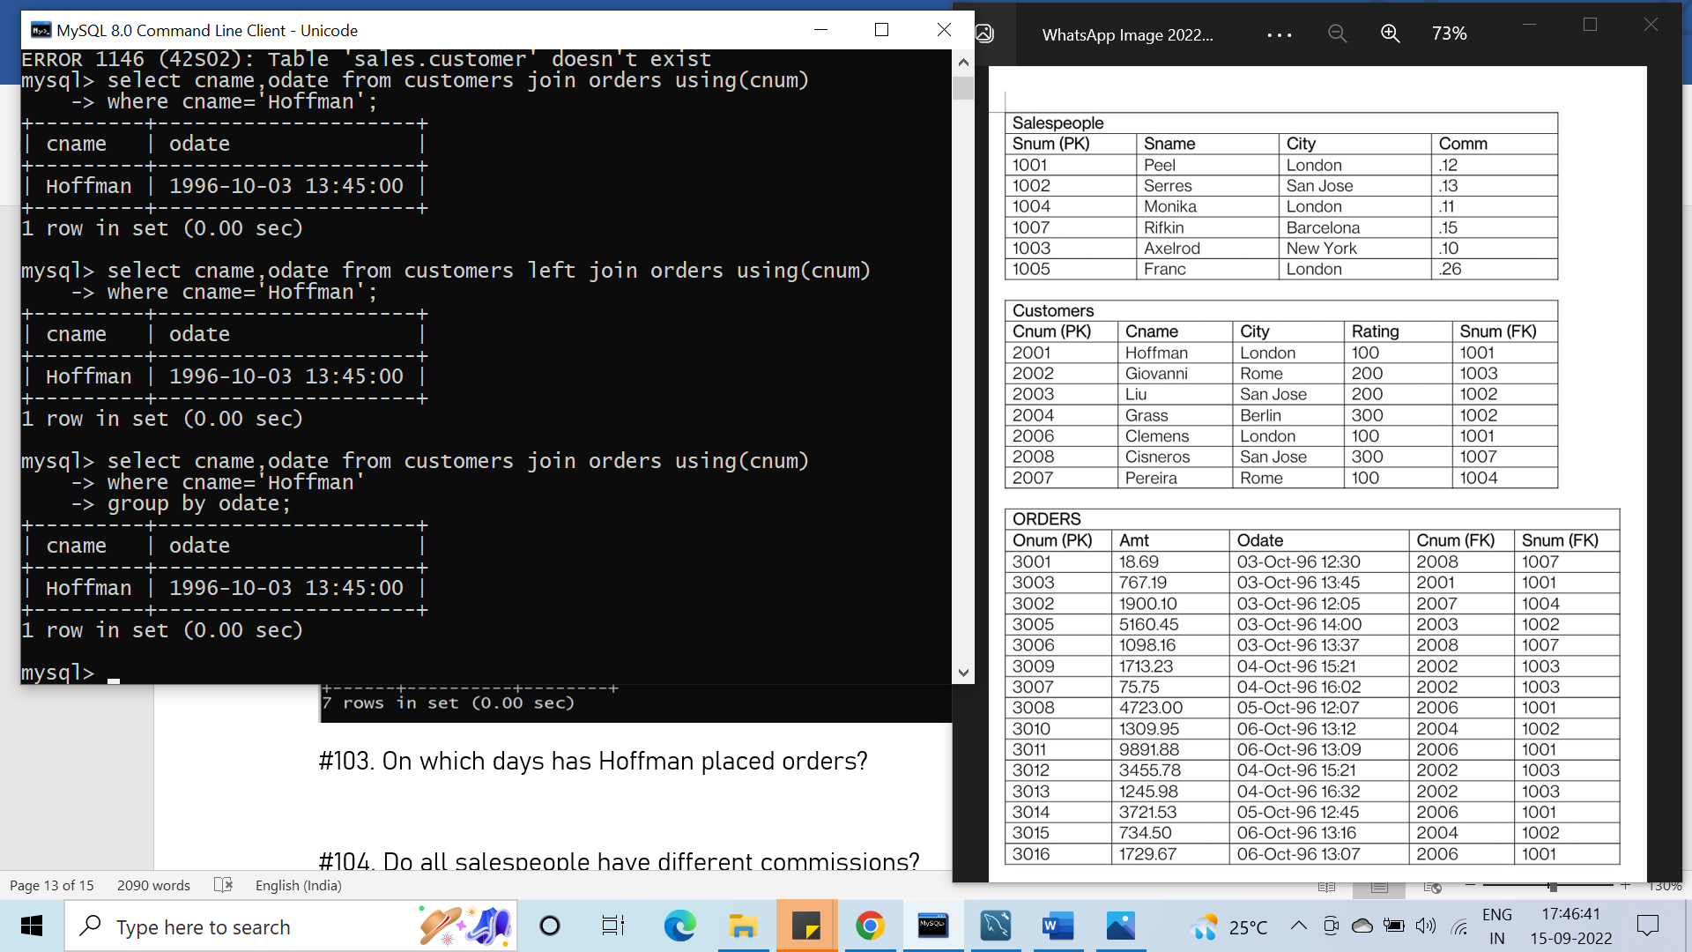

#104. Do all salespeople have different commissions?

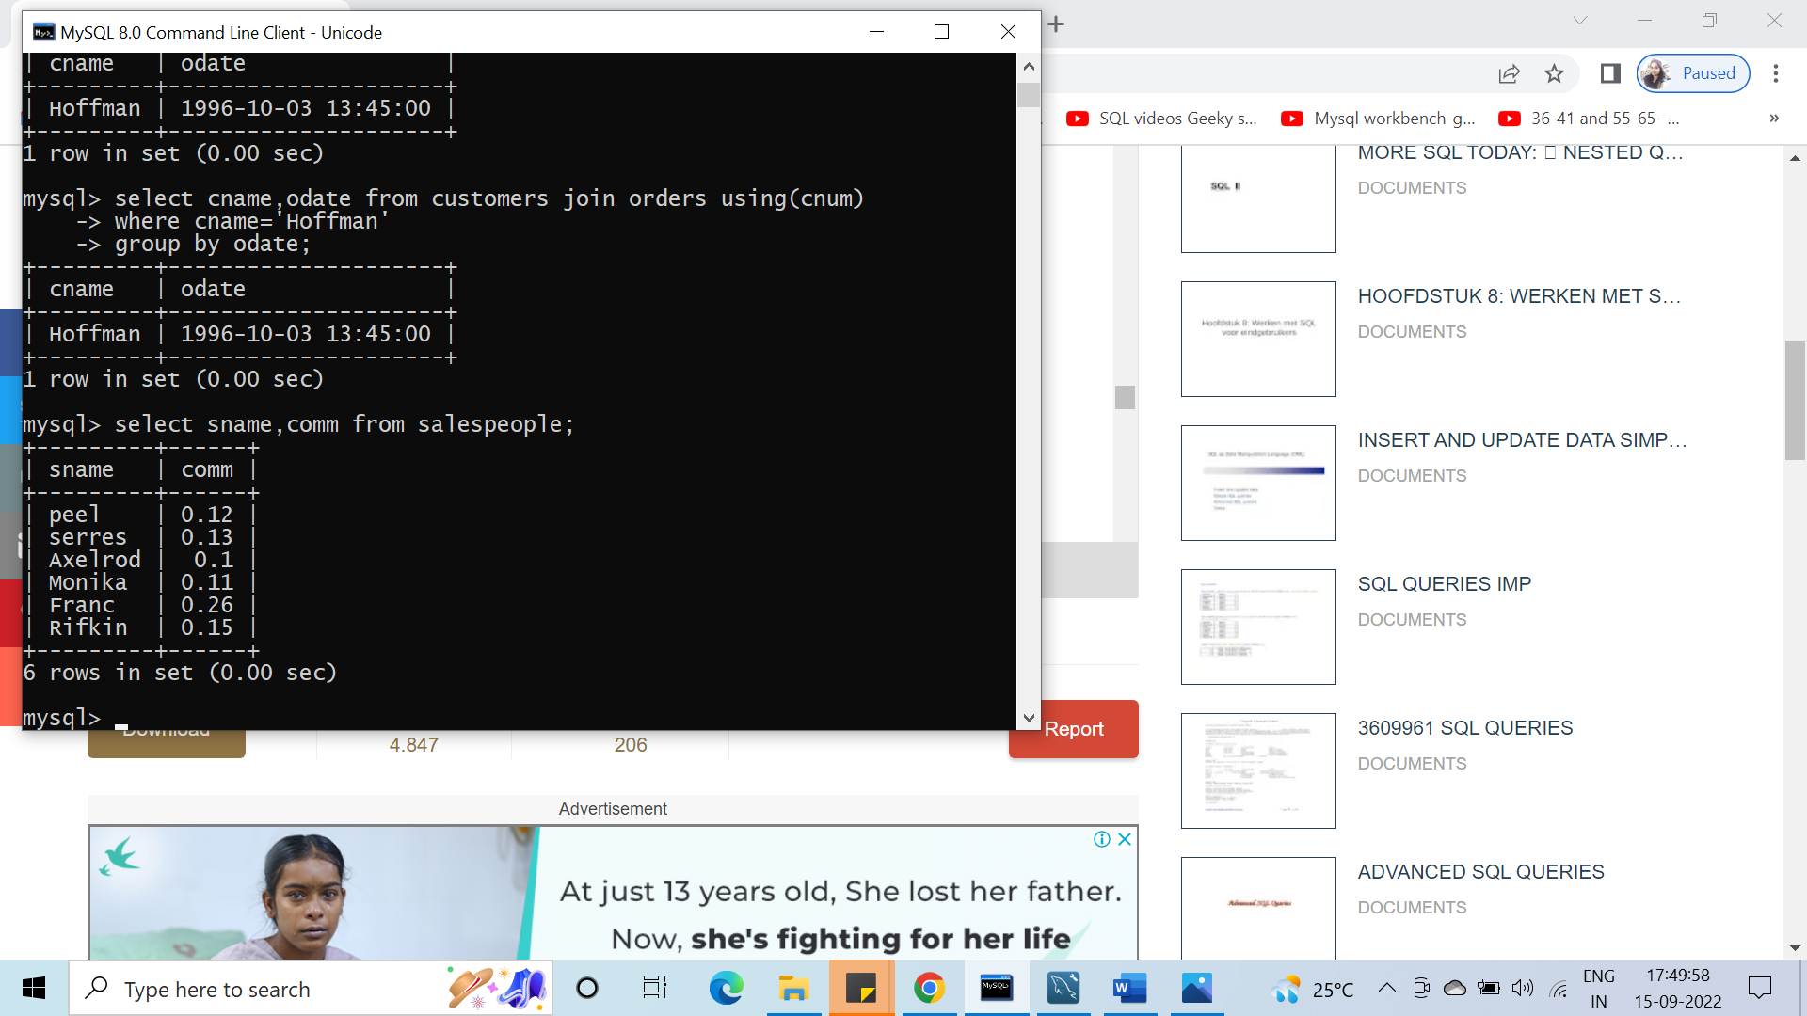

#105. Which salespeople have no orders between 10/03/1996 and 10/05/1996

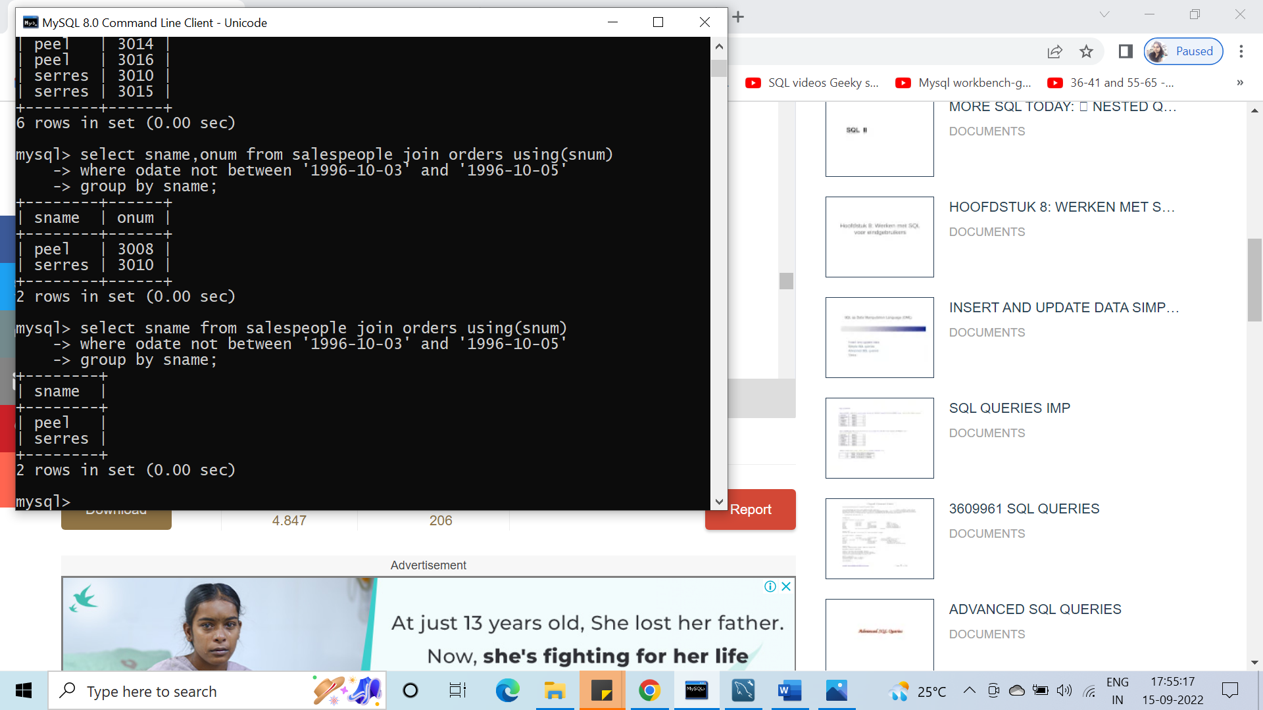

#106. How many salespersons have succeeded in getting orders?

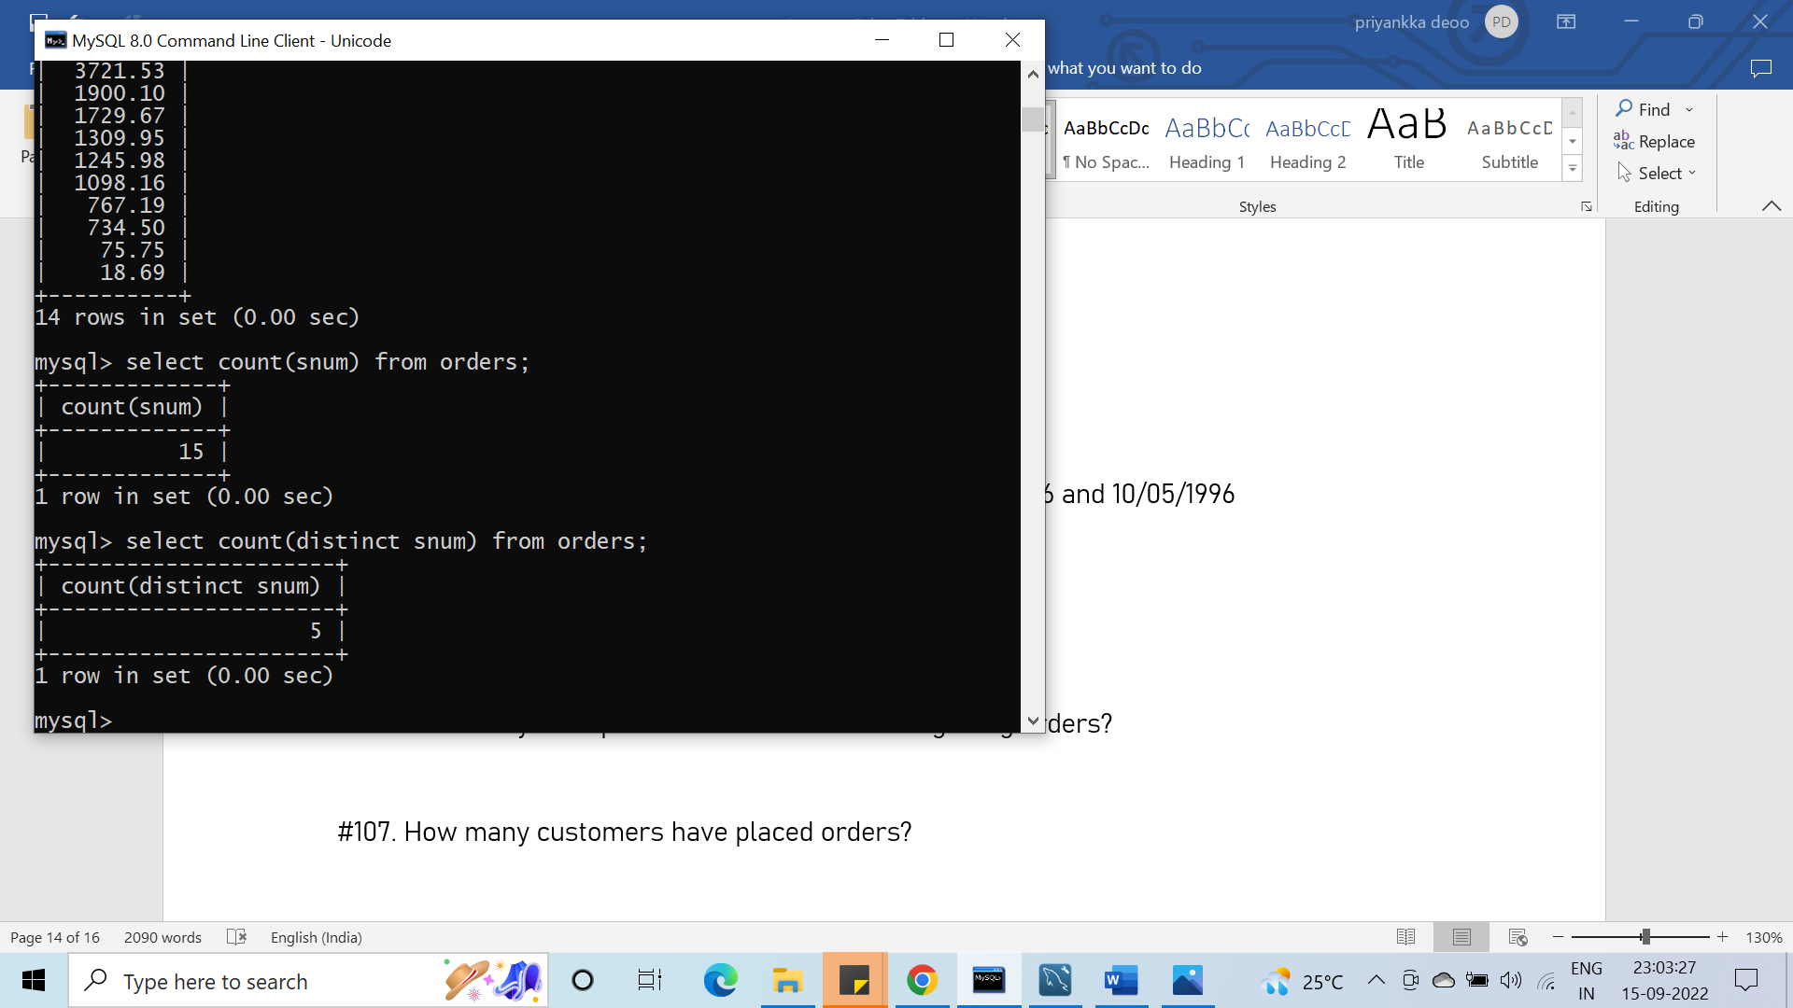

#107. How many customers have placed orders?

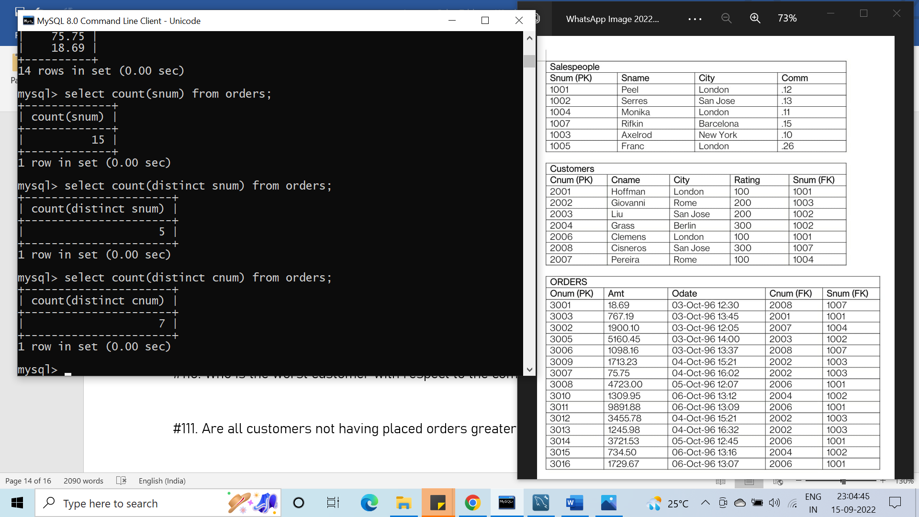

#108. On which date has each salesperson booked an order of maximum value?

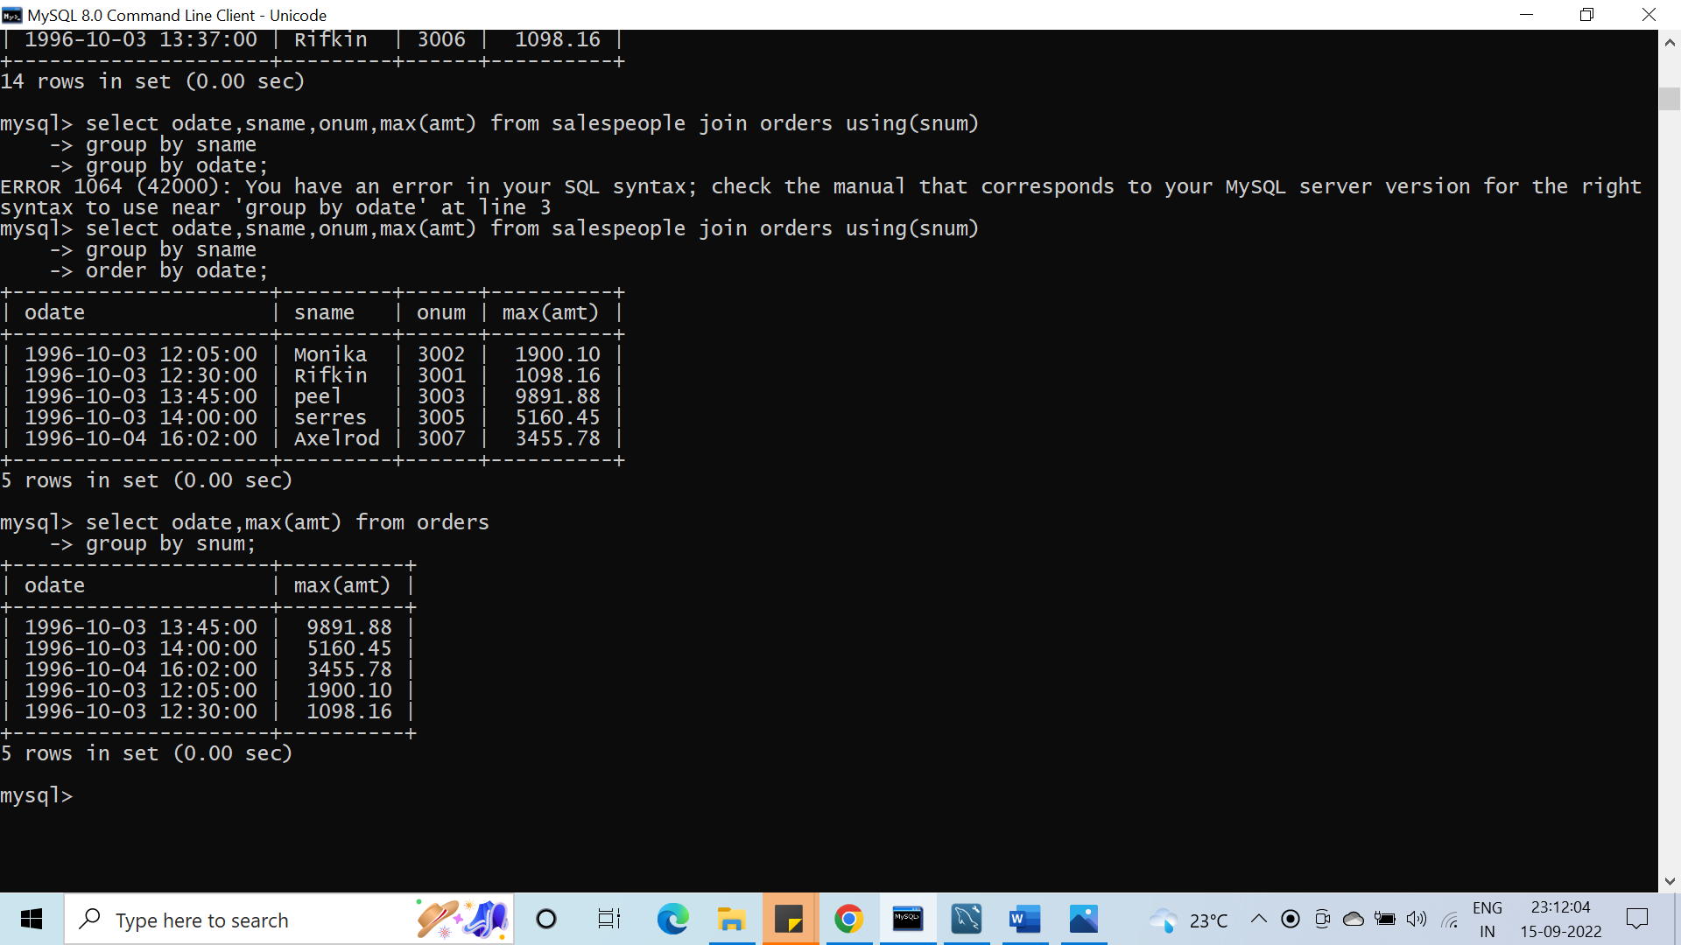

#109. Who is the most successful salesperson?

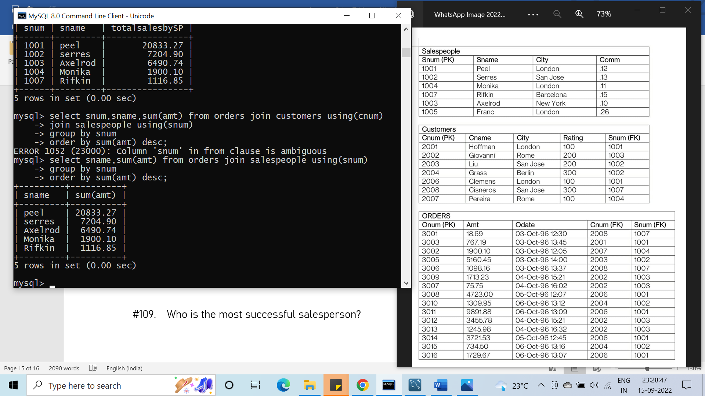

#110. Who is the worst customer with respect to the company?

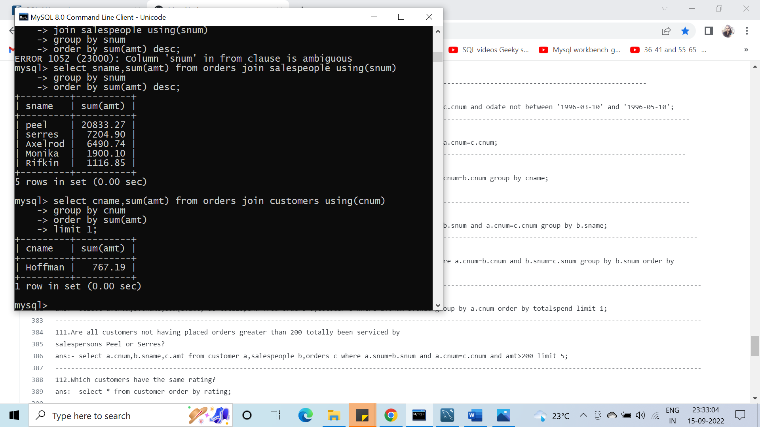

#111. Are all customers not having placed orders greater than 200 totally been serviced by

salesperson Peel or Serres?

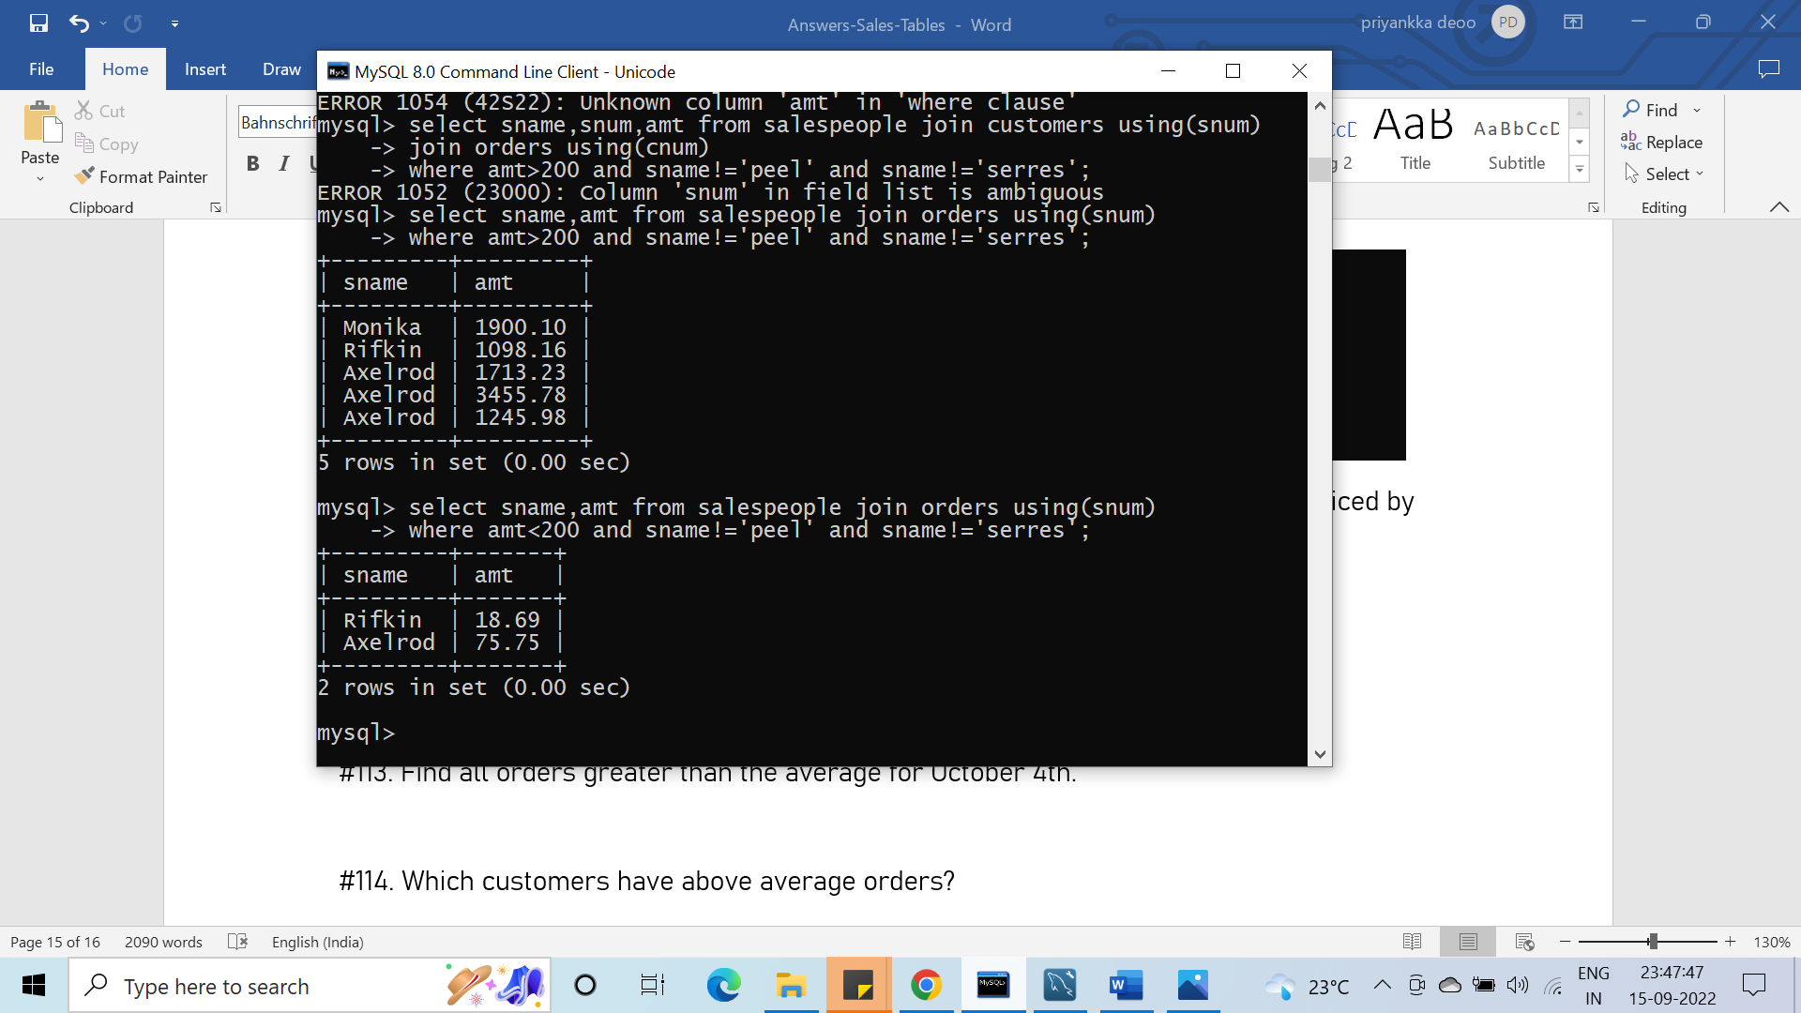

#112. Which customers have the same rating?

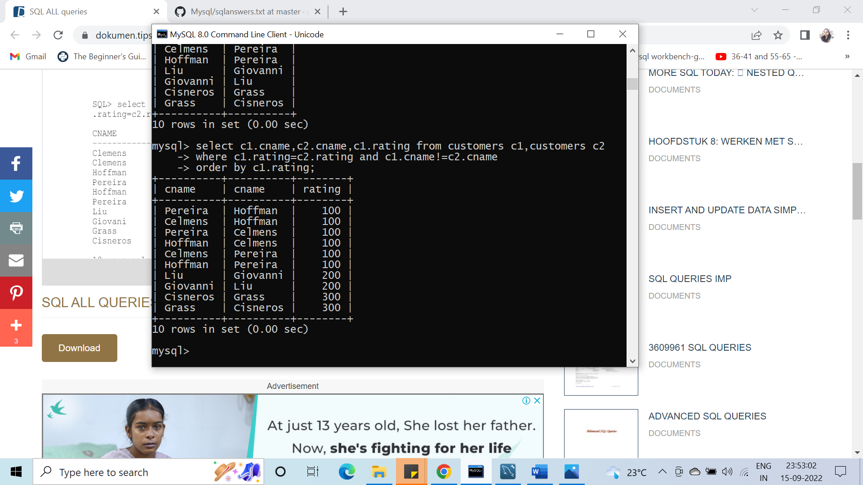

#113. Find all orders greater than the average for October 4th.

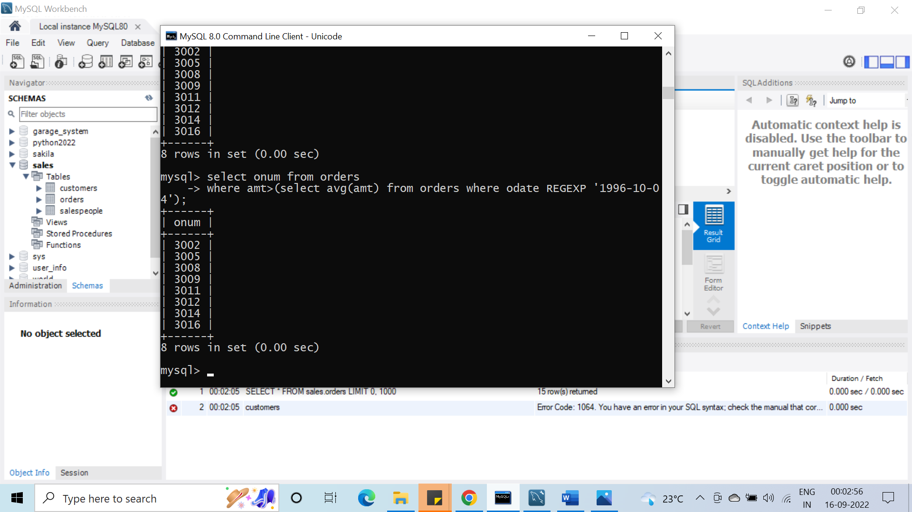

(ideally answer should be 3012)

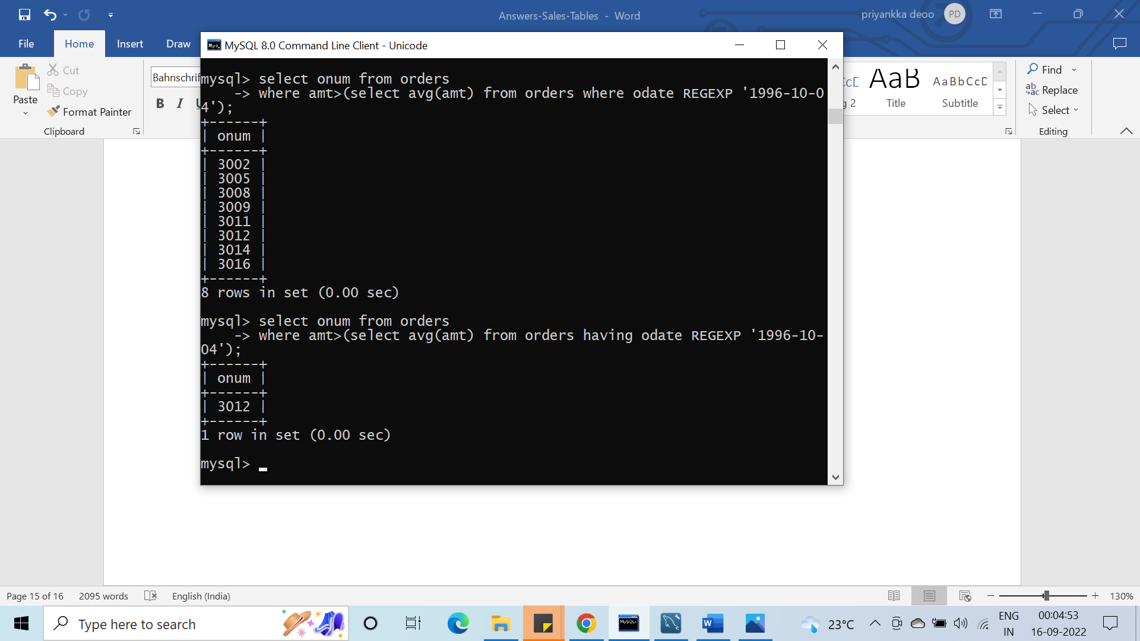

#114. Which customers have above average orders?

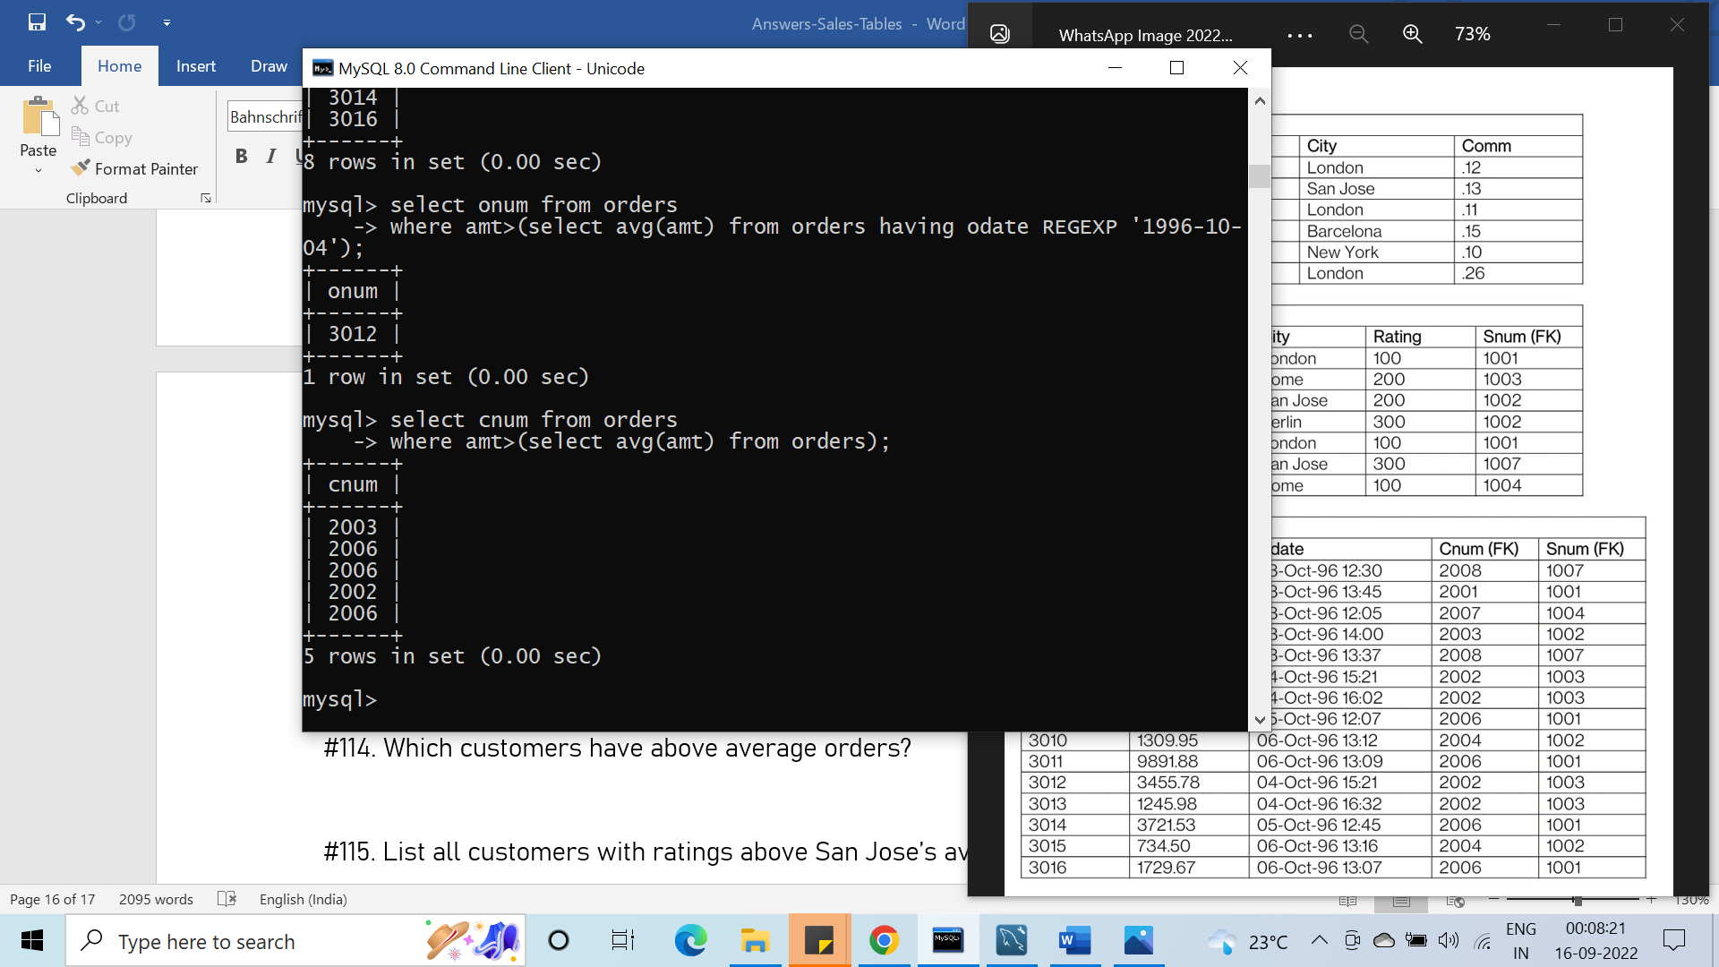

#115. List all customers with ratings above San Jose’s average.

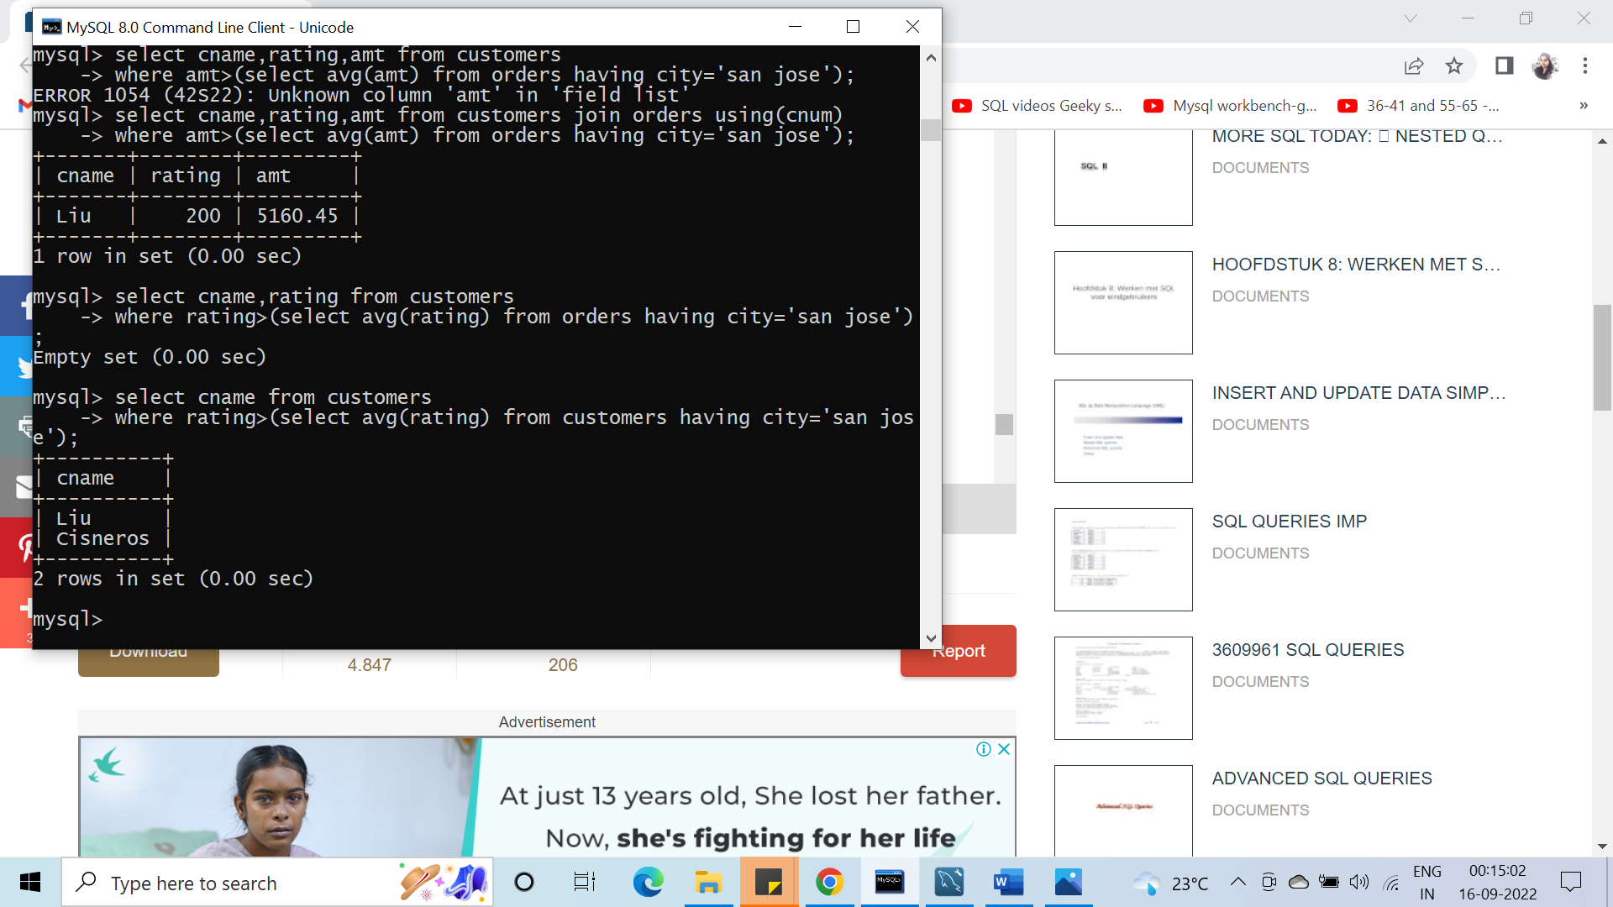

#116. Select the total amount in orders for each salesperson

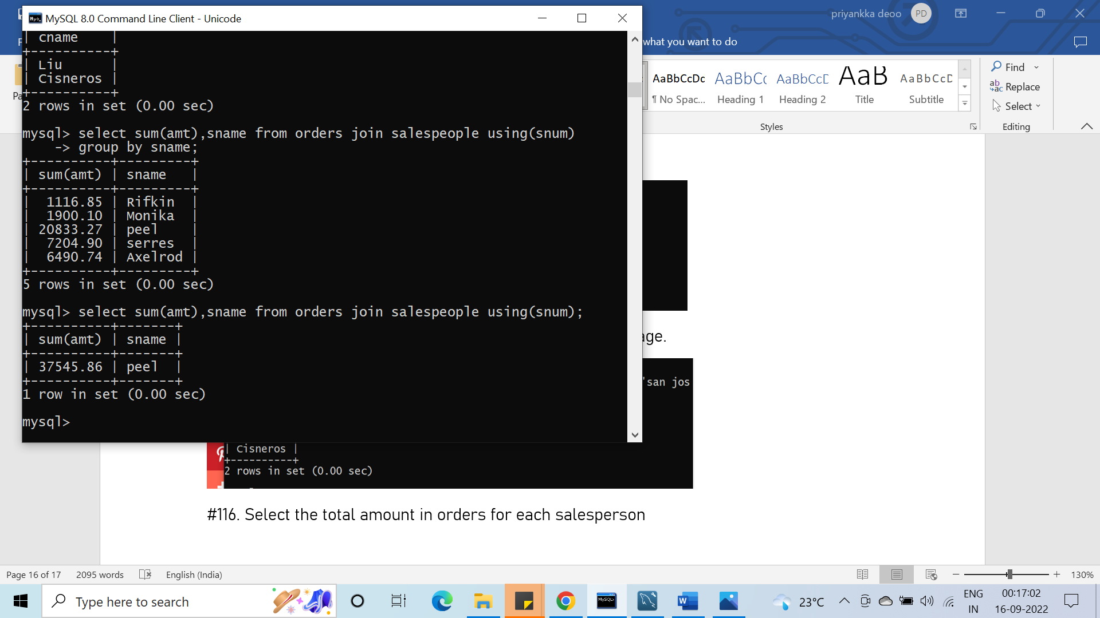

#for which the total is greater than the amount of the largest order in the table

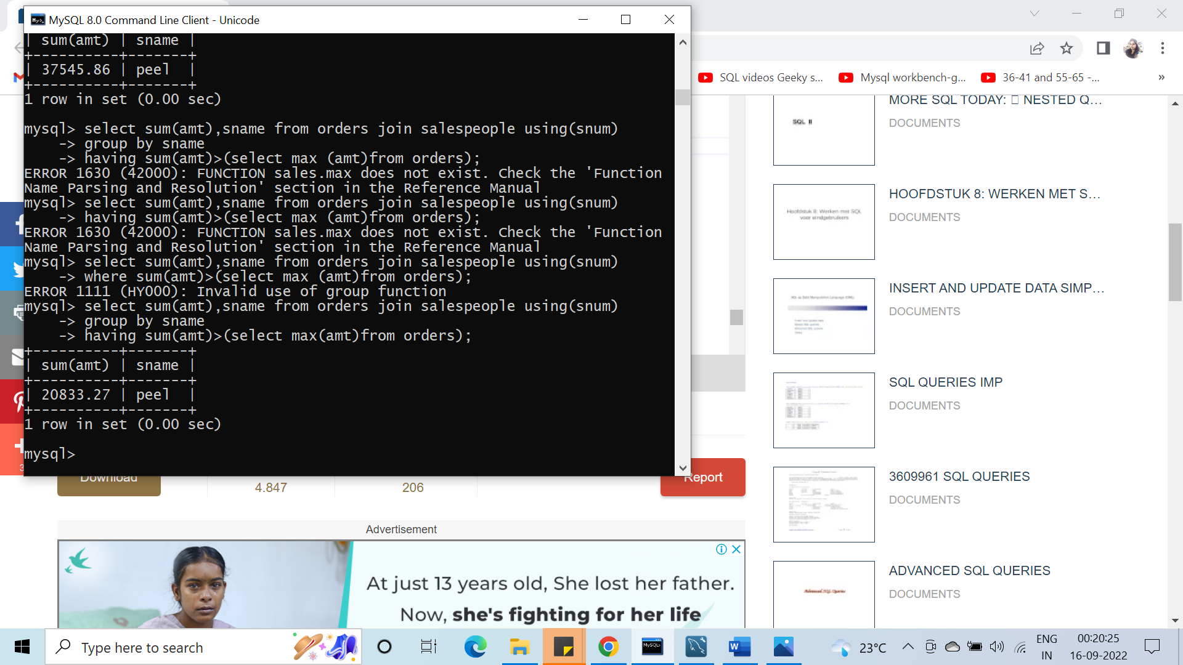

#117. Give names and numbers of all salesperson that have more than one customer.

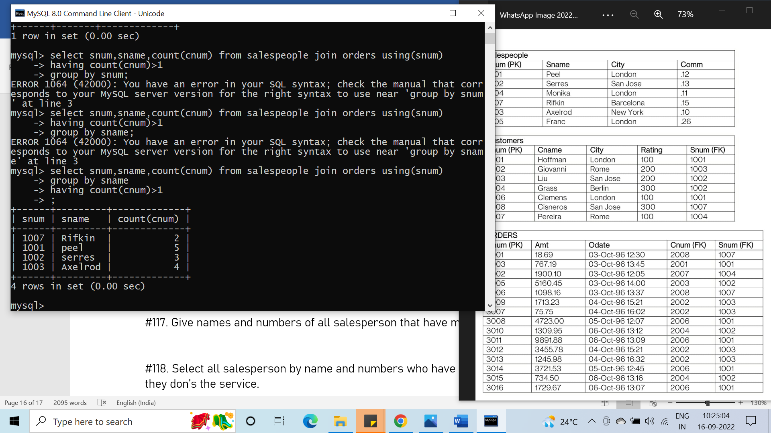

#118. Select all salesperson by name and numbers who have customers in their city whom they don’s the service.

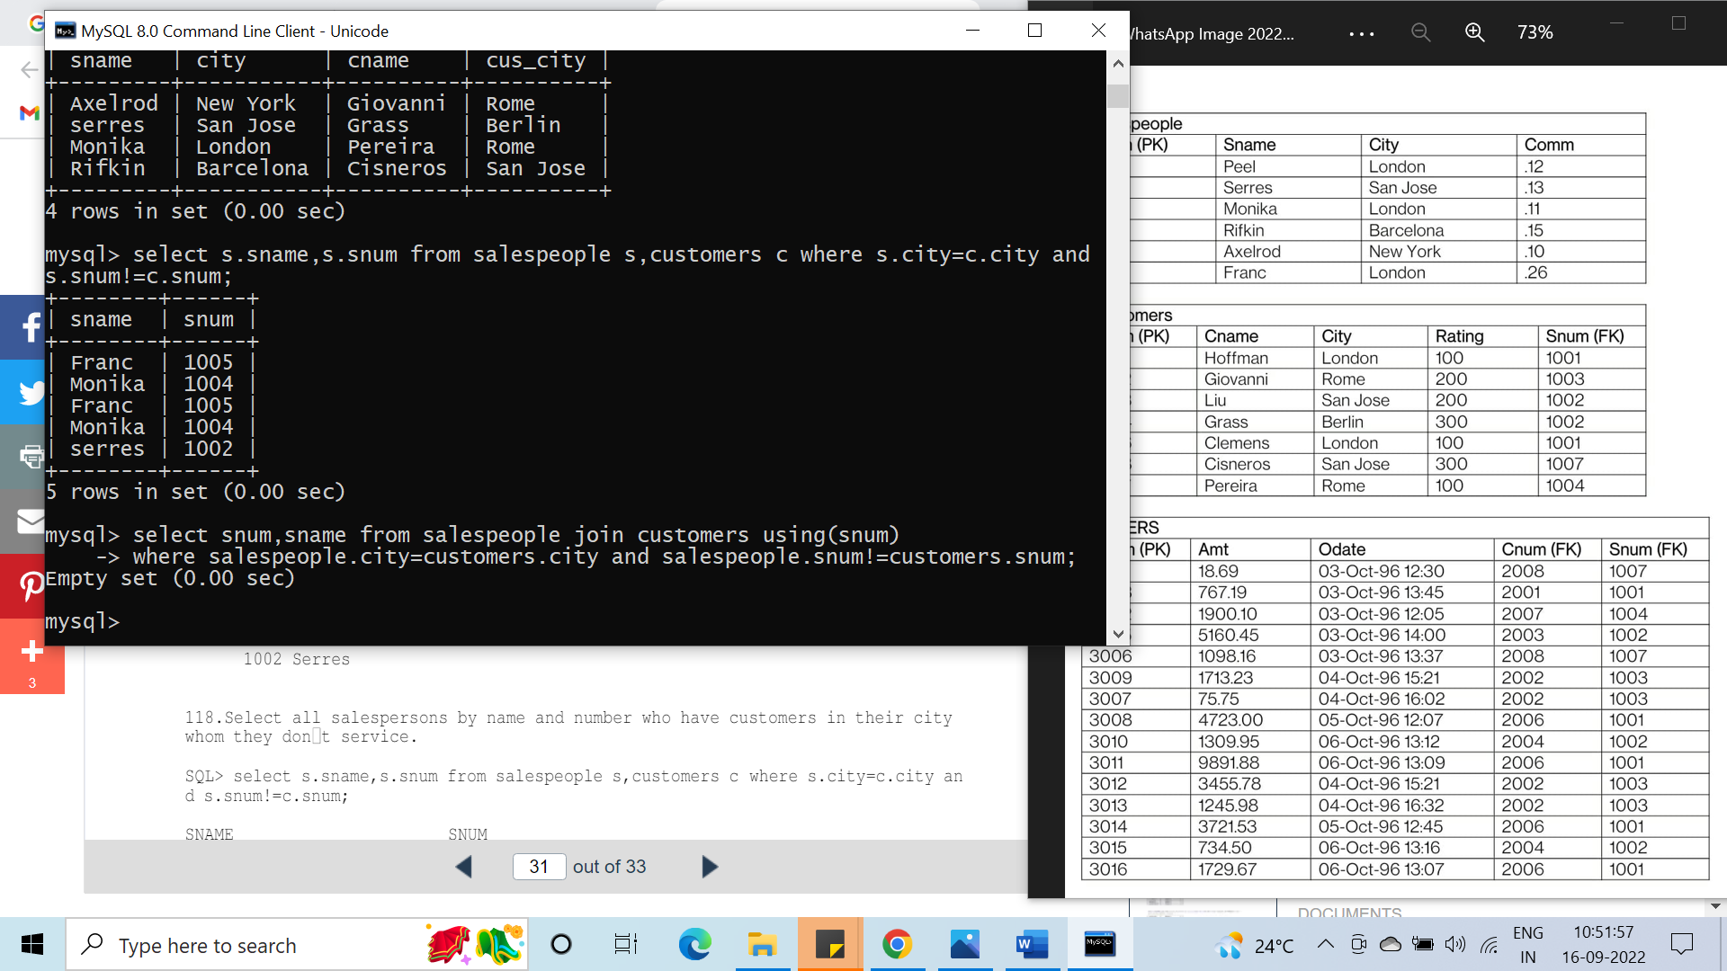

#119. Which customer's rating should be lowered?

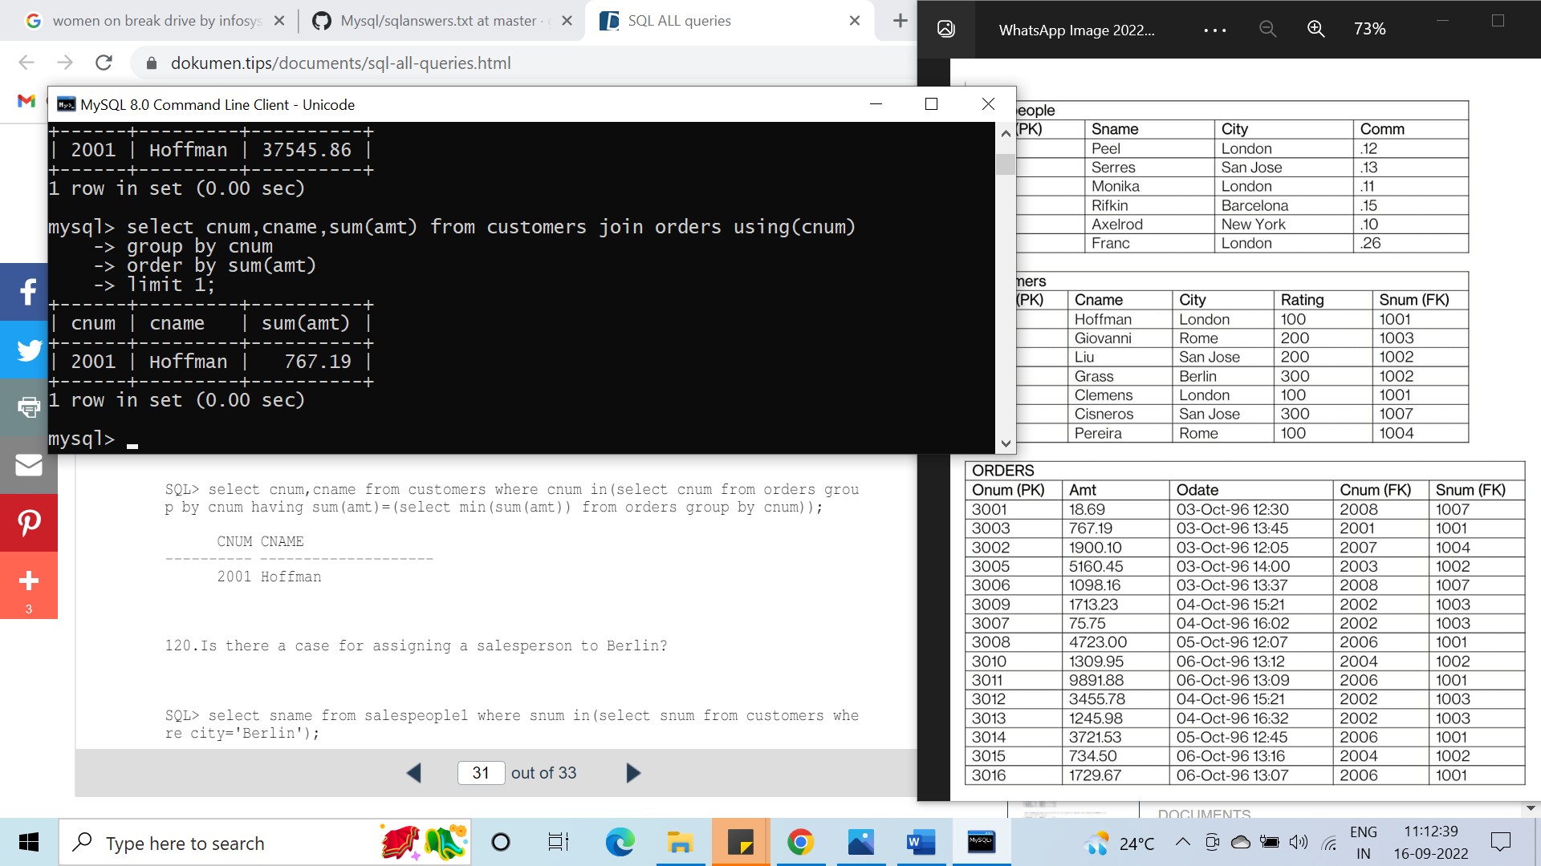

#120. Is there a case for assigning a salesperson to Berlin?

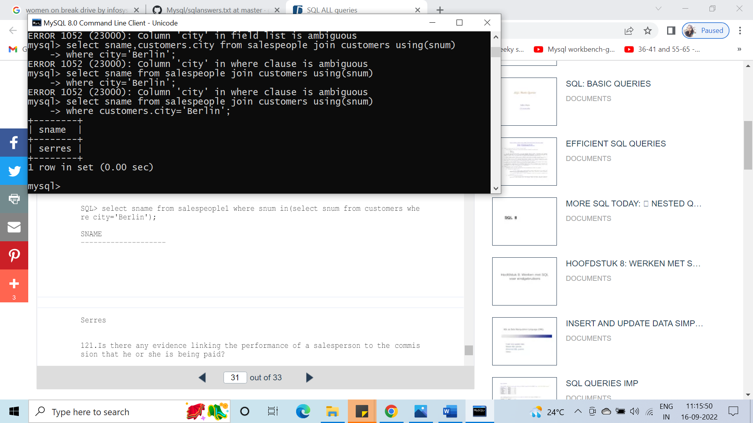

#121. Is there any evidence linking the performance of a salesperson to commission that he or she is being paid?

#122. Dose the total amount in orders by customer in Rome and London exceeds the commission paid to salesperson in London and New York by more than 5 times?

#123. Which is the date, order number, amt and city for each salesperson (byname) for the maximum order he has obtained?

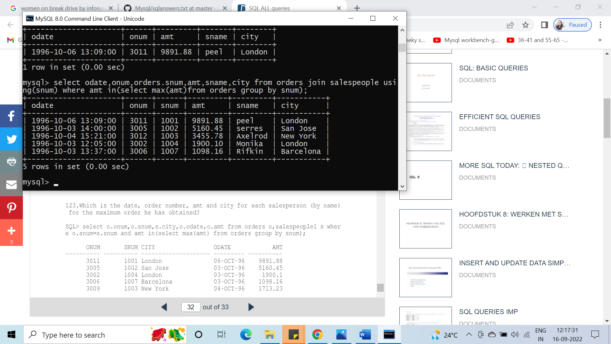

#124. Which salesperson(s) should be fired?

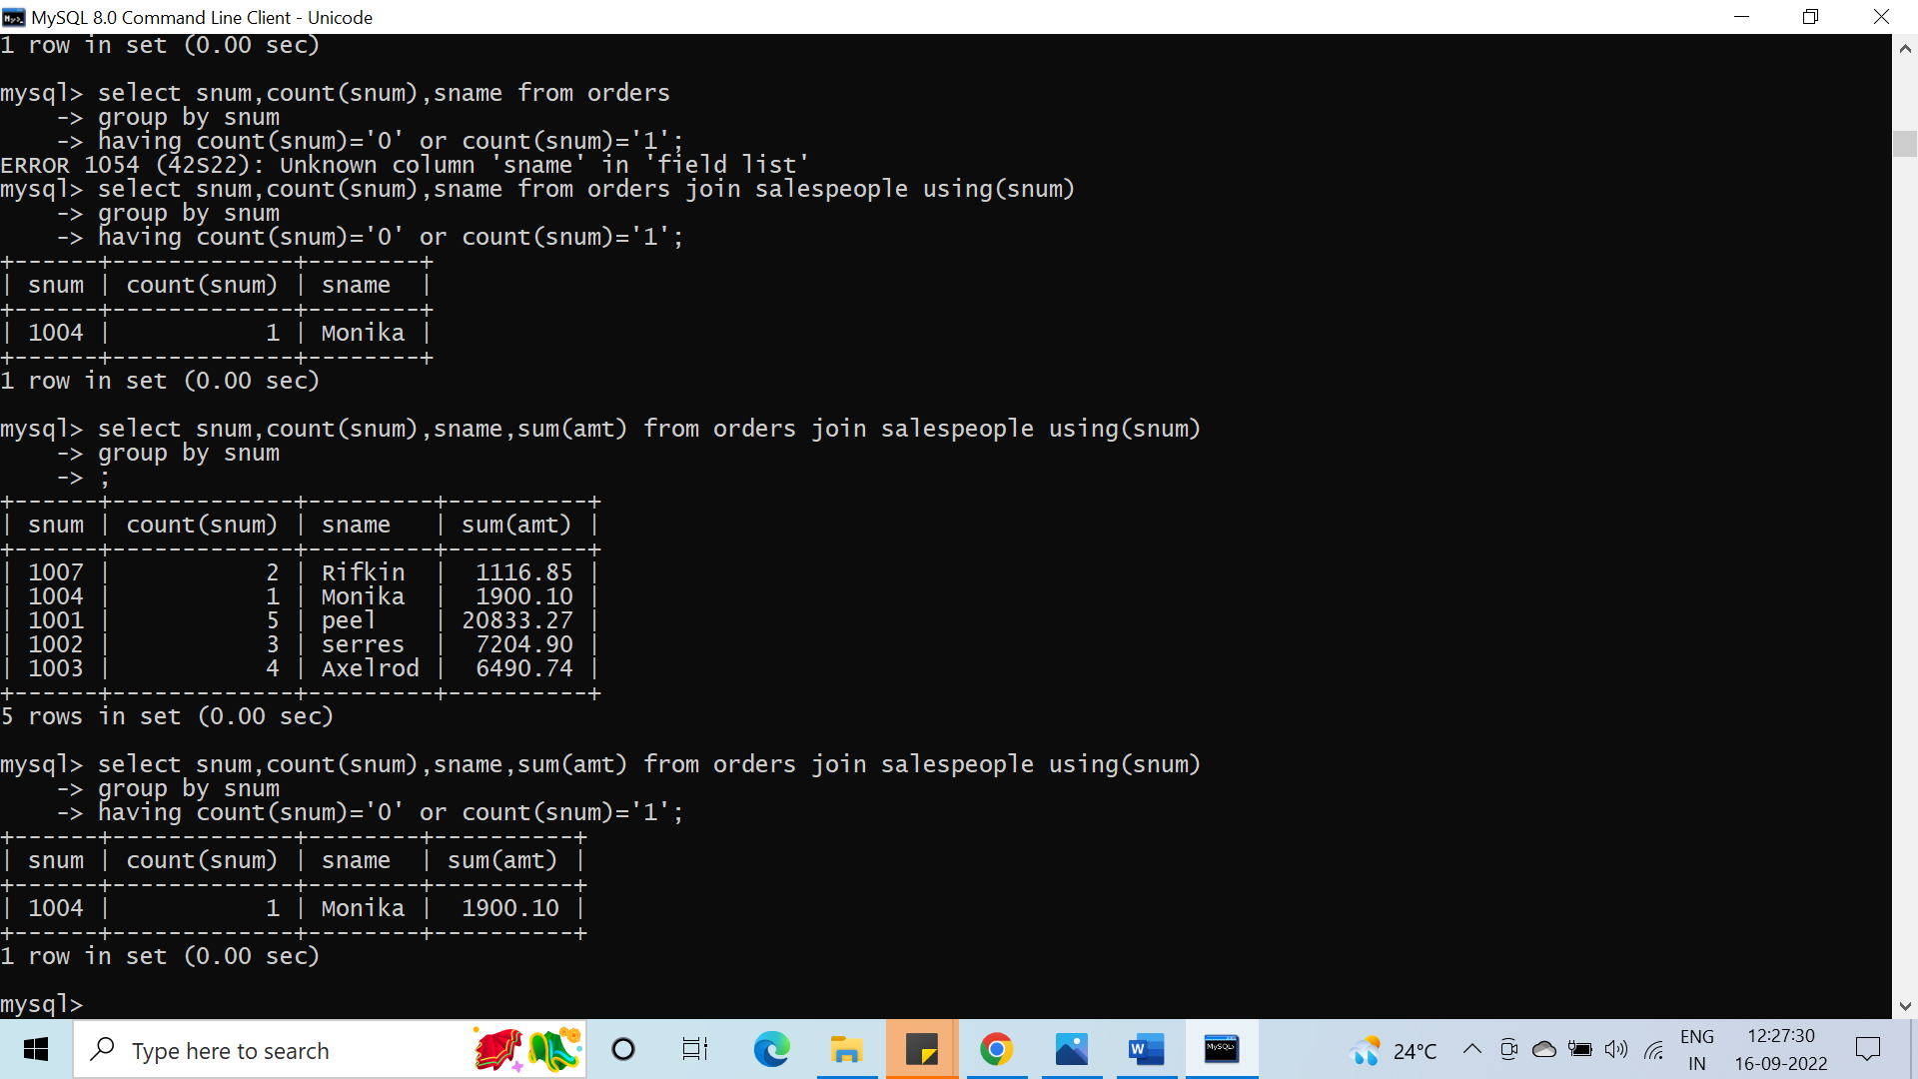

#125. What is the total income for the company?

